Knowledge Organiser
Year 5: Properties of Materials
Key Knowledge: Compare and group together everyday materials based on their properties, including hardness, solubility, transparency, conductivity and response to magnets. Know that some materials will dissolve in liquid to form a solution and describe how to recover a substance from a solution. Use knowledge of solid, liquid and gas to decide how mixtures might be separated including through filtering, sieving and evaporation. Give reasons based on evidence from comparative tests for the particular uses of everyday materials including metals, wood and plastic. Demonstrate that dissolving, mixing and changes of state are reversible changes. Explain that some changes result in the formation of new materials and this kind of change is not usually reversible including changes associated with burning and the action of acid on bicarbonate of soda.

VOCABULARY
solid- Firm shape or form that can be measured in length, width, and height not like a liquid of gas. Tightly packed molecules.
liquid- no defined shape, takes the shape of its container. Particles free to move over each other.
gas- easy to compress, expand to fill containers and occupy more space than liquids or solids.
transparent- You can see through it
soluble- able to be dissolved
insoluble- cannot be dissolved.
conductor- a substance that heat or electricity can pass along or through.
filtering- a device used to remove dirt or other solids from liquids or gasses.
evaporation- turn liquid into a gas; pass away in the form of vapour.
condensation- small drops of water which form when water vapour or steam touches a cold surface.
reversible- can be changed back e.g. ice to water.

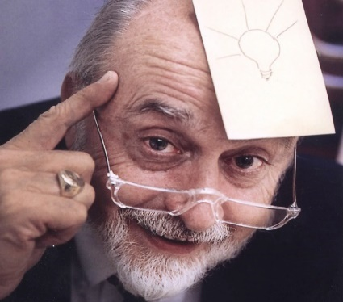
r
nnh
States of Matter
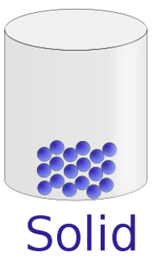
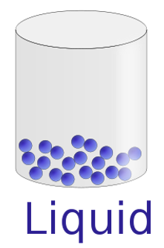
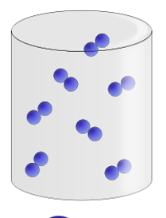

Spencer Silver invented the ‘Post It Note’ by mistake.

Solid- firm shape with tightly packed molecules.
Liquid- no defined shape, takes the shape of its container.
Gas- particles move freely and expand to fill container.

Electrical conductors
Grouping Materials based on properties.
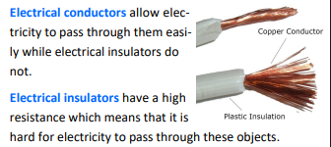
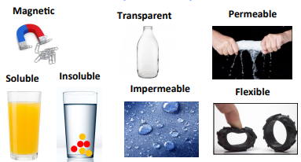





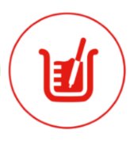



Prior Knowledge (Year 2): To identify and compare the suitability of a variety of everyday materials including wood, metal, plastic, glass, brick, rock, paper, cardboard for particular uses. I can find out how the shape of solid objects made from materials can be changed by squashing, bending, twisting and stretching.
Boiling
Sieving
Processes

Dissolving
Melting

Two substances becoming one solution.
Changes state but does not mix.
Condensation
Filtering
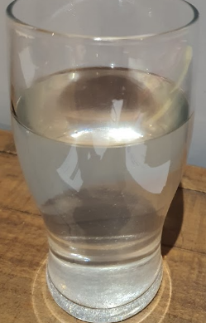
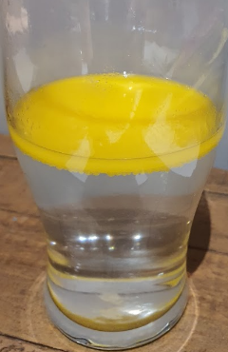

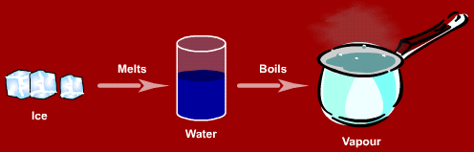
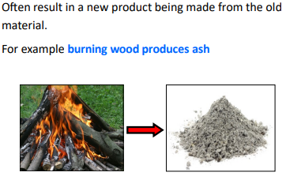



You can change it back to its original state.
Reversible Changes
Irreversible Changes
Distillation
Evaporation

