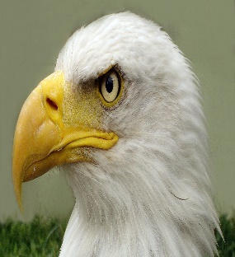
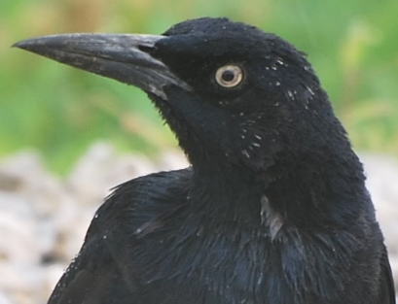
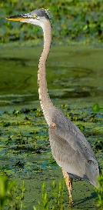

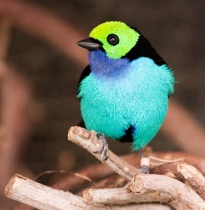
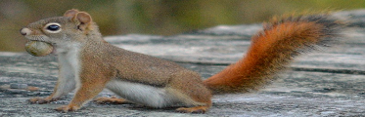

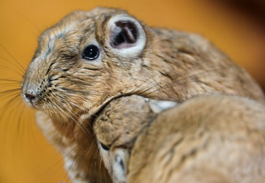
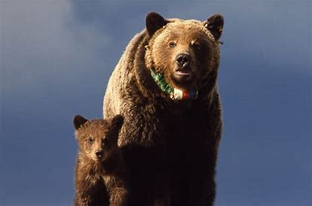
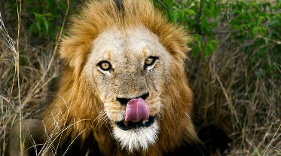
Key Knowledge: Can name a range of animals which includes animals from each of the vertebrate groups. Can describe the key features of named animals. Can label key features on a picture/diagram. Can write descriptively about an animal. Can write a ‘What am I? Riddle about an animal. Can describe what a range of animals eat. Can compare and classify animals.
Knowledge Organiser- Year 1 Animals Including Humans
VOCABULARY
carnivore- eats meat.
omnivore- eats plants and meat.
herbivore- eats plants
amphibian- live on land and water.
reptile- cold blooded with skeleton inside body, dry scales, or hard skin.
bird- warm blooded and lay eggs. Body covered in feathers.
mammal- warm blooded vertebrates.
fish- lives in water and has fins for swimming and gills for breathing.
insect- have bodies with 3 segments, protected by hard shell.
minibeast- small creatures without backbones.
vertebrate- has a backbone.

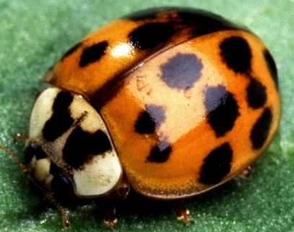
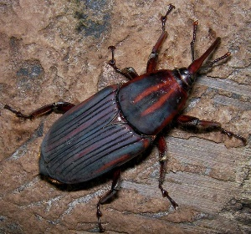
BIRDS
Have feathers and wings.
Lay eggs.
Have two legs.
Ear holes instead of ears
Warm blooded.
Have a beak.
MAMMALS
Have hair or fur
Give birth to ‘live young’
Mammal mothers nurse their young with milk.
Have lungs and need air to breathe.
Mammals that live on land have 4 legs and ears that stick out.
Warm blooded.
INSECTS
Invertebrate (no backbone)
Have exo-skeleton
Segmented body
Lay eggs
Have antennae on head

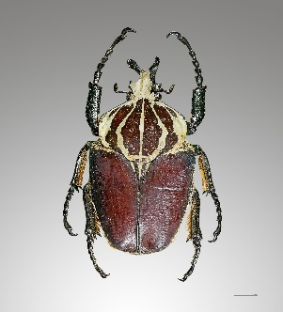
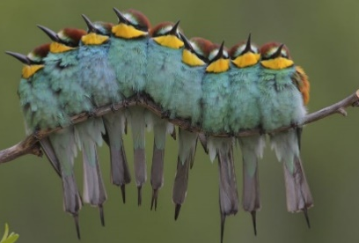

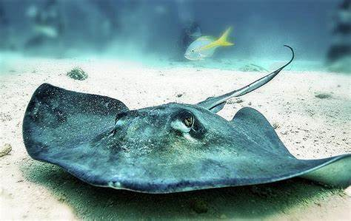
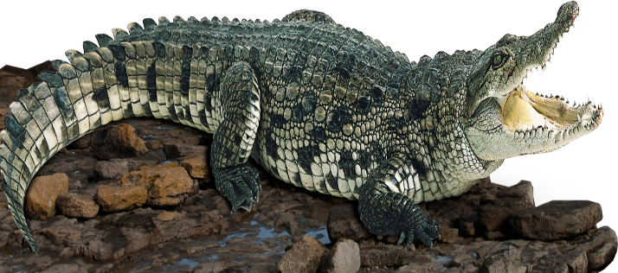
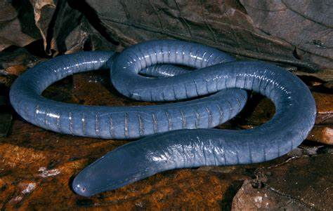
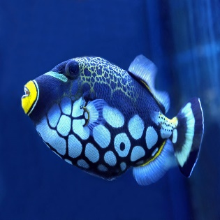
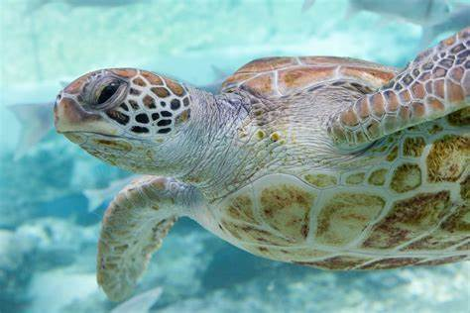
REPTILES
Have scales not fur.
Have dry skin.
Usually lay eggs, sometimes live young.
Ear holes instead of ears.
4 Legs or no legs.
Cold blooded.

FISH
Breathe under water using gills not lungs.
Live in water.
Have scales and fins (no fur or hair)
Cold blooded.
Lays may eggs.
AMPHIBIANS
Live on land and on water.
Have webbed feet.
Breathe with lungs and gills.
Cold-blooded.
Moist smooth skin, no fur or hair.
Lay many eggs.

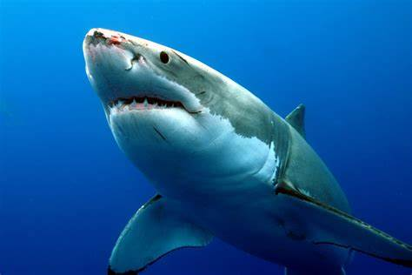
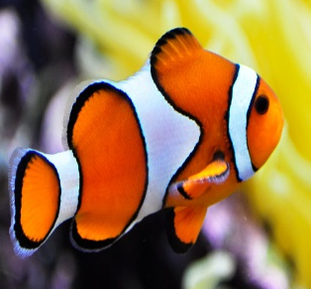
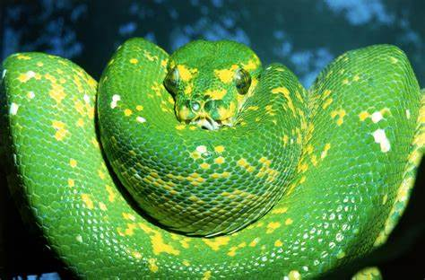
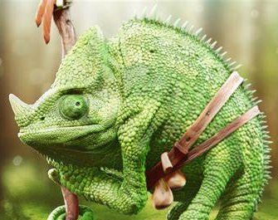
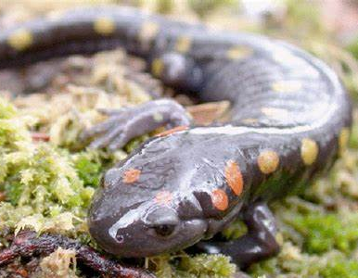
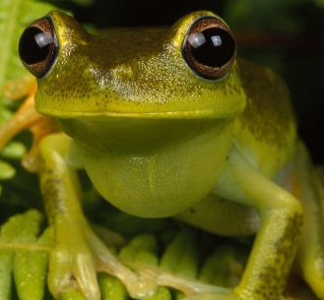

There are lots of animal groups: there are also arachnids, vertebrate, invertebrate, arthropods and many more.










Year 1
Animals Including Humans
VOCABULARY

ears- found on the side of your face to help you hear.
head- at the top of the body contains the brain.
eyes- On our face, helps us see.
nose- on the face- helps us smell.
hands- on the end of the arm, help us touch.
skin- biggest organ of the body, covers our skeleton.
mouth- On the face, helps us taste and houses the tongue and taste buds.
sweet, sour, bitter and salty- words associated with taste.

Our Senses
sight  Your eyes and light let you see things all around you. | 
smell  You smell using your nose. | 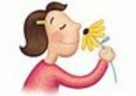
hearing  Your ears let you listen to sounds. | 
touch  Your skill gives you the sense of touch. | 
taste  Your sense of taste comes from your tongue. | 

head
ears





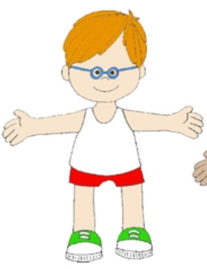
hair
eyes
mouth
hand
elbow
knee
foot
neck
shoulder
chest
stomach/
tummy
leg
toes

