Key Knowledge: I can distinguish between an object and the material from which it is made. I can identify and name a variety of everyday materials including wood, plastic, glass, metal, water and rock. I can describe the simple properties of a variety of everyday materials. I can compare and group together a variety of everyday materials on the basis of their simple properties.
Knowledge Organiser-
Year 1 Materials

Materials Vocabulary
Properties of materials.

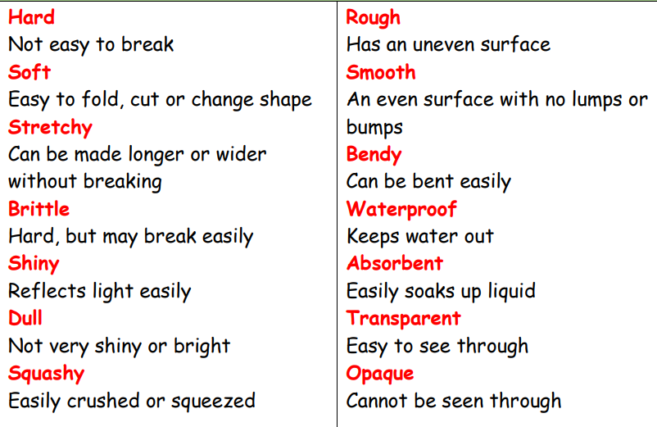
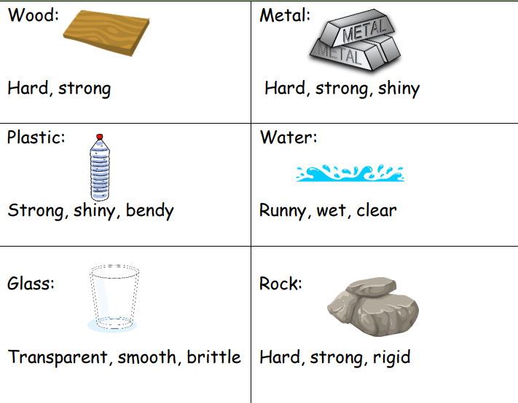

Wood is a strong material
Plastic is a waterproof material
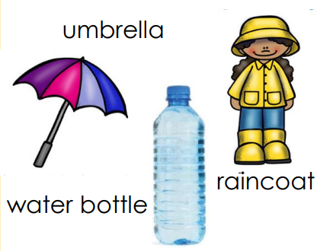
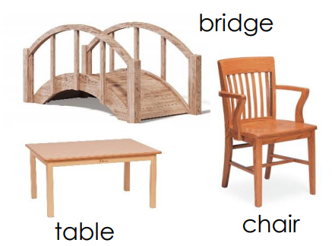










Year 1
Materials

Words to describe materials
Famous Scientists (Science Capital)

JOHN
MCADAM
1756-1836
Scottish engineer who experimented with using new materials to build roads, inventing a new process called ‘macadamisation’. His effective and economical method of constructing roads is used across the world.

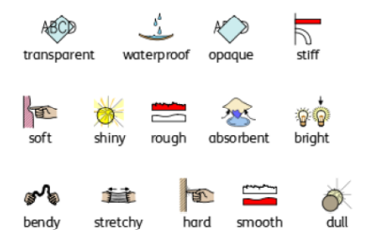

JOHN DUNLOP
1840-1921
Scottish engineer and veterinary surgeon. Made rubber devices and invented the pneumatic tyre, developed the use of them in cycle racing.

Scottish chemist and inventor of waterproof fabric. His process involved painting a dissolved rubber solution into cloth. The Macintosh raincoat is named after him.

CHARLES MACINTOSH
1766-1843




Prior Knowledge: EYFS- Moving and handling: Introduce and encourage children to use the vocabulary of manipulation, e.g. squeeze and prod.
The world- Can talk about why things happen and how things work.
Exploring media and materials- notice changes in properties as they are transformed through becoming wet, dry, flaky or fixed. Think about cause and effect.

