


Autumn Term F1
Lingham Primary School

PSHE
Communication and Language
Maths
English



-Showing more confidence in new situations.
-Beginning to express own interests and preferred activities.
-Beginning to understand how others may be feeling.
-Developing friendships with other children.
-Feelings

Our key texts:
-Titch by Pat Hutchins
-Eyes, Nose, Fingers and Toes by Judy Hindley
-Ten Little Fingers and Ten Little Toes by Mem Fox
-Goldilocks and the Three Bears
-The Three Little Pigs
-Jack and the Beanstalk

-Reciting Numbers to 5
-1:1 counting
-Sorting objects by colour, size or shape
-All about number 1
-All about number 2
-Subitising to 2.
-Pattern
-Listening to a range of stories remembering and talking about what happened.
-Developing understanding of ‘who’, ‘what’ and ‘where’ questions.
-Using longer sentences when sharing thoughts and ideas.
-Learning rhymes and songs.

Physical Development

The Natural World
People, Culture and Communities
Past and Present



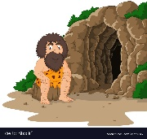
M
-Balance
-Coordination
-Movement
-Spatial Awareness
-All about me
-Body parts
-The 5 senses
-Autumn

-The Big Book of Families by Hoffman Mary
-It’s Okay to be Different by Todd Parr
-Where do I live? Moreton – my house, school, park and beach.
-Differences between places in Moreton.
-Different types of buildings.
- How have I changed from a baby?
- Baby – Toddler – Child
- My Family


Being Imaginative and Expressive

Autumn Term F1
Lingham Primary School
Creating with Materials
Other bits & bobs


-Making marks
-Drawing Circles
-Beginning to enclose space when drawing and using these shapes to represent objects.
-Exploring Different materials when creating.

-Singing familiar songs
-Nursery rhymes
-Action songs
-Showing an interest in the way musical instruments sound
-Taking part in pretend play.
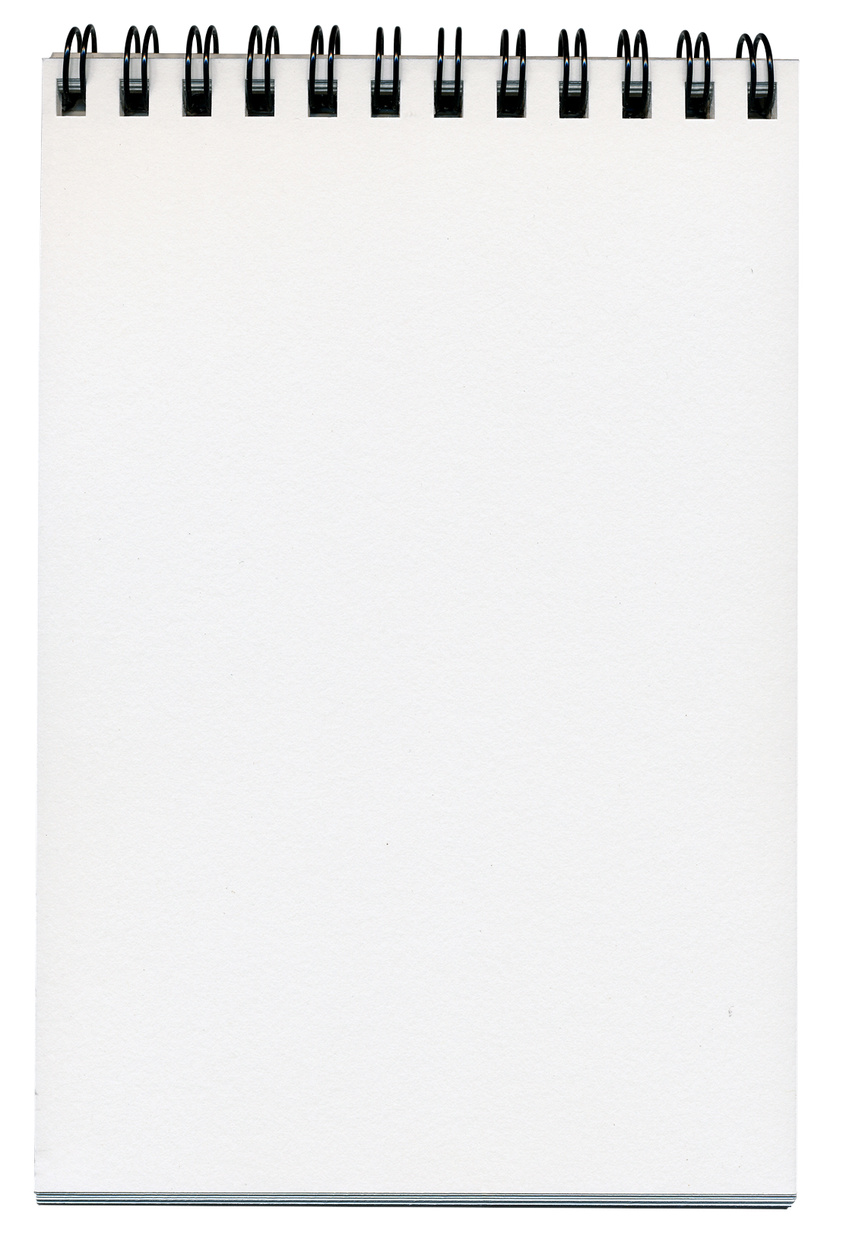

- PE is every Monday– Children to come to school in their PE kit.
- PLEASE make sure jumpers and cardigans are labelled.
- Please make sure your child has water in their water bottles. Thank you.



