
What should I already know?
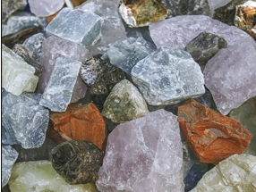
- Name a variety of everyday objects and describe their physical properties.
- Compare and group a variety of objects based on their appearance and properties.
- Why some materials are used for certain purposes because of their properties.

What will I know by the end of the unit?
- Compare and group together different kinds of rocks based ontheir appearance and properties.
- Describe in simple terms how fossils are formed.
- Recognise that soils are made from rocks and organic matter
Classification of Rocks | Classification of Soil
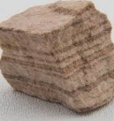  Sedimentary  These are made when sand, mud and pebbles get laid down in layers. Over time, these layers are squashed under more and more layers. | 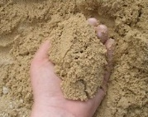  Sandy Soil  This is a dry soil with lots of air found in it. It is made up of tiny pieces of weathered rock.
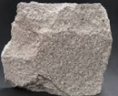  Igneous  Igneous rock is formed when magma cools and solidifies, it may do this above or below the Earth's surface. | 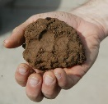  Clay Soil  This soil is sticky and doesn’t have much air in it. Clay soil often contains a lot of water.
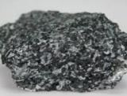  Metamorphic  When a rock experiences heat and pressure, it becomes a metamorphic rock. All metamorphic rocks start as another type of rock. | 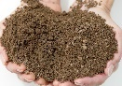  Loam Soil  A mixture between sandy and clay soil. It has some waer and some air in it. This is best for growing plants.
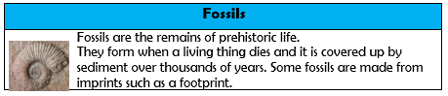
Key Vocabulary
absorb | soak up or take in
crystals | A clear colourless glass.
fossil | The remains or traces of a once living thing.
mineral | Something that is formed naturally in rocks and the Earth.
properties | The features that belong to something that makes it unique.
rock | a solid which is made up of minerals. Rock forms much of the Earth's outer layer.
soil | A mix of dead plants and animals with broken bits of rocks and minerals.
weathered | Worn down by the weather.

