Ready, Steady, let’s create…
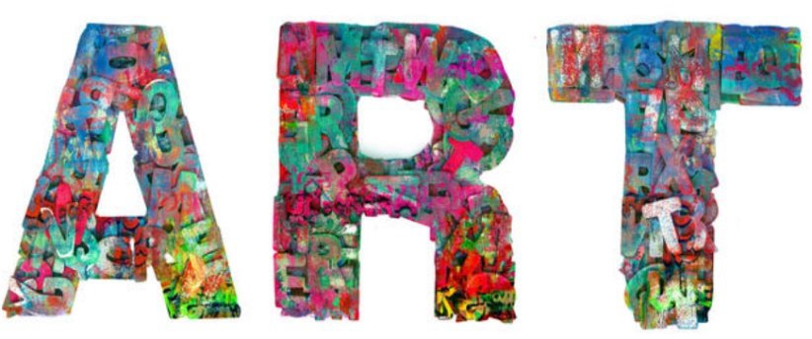

… together!
You are invited to join us online for a 1-hour workshop that will give you and your child an opportunity to create some art together at home.
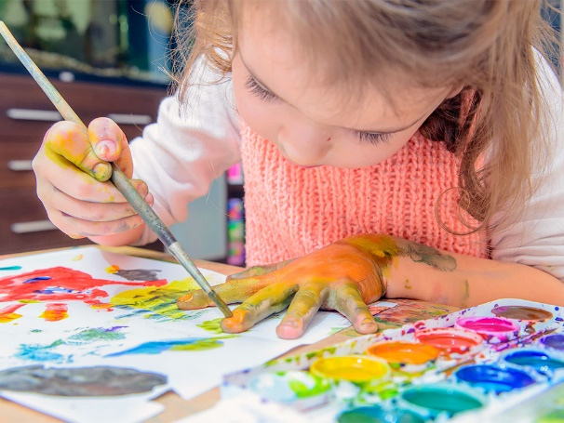

Friday 12th March
1-2pm
OR
Friday 19th March
10am-11am
Interested? Please let your child’s school know by Tuesday 9th Feb giving your name, email address, telephone number and preferred date.
The programme will run on Microsoft Teams and once you have signed up, your Tutor will be in touch to discuss details.

Please note:
So that we can offer this course free of charge, you will be required to complete some paperwork. You will also need to have access to materials from a list that will be emailed to you.
Please ensure that your video camera works on the device that you are going to use.

Future Family Learning programmes April onwards:
Help Your Child with Maths, Family English, Family Health and Wellbeing and many more…

