
Welcome to the Reception dream team! We hope you have had a lovely half-term break and you have recharged ready for an exciting half-term ahead with you. Your teaching team this year consists of Mrs McCarroll and Miss Lofthouse

Uniform: We expect all children to wear school uniform. Please ensure all items of uniform are labelled including coats, shoes and PE Pumps, book bags etc.
PE: - Drawstring pump bag/labelled, pull on/Velcro black pumps, navy or black shorts, white T-shirt.PE will be on Tuesday and Thursday. P.E. kit can be taken home to be washed half termly. Please bring in a water bottle that your child can identify which can be filled with fresh water every day.
Homework will be sent home on Fridays and is due in by Wednesday. There will be a phonics task that is linked to our RWI phonics lessons and a learning log task linked to our focus of that week.
Please read with your child as often as possible, every day if you can. Please write a comment in the yellow diary eg. Did they enjoy it? How well are they blending? Could they retell the story? Could they discuss the character’s behaviour? The more practice your child gets, the quicker your child will become fluent. We will change your child’s reading book once a week and we will read with them at least once a week. Please keep the reading book and yellow reading diary in their book bag and send it in every day.

Late arrivals: Children who arrive after 9:00am are considered late for school. All late arrivals should use the main entrance and will be requested to sign the late book. Parents of children who are frequently late will be requested to meet with the Headteacher to discuss the problem. The number of late arrivals will be monitored and entered on the child’s school report at the end of the academic year.

Absence: Parents are asked to phone the school office if their child is absent and the reason for the absence. If parents do not let the school know the reason for the absence on the first day then the secretary will phone to ensure there are no problems.

Medicines: Requests for medicine to be administered in school must be made to the school office. This relates ONLY to prescribed medicines. They should be handed in to the school office with clear written instructions on their administration to the child. Antibiotics will be stored in the fridge until the end of the day. The fact that the medicine has been administered will be recorded in the medicine log book.
Asthma Inhalers are kept in the classroom where the children can obtain them easily.

.
Starlight

Over this half term we will be looking at the world around us learning about how it changes at different times of the year. We will also look at different celebrations such as Christmas and Diwali.

Term: Autumn 1 Topic: Starlight Year Group: Reception
 | English | Maths | Wider Curriculum
 |  | 1,2,3, it’s me, Light and Dark
Book links | 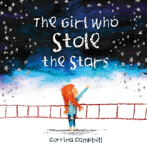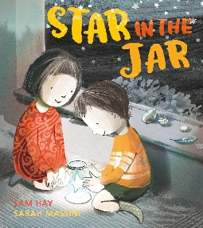 |  | 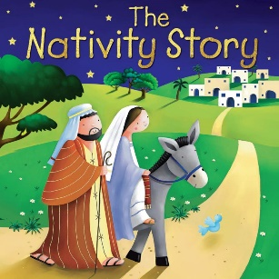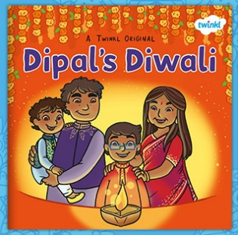
Specific Vocabulary | Author  Illustrator  Setting  Character  Star | More  Fewer  Morning  Afternoon  Evening  Night  Circle  Square | Celebration  Diwali  Festival of light  Nativity  Seasons  Summer  Spring  Autumn | Winter  Freezing  Boiling
sticky Knowledge about… | Set one sounds:  m, a, s, d, t, I, n, p, g, o, c, k, u, b, f, h, l, e, r, j, y, w, z, x, y, qu, ch, sh, th, ng ,nk  Letter have a sound and a name.  Know the first sound of a word.  Know how to us a tripod grip.  I know how to write my own name.  Information can be retrieved from books and computers. | Circles have 1 curved side and that triangles have 3 straight sides.  Squares and rectangles have 4 sides.  Subitise up to 5 items.  1 more and 1 less up to 5.  I know the time of the day | There are four season.  The seasons are called, Spring, Summer Autumn and Winter.  Christens celebrate Christmas.  Christmas is to celebrate the birth of Jesus.  Diwali is a Hindu celebration.  Diwali is the festival of light.

