❓ Big Questions This Half Term
- Why do people celebrate different festivals?
- How are celebrations similar and different?
- How do people celebrate in other countries?
- How does our environment change during the seasons?
- What can we learn from different cultures and communities?

🏡 How You Can Help at Home
📖 Read with your child every day.
🔤 Practise Read Write Inc. sounds regularly.
🎄 Talk about family celebrations and traditions.
📸 Look at family photographs and discuss how things have changed.
🔢 Count objects and spot shapes in the environment.
✏️ Encourage drawing, colouring and name writing using Letter-join formation.
🌍 Talk about different countries, cultures and celebrations around the world.

🤝 Home School Partnership
The children have settled brilliantly into Reception and we are so proud of how much they have achieved already. They are becoming more independent every day, making friendships, learning to take turns, share and work together, and growing in confidence as learners.

As we continue through the year, working together between home and school will help your child get the very best from their learning. Reading is one of the most important skills your child will develop and a little practice every day makes a huge difference. Regular reading, practising sounds and talking about stories helps to build confidence, fluency and a love of books.

If you ever have any questions, worries or need support, please come and speak to us. We value our partnership with families and are always happy to help. Together, we can ensure your child continues to thrive and enjoy their Reception journey. 🌟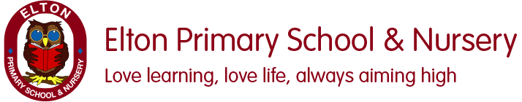.
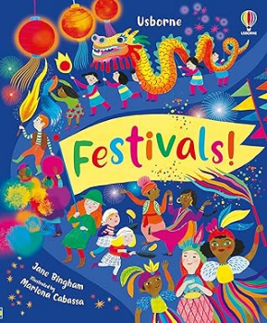

Welcome to a Busy and Exciting Half Term!
This half term our topic is Festivals. Children will learn about a variety of celebrations and traditions, including Bonfire Night, Diwali and Christmas. Through stories, discussions, creative activities and investigations, we will explore similarities and differences between people, families and communities, developing respect and understanding of the world around us

🎨 Expressive Arts and Design
Children will:
Create fireworks artwork by colour mixing.
Experiment with texture and materials.

Music

Children will:
Listen to music from different cultures.
Join in with songs and rhymes.
Explore instruments and sounds.
Use their voices to create and imitate.
Respond to music through movement.

⚽ Physical Development
Children will develop both their gross and fine motor skills through a range of exciting activities.
Gross Motor Skills
Children will develop:
Running, jumping and balancing.
Coordination and control through PE activities.
Building strength, balance and spatial awareness.
✏️ Fine Motor Skills & Handwriting
Using Letter-join, children will continue to develop the skills needed for successful writing through:
Forming letters correctly.
Improving pencil control and letter sizing.
Building hand and finger strength.
Using a range of tools safely and confidently.

💛 Personal, Social and Emotional Development
We will be learning to:
Respect and celebrate differences.
Understand that families, cultures and traditions can be different.
Show empathy and kindness towards others.
Build positive friendships and relationships.
Learn about celebrations that are important to different people.

🔢 Mathematics
Following White Rose Maths, children will learn through practical activities and play.

It's Me 1, 2, 3

Finding and recognising numbers 1, 2 and 3.

Subitising small quantities.

Exploring one more and one less.

Looking at different ways numbers can be made.

Circles and Triangles

Identifying and naming circles and triangles.

Finding shapes in the environment.

Comparing shapes.

Using positional language.

1, 2, 3, 4, 5

Recognising and representing numbers to 5.

Exploring number composition.

Finding one more and one less.

Shapes with 4 Sides

Identifying squares and rectangles.

Exploring shapes in the environment.

Combining shapes to create pictures and patterns.
English
We follow The Literacy Company planning alongside Read Write Inc. Talk Through Stories and Read Write Inc. Phonics.
Texts We Will Explore
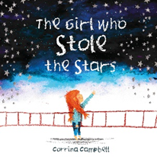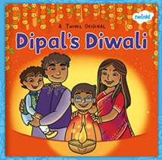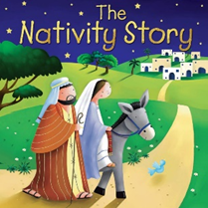
Through these stories, children will:
✅ Develop a love of reading and storytelling.
✅ Learn and use new vocabulary.
✅ Retell familiar stories and discuss characters.
✅ Talk about celebrations, traditions and communities.
✅ Develop confidence when speaking and listening.
✅ Begin to communicate ideas through drawing and early writing.

🔤 Read Write Inc. Phonics
Children will continue learning Set 1 sounds and will practise:
Recognising sounds quickly.
Blending sounds to read words.
Forming letters correctly.
Reading and writing simple words and phrases.
Building confidence as readers and writers.
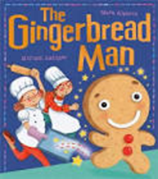

🌍 Understanding the World
History
Children will:
Compare Christmas celebrations past and present.
Talk to family members about their own experiences.
Explore how Christmas has changed over time.
Use photographs to discuss the past
Geography
Children will:
Learn that people live in different countries.
Explore how Christmas is celebrated in Spain.
Compare life in the UK with life in other countries.
Use stories and photographs to learn about different places.
Science
Children will:
Learn about seasonal changes.
Explore signs of autumn and winter.
Talk about weather and how it changes.
Observe changes in the environment over time.
Make links between seasons, weather and celebrations. Develop scientific vocabulary through practical investigations.

