❓ Big Questions This Half Term
- What makes me special?
- Who is in my family?
- How have I changed?
- Where do I live?
- How do I stay healthy?
- How do I feel and why do I feel that way?

🏡 How You Can Help at Home
📖 Read with your child every day.
🔤 Practise Read Write Inc. sounds.
✏️ Encourage mark-making, drawing and name writing using correct Letter-join formation.
😊 Talk about feelings and emotions.
📸 Look at family photographs and discuss memories.
🔢 Count, sort and spot patterns in everyday life.
🍎 Encourage healthy eating and healthy habits.
🧥 Practise putting on coats, fastening zips and looking after belongings independently.

Home School Partnership

Starting school is an exciting milestone and we are here to support both you and your child every step of the way. By working together, we can help your child feel happy, confident and successful in Reception.

If you ever have any questions, worries or concerns, please come and speak to us. We value our partnership with parents and are always happy to help. Together, we can give your child the very best start to their school journey. 🌟

We are looking forward to a wonderful first half term of friendship, learning and discovery! 🌟
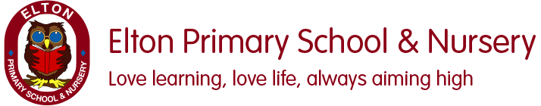.
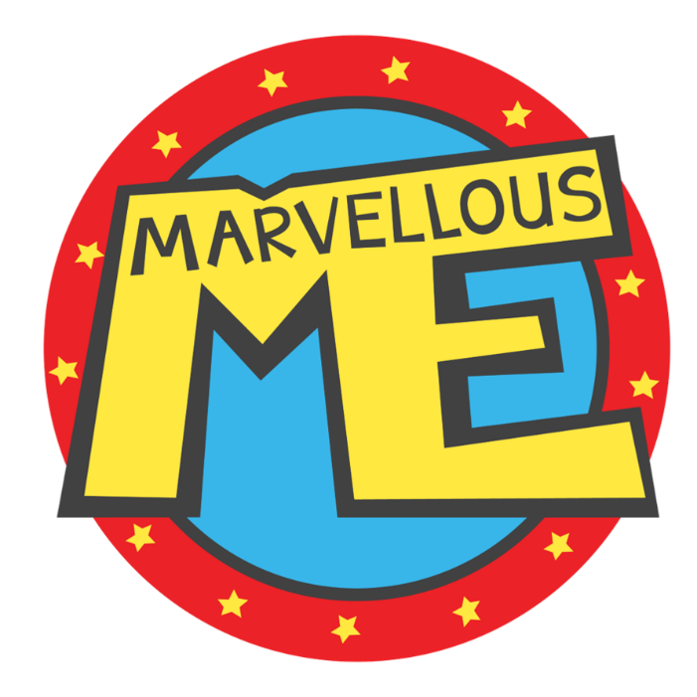
Welcome to our Reception class! This half term our topic is Marvellous Me!
We will be spending time getting to know one another, making new friends and settling into school life. Through exciting stories, investigations and practical activities, children will explore what makes them unique, learn about their families, recognise their feelings and discover the world around them.

⚽ Physical Development
Children will develop both their gross and fine motor skills through a range of exciting activities.

Gross Motor Skills
- Running
- Jumping
- Climbing
- Balancing
- Hopping and skipping
- .
✏️ Fine Motor Skills
Using Letter-join, children will begin to:
- Develop a comfortable pencil grip.
- Practise pre-writing patterns and movements.
- Form letters correctly.
- Develop pencil control and hand strength.
- Cutting and sticking
- Creating self-portraits.
- Using tools safely and effectively.

🎨 Expressive Arts

and Design

Art
Children will:
- Create self-portraits.
- Draw faces and features.
- Explore pattern and texture.
- Develop mark-making skills using a variety of media including crayons, chalks, pencils and felt tips.
Music
Children will:
- Explore musical instruments.
- Use their voices to make different sounds.
- Listen to sounds in the environment.
- Join in with songs and rhymes.
Describe and compare sounds they hear.

💛 Personal, Social and Emotional Development
We will be learning to:
- Recognise and talk about our feelings.
- Understand what makes us unique and special.
- Build positive friendships.
- Learn ways to stay healthy.
- Develop independence and confidence.
- Follow classroom routines and expectations
Key Vocabulary
Unique • Special • Family • Relationships • Past • Present • Exercise • Feelings • Emotions

🔢 Mathematics
Following White Rose Maths, children will learn through practical activities and play.

Match, Sort and Compare
- Matching objects that are the same.
- Sorting objects in different ways.
- Comparing groups of objects.
- Using language such as more, fewer and the same.

Talk About Measure and Pattern
- Comparing size, mass and capacity.
- Describing objects using mathematical language.
- Identifying, continuing and creating repeating patterns.
English
We follow The Literacy Company planning alongside Read Write Inc. Talk Through Stories and Phonics.
Texts We Will Explore:
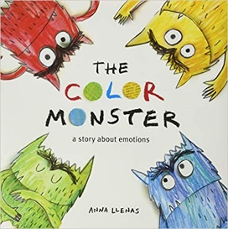
Through these texts, children will:
✅ Develop a love of reading and storytelling.
✅ Learn and use new vocabulary.
✅ Talk about characters, settings and events.
✅ Retell stories through role play and small world play.
✅ Explore feelings, friendships and relationships.
✅ Develop confidence in speaking and listening.
✅ Begin to communicate ideas through drawing and early writing.
In Phonics children will begin learning Set 1 sounds and will practise:
• Recognising letter sounds.
• Correct letter formation.
• Hearing sounds in words.
• Blending sounds to read simple words.
Developing confidence in reading and writing
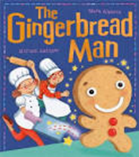

🌍 Understanding the World

History - My Family and Me
Children will:
- Learn about their families.
- Compare family life in the past and present.
- Explore favourite toys from different generations.

Science - The Gingerbread Man
Children will:
- Explore materials using their senses.
- Compare different materials.
- Bake Gingerbread Men.
- Investigate what happens when the Gingerbread Man goes into water.
- Develop scientific vocabulary through practical investigations.

