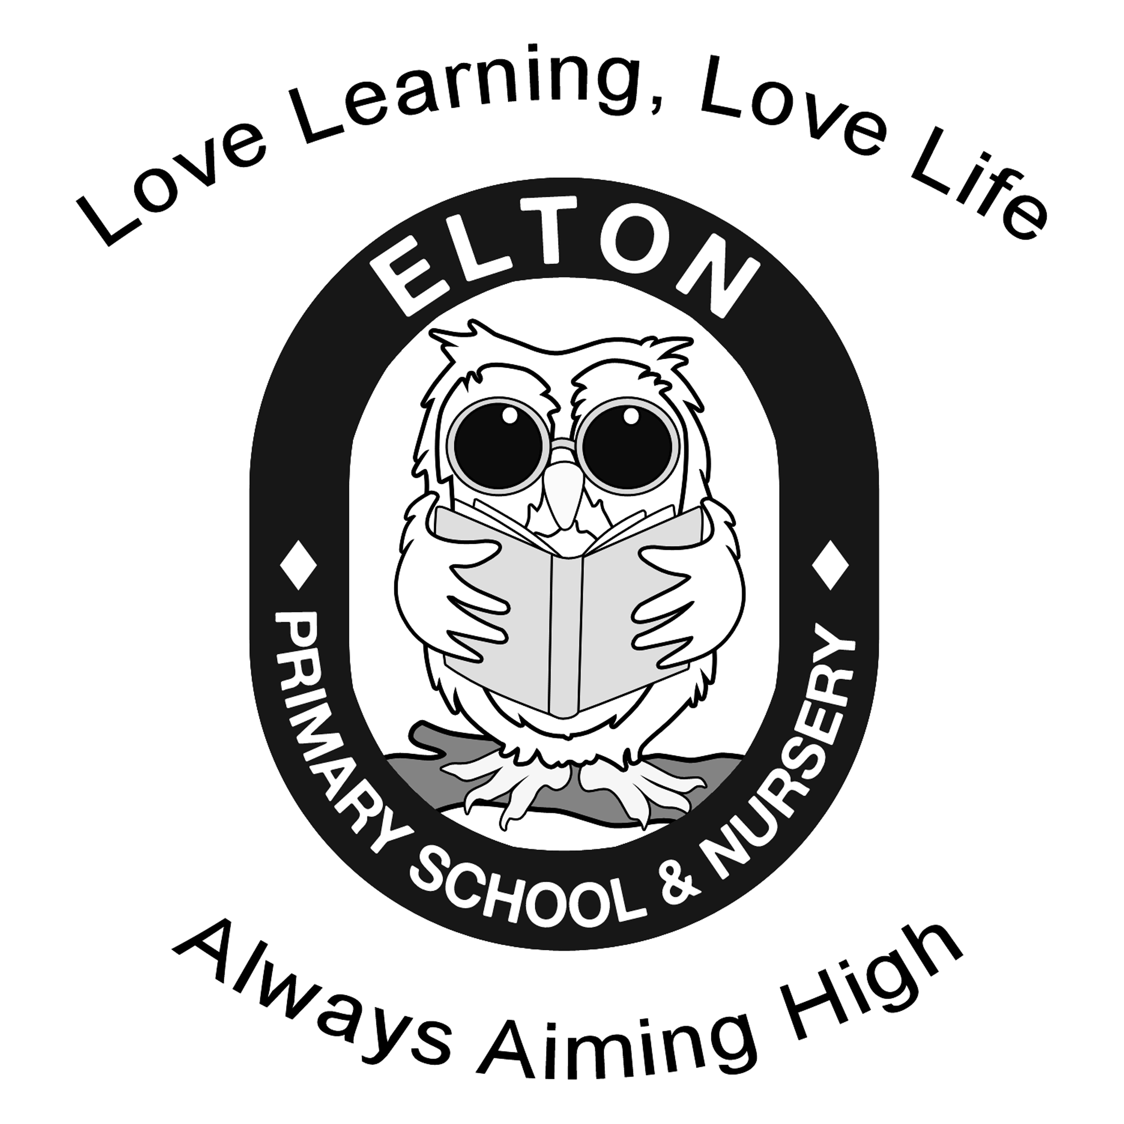 | Elton Primary and Nursery School  Medium Term Overview |  |  | Year Group: 4  Term: Spring 1  Week Beg: Jan 5th 2026 |  |  | Topic Title: Natural disasters
 | Week 1 | Week 2 | Week 3 |  | Week 4 | Week 5 | Week 6
Enrichment
S+L opps | RE: hot seating  Literacy: Hot seating |  | English: Hot seat |  | Conscience Alley |  | English: Sharing the story with peers.
English  Pathways to write | Escape from Pompeii  Range of sentences including of conjunctions.  Setting description from Tranio’s point of view including conjunctions, adverbs and prepositions.  Plan diary entry | Escape from Pompeii  Write diary entry  Speech sandwiches focusing on skills to be included  Write diary entry based on Tranio’s day of the eruption including rhetorical questions. | Escape from Pompeii  Plan and write an explanatory letter- applying present perfect form of the verb.  Punctuated dialogue in writing |  | Escape from Pompeii  Research information based on volcanos  Create letter from Tranio or Livia | Escape from Pompeii  Investigate a model  Plan story from point of view from either Livia or Tranio. | Escape from Pompeii  Write story over few days
Maths  White  Rose Maths | Multiplication and division  -Factor pairs  -multiply by 10, 100  - divide by 10 and 100  - Efficient multiplication  -Written methods | Multiplication and division  - Efficient multiplication  -Written methods  -Multiply 2-digits by 1-digit | Multiplication and division  -Multiply 3-digits by 1-digit  -Divide 2-digits by 1 digit (2 sections) |  | Multiplication and division  -Divide 3 digits by 1 digit  - Correspondence problems | Length and Perimeter  - km and m  - equivalent lengths  - perimeter on a grid  - perimeter on rectilinear shape | Length and Perimeter  - finding missing lengths  - calculate perimeter of rect shapes  - perimeter of regular polygons
Reading  Pathways to read | Session 1  Volcanoes by Maria Gill (index on pages 62-63)  Identify how language, structure and presentation contribute to meaning  Use dictionaries to check the meaning of words that they have read | Session 2  Volcanoes by Maria Gill (pages 4-5) Mastery focus: Structure and Organisation, | Session 3  Text: Volcanoes by Maria Gill (pages 6-9)  Identify how language, structure and presentation contribute to meaning |  | Session 4  Text: Volcanoes by Maria Gill (pages 18-19)  Read and retrieve information from non-fiction books | Session 5  Text: Volcanoes by Maria Gill (pages 32-33, 34-35, 60-61)  Retrieve and record information from non-fiction | Session 6  Volcanoes by Maria Gill (pages 42-43, 44-45)  Retrieve, Structure and Organisation Retrieve and record information from non-fiction Identify how language, structure and presentation contribute to meaning
Spelling  Pathways to spell | Word list – years 3 and 4 | Endings which sound like /ʃən/ spelt -tion, -sion | Endings which sound like /ʃən/ spelt -ssion |  | Endings which sound like /ʃən/ spelt -cian | The suffix -ation | The suffix -ation
Computing  Teach  computing | Programming a screen turtle  Introduction to programming in Logo. | Programming letters  Creating algorithms for their initials | Patterns and repeat  Creating algorithms for their initials |  | Using loops to create shapes  Trace code to predict which shapes will be drawn and will modify existing code. | Breaking things down  Think about how code snippets can be broken down | Creating a program  Apply skills
History/Geography  Chris Trevor Planning | The Roman Empire and the impact on Britain  When did the Romans start to take over?  Explore how the Romans spread their influence over time. | The Roman Empire and the impact on Britain  What was Britain like in 55 B.C and why did the Romans want to invade? | The Roman Empire and the impact on Britain  Why did Julius Caesar fail in the first invasion and why was Claudius successful? |  | The Roman Empire and the impact on Britain  Hadrian’s wall | The Roman Empire and the impact on Britain  What impact did the Romans have on the way people live? | The Roman Empire and the impact on Britain  When did the Romans start to take over?
DT  KAPOW |  |  | Electrical system – electrical poster  Lesson 1  information design  To understand the purpose of information design. |  | Electrical system – electrical poster  Lesson 2 – topic research  To research a set topic to develop a range of initial ideas. | Electrical system – electrical poster  Lesson 3 – design development  To develop an initial idea into a final design. | Electrical system – electrical poster  Lesson – electric poster assembly  To assemble my final product and incorporate a simple circuit.
Art | None this term
Science  States of matter  Rising stars | In a state  Compare and group materials together, according whether they are solids, liquids or gases | Ice hands  Observe that some materials change state when they are heated or cooled and measure the temperature at which this happens. | It’s melting  Set up simple practical enquires – melting chocolate |  | Evaporation  Identify the part played by evaporation and condensation in the water cycle | Water cycle  Explore how evaporation in the water cycle can be speeded up or slowed down e.g. temperature, wind, size of puddle | Assessments
RE  CWAC | What is a worldview? Who influences my worldview? | What is my worldview? What do I believe? | What are my values? How may these be similar or different to others with a religious or non-religious worldview? How can I show empathy? |  | What worldviews do we learn about in RE in our school? | Can holding a particular worldview impact the choices you make about what you eat? | What key vocab do I need to remember to help me to talk about worldviews?
P4C | Young Carers Day – end of January | Why do people choose to live and stay in ‘disaster zones’? | Safer Internet Day – early February |  | World Interfaith Harmony Week – start of February
PE | Netball – complete pe – lesson 1  Gymnastics - complete pe – lesson 1 | Netball – complete pe – lesson 2  Gymnastics - complete pe – lesson 2 | Netball – complete pe – lesson 3  Gymnastics - complete pe – lesson 3 |  | Netball – complete pe – lesson 4  Gymnastics - complete pe – lesson 4 | Netball – complete pe – lesson 5  Gymnastics - complete pe – lesson 5 | Netball – complete pe – lesson 6  Gymnastics - complete pe – lesson 6

