💡 Ways to Help at Home
At home, you can make a big difference to your child’s learning by building simple activities into everyday routines. Reading together as often as possible is one of the most powerful things you can do. This includes storybooks, menus, signs, shopping lists and magazines. Encourage your child to look closely at pictures, talk about what might happen next and spot letters or words they recognise. Asking open questions like “Why do you think that happened?” helps them develop deeper thinking and confidence when sharing ideas.
Talking is another key part of learning. Chatting about what you see on a walk, how the weather feels or what you’re cooking helps build vocabulary and understanding. Give your child time to explain their ideas, even if they’re still working them out. Wondering aloud together encourages curiosity and problem-solving.
Maths can be explored naturally throughout the day. Count steps as you climb the stairs, compare the sizes of fruit or ask your child to help work out how many plates you need for dinner. Sharing toys or snacks introduces early ideas about fairness and equal amounts, helping children build number sense without it feeling like a lesson.
Encouraging independence is also incredibly valuable. Giving your child time to get dressed, put on their shoes, tidy their toys or help with small household jobs builds confidence and resilience. Even if it takes a little longer, these moments help them develop important life skills.
Finally, please remember to send a water bottle each day. Staying hydrated helps children concentrate, feel comfortable and stay ready to learn.

Reception Spring 1 Learning Leaflet
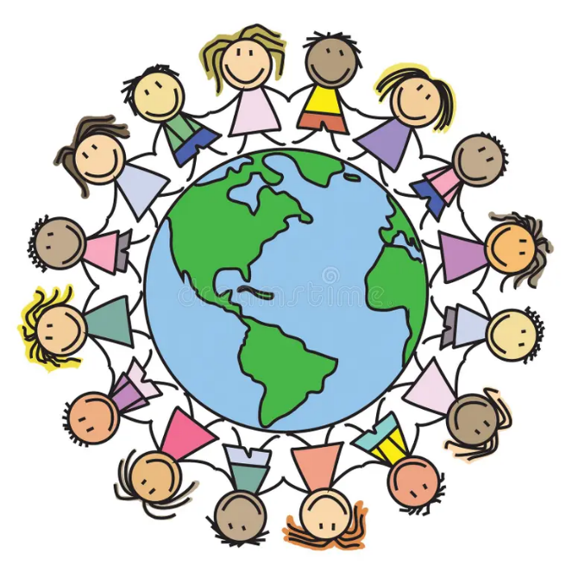
We can’t believe how quickly the first term has gone. The children have already grown in confidence, independence and curiosity, and it has been wonderful to see how excited they are to learn each day.
This term our topic is Exploring our world. We’ll be exploring different countries, cultures, animals and environments through stories, play and hands-on learning

📚 English
We will be sharing stories such as The Magic Paintbrush, Dragon in the City, Bringing the Rain to Kapiti Plain, and, Handa’s Hen. These books will inspire map-making, dragon designs, mask making, role-play and building different types of transport using boxes and loose parts.
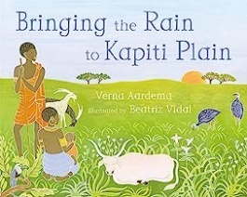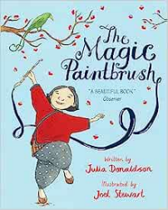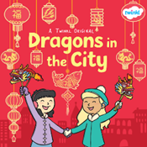

🔢 Maths
In Maths, the children will continue with Alive in 5! before moving on to Growing 6, 7, 8. They will deepen their understanding of numbers through counting, comparing quantities and exploring how numbers are made using practical activities and games.

🗣️ Communication & Language
The children will learn new vocabulary linked to animals, habitats and different countries. They will be encouraged to share ideas, express opinions and explain what they notice during activities such as exploring melting ice, comparing environments and learning about celebrations like Chinese New Year.

💛 Personal, Social & Emotional Development
This term, the children will continue building independence by choosing resources, developing their own ideas and solving problems during play. They will work together during creative and scientific activities and will be supported to express their thoughts and feelings with growing confidence.

🔬 Understanding the World – Science
In Science, the children will learn to name and describe a variety of animals, including those from Africa and the polar regions. They will begin using vocabulary such as habitat, camouflage, carnivore, herbivore and omnivore as they explore how animals are suited to their environments.

🌍 Understanding the World – Geography
The children will learn that there are many different countries in the world and that people live in a range of environments. They will compare the UK with places such as Kenya and Antarctica, noticing similarities and differences in landscapes, weather, animals and ways of life.

🎨 Expressive Arts & Design – Art
In Art, the children will explore finger painting, outdoor painting and painting to music. They will learn about abstract and figurative art and create their own transient art using loose parts, while practising safe and accurate use of scissors and tools.

🎵 Expressive Arts & Design – Music
In Music, the children will explore the sounds of different instruments and listen to music from around the world, including African music. They will experiment with creating and copying sounds linked to transport and begin to understand rhythm and tempo.

✂️ Physical Development

The children will use small tools such as scissors, pipettes and spoons safely and with increasing control. They will explore freezing and melting through practical activities, helping to strengthen their fine motor skills while encouraging curiosity and careful observation.

