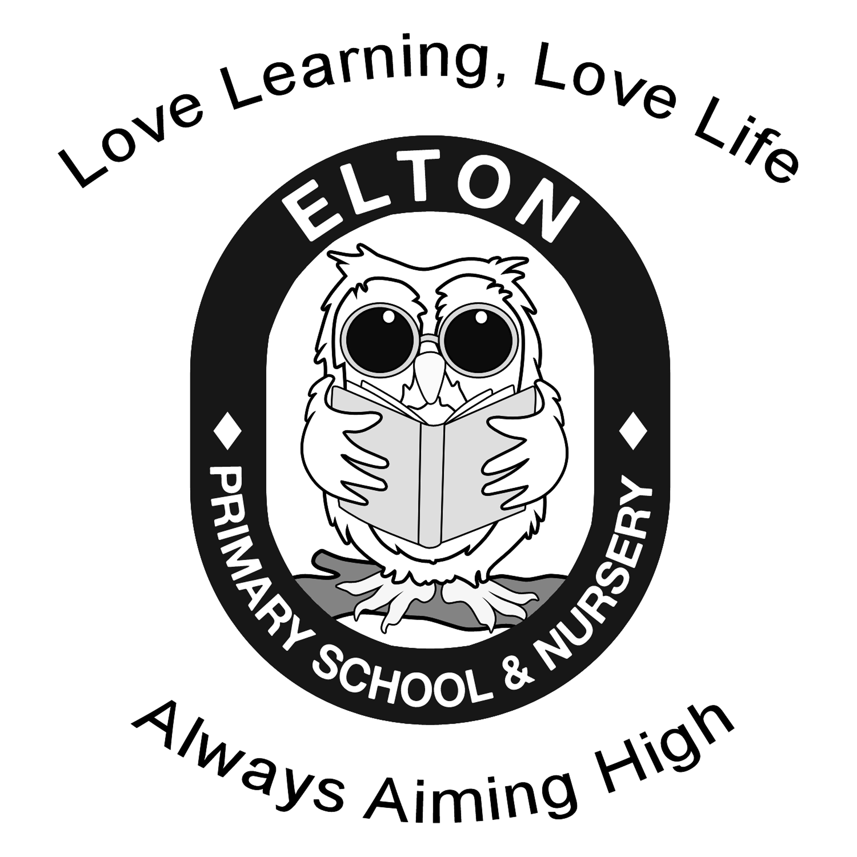 | Year 4 Long Term Plan 2025-2026
 | Autumn A (8) | Autumn B (8) | Spring A (6) |  | Spring B (6) | Summer A (5) | Summer B (7)
Topic Title | Europe |  | Natural disasters |  |  | Planet Earth
Enrichment
S+L opps | Well-structured descriptions.  P4C | Use relevant strategies to build vocabulary. | Participate in debates.  Articulate and justify answers, arguments and opinions. |  | Participate in performances. | Develop understanding through speculating, hypothesising, imagining and exploring ideas. | Participate in discussions  , performances and role play.
Literacy  Pathways to write | Pathways to write  Gorilla by Anthony Browne  Outcome - Fiction: fantasy story | Pathways to write  Leon and the place between by Graham Baker-Smith  Outcome - Recount: diary | Pathways to write  Escape from Pompeii  by Dianne Hofmeyr  Outcome - Persuasion: leaflet |  | Pathways to write  When the Giant stirred by Celia Godkin  Outcome - Fiction: adventure story from POV of the boy | Pathways to write  Where the Forest Meets the Sea by Jeannie Baker / Rainforests in 30 seconds by Jen Green  Outcome - Non-chronological report | Pathways to write  Blue John by Berlie Doherty  Outcome - Letters & Explanation
Reading  Pathways to Read | Pathways to Read  A world full of animal stories – 50 folktales and legends by Angela McAllister | Pathways to Read  The Train to Impossible Places by PG Bell | Pathways to Read  Volcanoes by Maria Gill |  | Pathways to Read  Ariki the island of wonders by Nicola Davies | Pathways to Read  Fantastically Great Women who saved the planet by Kate Pankhurst | Pathways to Read  A myth hunter’s travel guide by Literacy Company
Numeracy  White Rose SOL | White Rose SOL  - Number - Place value (4 weeks)  - Addition and subtraction (3 weeks) | White Rose SOL  -Measure (2 weeks)  - Multiplication and division (5 weeks) | White Rose SOL  Multiplication and division (3 weeks)  Measurement – Area (1 week)  Fractions (2 weeks) |  | White Rose SOL  Fractions (2 weeks)  Decimals ( 3 weeks) | White Rose SOL  Decimals (2 weeks)  Money (2 weeks)  Time (1 week) | White Rose SOL  Statistics (2 weeks)  Shape (3 weeks)  Position and direction (2 weeks)
Science  My Rising Stars | My Rising Stars  Animals including Humans | My Rising Stars  Sound | My Rising Stars  States of matter – link with volcano |  | My Rising Stars  Living things and their habitats | My Rising Stars  Living things and their habitats | My Rising Stars  Electricity
ICT  Teach computing | Teach computing  Computing systems and networks – the internet | Teach computing  Creating media – audio production | Teach computing  Programming A – Repetition in shapes | Teach computing  Data and information – Data logging |  | Teach computing  Creating media – photo editing | Teach computing  Programming B – Repetition in games

History  Chris Trevor Planning |  |  | Chris Trevor Planning  Ancient Greece | Chris Trevor Planning  The Roman empire and the impact on Britain |  |  | Chris Trevor Planning  Iron age hill forts
Geography  Chris Trevor Planning | Chris Trevor Planning  In depth study of Europe.  Southern and Eastern Europe |  | History term with 1 or two lessons on spread of Greece Empire over Mediterranean Europe. | Chris Trevor Planning  Just one or two lessons on Northern Europe | Chris Trevor Planning  In depth study of Europe  Volcanoes and earthquakes | Chris Trevor Planning  In depth study of Europe  Comparing the bay of naples with UK region | Chris Trevor Planning  In depth study of Europe  Central Europe
Art  KAPOW | KAPOW  Painting and mixed media: light and dark |  |  |  | KAPOW  Drawing: power prints | KAPOW  Craft and design: fabric of nature  (rainforests)
DT  KAPOW |  |  | KAPOW  Mechanical systems: making a slingshot car | KAPOW  Electrical systems: electric Roman poster |  |  | KAPOW  Cooking and nutrition:  adapting a recipe. Bake biscuits
RE  CWAC | CWAC  How do Jews demonstrate their faith through their communities? | CWAC  Why do Christians think about Incarnation at Christmas? What is trinity? |  | CWAC  Free choice  What is a worldview?  “We have far more in common than that which divides us.” | CWAC  What can I learn from Christian art about Christian beliefs about Easter, Salvation and the Trinity? | CWAC  How do Humanists arrive at their views about the world? | CWAC  How do Hindus worship in their daily lives?
PE  Complete PE | Complete PE  Games  Invasion games –  Tag rugby  Games  Invasion games –  Football | Complete PE  Games  Dodgeball  Dance – cats |  | Complete PE  Games  Invasion games - Netball  Gymnastics  Developing actions, skills and movements and sequences. | Complete PE  Games  Racket games to include skill development through adapted version of tennis.  Games  Team striking and fielding games to include adapted version of cricket. ** | Complete PE  Games  Team striking and fielding games to include adapted version of rounders.  OAA  Individual and team activities focusing on problem solving and team work. | Complete PE  Athletic activities  Developing running, jumping and throwing skills with improvements in flexibility, strength, technique, control and balance.
Music  KAPOW | KAPOW  Rock and Roll | KAPOW  Changes in pitch: tempo and dynamics |  | KAPOW  Samba and carnival sounds and instruments (South America) | KAPOW  Haiku, music and performance (Theme: Hanami festival) | KAPOW  Body and tuned percussion  (rainforests) | KAPOW  Adapting and transposing motifs
French  Primary language network | Primary language network  Welcome to school  recap core language, rooms in a school, classroom object | Primary language network  My town, your town  commands, shops, asking and giving directions |  | Primary language network  Alien family  Family member, personal info, face parts and numbers | Primary language network  Moving our bodies  face and body parts, nouns and commands | Primary language network  At the doctors and jungle animals  aches and pains, doctor role play, animal nouns, adjectives, simple sentences | Primary language network  Ice creams  Language Puzzle  summertime weather  seasons and ice creams
P4C | DREAM TEAM  global dimensions  right/wrong  leisure  rule of law |  |  | Disaster  standard of living  work  education |  | friendships  mental health  safety  discrimination

