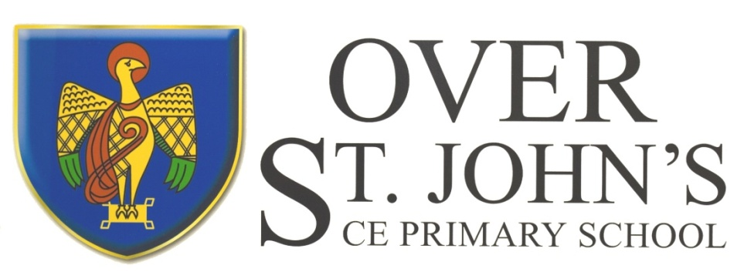

**Over St. John’s CE Primary School**

‘Let your light shine before others.’ Matthew 5:16

**Art Policy**

Throughout this document, art should be interpreted as Art, Craft and Design.

# **Introduction**

Art stimulates creativity and imagination. It provides visual, tactile and sensory experiences and a special way of understanding and responding to the world. It enables children to communicate what they see, feel and think, through the use of colour, texture, form, pattern and different materials and processes. Children become involved in shaping their environments through art and design activities. They learn to make informed judgements and aesthetic and practical decisions. They explore ideas and meanings through the work of artists and designers. Through learning about the roles and functions of art, they can explore the impact it has had on contemporary life and on different periods and cultures. The appreciation and enjoyment of the visual arts enrich all our lives. In addition to developing a wide range of practical skills, art also provides opportunity for children to develop a range of desirable personal qualities, such as communication, sharing, sensitivity and co-operation.

# **Philosophy**

At Over St John CE Primary School, through the teaching of art we believe:

* art, craft and design contributes to all areas of the curriculum;
* that a child’s talents, confidence and enthusiasm should be developed and encouraged;
* that learning and levels of expectation are reflected in the aesthetic provision of the classroom environment, facilitating exploration and investigation for the child;
* that through art, children will develop self-awareness, confidence and a belief in their own sense of worth;
* that the child should encounter a wide range of experiences and materials;
* that the open ended nature of art should lead to further and wider development and experiences as the child matures;
* that positive links across key stages should be encouraged ensuring continuity, progression and good practice.

# **Aims**

* To equip children with the knowledge and skills to experiment, invent and create their own works of art.
* To engage, inspire and challenge all children.
* To provide all children with a balanced programme of opportunities
* To develop the cross curricula use of art and design in support of a ‘creative curriculum’.
* To encourage a child’s natural curiosity and wonder of their world.
* To observe, evaluate and analyse artist’s work using the language of art.
* To improve children’s ability to control materials, tools and techniques.
* To explore, develop and record their own creative ideas.
* To provide opportunities for personal discovery and imaginative enquiry, through inventive use of materials and techniques.
* To build upon a child’s confidence, self-esteem and decision making.
* To promote a sense of pride, enjoyment and achievement in art.
* To develop a knowledge and understanding of the multi-cultural, historical and contemporary work of artists, craft makers and designers and how this contributes to our culture and wealth as a nation.
* To provide opportunities to work independently and in groups.
* To provide a safe working environment for all activities.
* To provide continuity and progression both individually and across key stages.

## Implementation and Planning

All children will be given the opportunity to develop their **knowledge, skills & understanding of art** through:

* exploring, developing and evaluating ideas and techniques;
* investigating, designing, recording and making as outlined in the Programmes of Study of the National Curriculum.

The general requirements for the Programmes of Study are for a balanced programme of art activities and skills which build upon previous work and achievements.

The following areas outline the basis for a balanced programme of art activities across the key stages:

* drawing;
* sketchbooks;
* printmaking;
* painting;
* collage;
* making;
* Visual Literacy/articulation

Throughout their work, children will also be introduced to the visual and tactile elements and how these can be organised and combined to produce different effects for different purposes. These elements include:

* pattern;
* texture;
* colour;
* line;
* tone;
* shape and form;
* space.

Within each area or focus, there should be opportunities to develop and extend children’s knowledge about the roles and purposes of artists through time and from different cultures and teach specific skills.

We encourage creative work in the reception class, as this is part of the Early Years Foundation Stage of the Curriculum. We relate the children’s creative development to the objectives set out in Development Matters, which underpin the curriculum planning for children aged three to five. The children’s learning includes art, music, dance, role-play and imaginative play. The range of experiences provided encourages children to make connections between one area of learning and another, and so extends their understanding. We provide a rich environment in which we encourage and value creativity.

At KS1 and KS2, time is allocated alternative half terms with DT. The children will then have opportunities to develop taught skills and practice application through the use of sketchbooks and in other subjects as appropriate.

All children are given the opportunity to experience different approaches to art, involving working independently, in collaboration with others, on projects, in 2/3 dimensions and at different scales.

Teachers encourage children to evaluate their own ideas and the work of others.

As we endeavour to provide a creative curriculum, art contributes to all areas, for example in English, speaking and listening skills are developed where children are encouraged to discuss and offer opinion about their own and others work. In Mathematics, children develop their understanding of pattern, shape and space through work in 2/3D. Art is widely used to illustrate History and Geography topics as well as making a valuable contribution to our children’s spiritual, moral, social and cultural development. Art and Design is linked to all areas of the curriculum.

All staff are responsible for the planning, organisation and teaching of art with specific skills being taught relating to a topic where possible.

## Differentiation

We recognise the fact that we have children of differing ability in all our classes and we provide suitable learning opportunities for all children by matching the challenge of the task to the ability of the child. We achieve this through a range of strategies:

* setting tasks that are open-ended and can have a variety of responses;
* setting tasks of increasing difficulty, where not all children complete all tasks;
* sometimes grouping children by ability, and setting different tasks for each group;
* providing a range of challenges with different resources;
* having more adults support the work of individual children or small groups;
* providing specialist support where individual children have particular gifts or talents.

## Progress and Continuity

As children progress across the key stages, they will be increasingly involved in a range of tasks which extend their knowledge, skills and understanding of Art, to increase their practical ability.

These tasks should build upon skills acquired at KS1 and the children themselves should aim to produce increasingly refined end products. For some children however, reinforcement and support will be needed.

## Assessment and Recording

Assessment is continual and is made by the teacher observing children working during lessons as an on-going process to inform future planning. The teachers will use this ongoing teacher assessment to track the children’s attainment and progress and this information will be put on the schools tracking system at the end of each term.

It is impossible to keep every piece of art work from children, especially in the Early Years and after being on display the children want ownership of their work to share with their parents.

From reception upwards, children should keep a sketchbook to collect visual evidence and information. At the beginning of each pathway, a knowledge organiser will be placed in the sketchbooks. At the end of each half term/topic, children may wish to make a self-assessment, in order to help them appreciate how they can improve their performance. The teacher also makes a comment as to the child’s attainment at the end of the year. Sketchbooks are passed to the next class teacher. Visual evidence in the form of photographs may also be used as a means of recording what children can do and have achieved.

## Health and Safety

We bear a responsibility for the children in our care and it is necessary to be safety conscious. The use of tools, equipment and materials used in art should be properly explained, monitored and when necessary, supervised.

## Inclusion

All children are given access to all art activities, whatever their ability or individual needs.

Foundation Stage children have the same access to the art curriculum as KS1 children with an emphasis on the practical use and exploration of materials. Provision is made for all pupils to express themselves through drawing, printmaking, painting, collage, making and visual articulation, where the consolidation of their learning is through practice, talk and reflection. We strive to meet the needs of all children with special educational needs, disabilities, special gifts and talents and those learning English as an additional language.

**Equality and Diversity**

At Over St John’s, we ensure that Art supports Equality and Diversity through our teaching. Our chosen planning format covers a variety of artists and crafts people from around the world and throughout history. This incorporates looking at and being inspired by various artists and being encouraged to explore a variety of techniques, styles and materials. The children will also look at a range of artists who explore drawing, printmaking, painting, collage and making. The children will explore how art was depicted through different cultures and historical periods.

**Display**

At Over St John’s CE Primary School, we value and promote the appreciation of a child’s own perceptions and expressions through their art work, therefore a selection of work from all ability levels is often displayed in an attractive and stimulating way.

## Resources

Materials, tools and equipment are accessible to all children. A range of resources are kept centrally and in individual classrooms. Resources for art are the responsibility of the Art Leader and any requests for consumables will be ordered, budget permitting. We have recently subscribed to an online art media bank which can be accessed by all the staff.

There are no major art galleries locally and although the school regard this as a valuable resource for our children, any visits will have to take into account travelling time and costs. However, use could be made of local secondary schools if appropriate. Occasionally, artists are invited into school but this depends upon available funds.

The school values the skills and expertise helpers and parents can bring into the classroom and make use of these where possible. In such cases, parents/helpers should be given sufficient direction to ensure their effectiveness.

## Policy Review

This policy document was written by the Art Subject Leader and will be reviewed every two years.

**Signed:** *KKelly* **Art Leader**

Signed: Head Teacher

Date: September 2025

Review Date: September 2027