

Over St. John’s C.E. Primary School
Progression through Calculations for Division

Deriving and recalling division facts

Tables should be taught every day from Y2 onward.

Year 2 2 times table
5 times table
10 times table

Year 3 2 times table
3 times table
4 times table
5 times table
8 times table
10 times table

Year 4 Recall division facts for multiplication tables up to 12 x 12

Year 5 & 6 Recall quickly division facts for all tables up to 12 x 12

Using and applying division facts
Children should be able to utilise their tables knowledge to derive other facts.
e.g. If I know 3 x 7 = 21, what else do I know?
30 x 7 = 210, 300 x 7 = 2100, 3000 x 7 = 21 000, 0.3 x 7 = 2.1 etc

Dividing by 10, 100 or 1000
Knowing that the effect of dividing by 10 is a shift in the digits one place to the right.
Knowing that the effect of dividing by 100 is a shift in the digits two places to the right.
Knowing that the effect of dividing by 1000 is a shift in the digits three places to the right etc

Use related facts
Given that 1.4 x 1.1 = 1.54
What is 1.54 ÷ 1.4, or 1.54 ÷ 1.1?

MANY MENTAL CALCULATION STRATEGIES WILL CONTINUE TO BE USED. THEY ARE NOT REPLACED BY WRITTEN METHODS.

The following are standards that we expect the majority of children to achieve.

Reception
Children solve problems, including doubling, halving and sharing.

Children to use a variety of models and images as well as physical objects, such as cakes or fruit, moving into numbers, to support their understanding. Lots of rich word problems will be used to support the children’s learning in context.
Children will use sharing circles to help support their understanding.

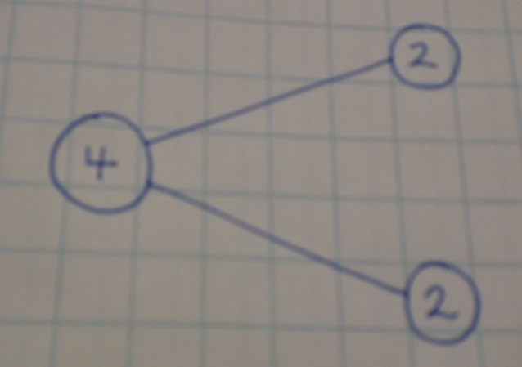

Year 1

Solve one step problems involving division by calculating using concrete objects, pictorial representations and arrays with the support of the teacher.

Children will understand equal groups and share items out in play and problem solving. They will count in 2s, 5s and 10s.

Year 2
Recall division facts for the 2, 5, and 10 multiplication tables, including recognising odd and even numbers.
Calculate mathematical statements for division within the multiplication tables and write them using the division (÷) and equals (=) sign.
Solve problems involving division using materials, arrays, repeated addition, mental methods, multiplication and division facts, including problems in context.

Children will develop their understanding of division and use jottings to support calculation

Sharing equally

6 sweets shared between 2 people, how many do they each get?


Grouping or repeated addition

There are 6 sweets, how many people can have 2 sweets each?

Repeated addition using a number line or bead bar

12 ÷ 3 = 4

0 1 2 3 4 5 6 7 8 9 10 11 12

3 3 3 3

The bead bar will help children with interpreting division calculations such as 10 ÷ 5 as ‘how many 5s make 10?’

Using symbols to stand for unknown numbers to complete equations using inverse operations

÷ 2 = 4 20 ÷ = 4 ÷ = 4

As children become more familiar with the method, ensure that the emphasis is on grouping rather than sharing.

Children will then use an empty number line to support their calculation.

24 ÷ 4 = 6

0 4 8 12 16 20 24

Children should also move onto calculations involving remainders.

13 ÷ 4 = 3 r 1

4 4 4

0 4 8 12 13

Using symbols to stand for unknown numbers to complete equations using inverse operations

26 ÷ 2 = 24 ÷ = 12 ÷ 10 = 8

Year 3
Recall division facts for the 2, 3, 4 5, 8, and 10 multiplication tables.
Write and calculate mathematical statements for division using the multiplication tables that they know, including TO ÷ O, using mental and progressing to formal written methods.
Solve problems, including missing number problems involving division, including positive integer scaling problems and correspondence problems in which n objects are connected to m objects.

Children will develop their use of repeated addition to be able to add on multiples of the divisor. Initially, these should be multiples of 10, 5, 2 and 1: numbers with which the children are more familiar, but the children should progress to using the 2, 3, 4, 5 and 8 times tables in line with the expectation for their year group.

72 ÷ 5

+5 +5 +5 +5 +5 +5 +5 +5 +5 +5 +5 +5 +5 +5 +2

0 5 10 15 20 25 30 35 40 45 50 55 60 65 70 72

Moving onto:
r2
+5
+5
+50
+5
+5

1
1
1
1
10

0 50 55 60 65 70 72

Any remainders should be shown as integers only at this stage, i.e. 14 remainder 2 or 14 r 2.

Year 4
Recall division facts for multiplication tables up to 12 x 12.
Use place value, known and derived facts to divide mentally, including: dividing by 1.

Short method of division for TO ÷ O

Children will continue to use written methods to solve division TO ÷ O but will progress to the formal short method of division and for all multiplication tables.

The short method of division is generally used when the divisor is less than ten.

96 ÷ 4
 | 2 | 4
4 | 9 | 16

Short method of division for HTO ÷ O

Children will then progress to the formal short division method for HTU ÷ U

196 ÷ 6 =

 |  | 3 | 2 | r4
6 | 1 | 9 | 16

Any remainders should continue to be shown as integers, i.e. 14 remainder 2 or 14 r 2.

Year 5
Recall division facts for multiplication tables up to 12 x 12.
Divide numbers mentally drawing on known facts.
Divide numbers up to 4 digits by a one digit number using the formal written method of short division and interpret remainders appropriately for the context.
Divide whole numbers and those involving decimals by 10, 100 and 1000.

Short method of division for HTO ÷ O

Children will continue with the formal short division method for HTO ÷ O

196 ÷ 6 =

 |  | 3 | 2 | r4
6 | 1 | 9 | 16

However, children need to be able to decide what to do with the remainder after division and round up or down accordingly. They should make sensible decisions about rounding up or down after division. For example 62 ÷ 8 is 7 remainder 6, but whether the answer should be rounded up to 8 or rounded down to 7 depends on the context.

e.g. I have 62p. Sweets are 8p each. How many can I buy?
Answer: 7 (the remaining 6p is not enough to buy another sweet)

Apples are packed into boxes of 8. There are 62 apples. How many boxes are needed?
Answer: 8 (the remaining 6 apples still need to be placed into a box)

Children also need to be taught to interpret the remainder as a fraction and/ or a decimal also.
e.g. 196 ÷ 6 = 32 r4, which is 32 4/6 or 32.66

Long method of division for TO ÷ O

Children will then be introduced to the formal written method of long division.
98 ÷ 7

 | 1 | 4
7 | 9 | 8
- | 7 | 0 | 7x10
 | 2 | 8
- | 2 | 8 | 7x4
 |  | 0
Year 6
Recall division facts for multiplication tables up to 12 x 12.
Divide numbers up to 4 digits by a 2-digit whole number using the formal written method of long division, and interpret remainders as whole number remainders, fractions, or by rounding, as appropriate for the context.
Divide numbers up to 4 digits by a two digit number using the formal written method of short division where appropriate, interpreting remainders according to context.
Solve problems involving division.

Children will continue to use written methods to solve short division TO ÷ O, HTO ÷ O and THTO ÷ O as in Year 5.

However, children will now develop their use of the formal written method for long division.

Long division HTO ÷ TO moving to THTO ÷ TO

The long method of written division is usually used when the divisor is greater than 10.

432 ÷ 15

 |  |  | 2 | 8
1 | 5 | 4 | 3 | 2
 | - | 3 | 0 | 0 | 15x20
 |  | 1 | 3 | 2
 | - | 1 | 2 | 0 | 15x8
 |  |  | 1 | 2
12 = 4
15 5

4
5
Answer = 28

3247 ÷ 25

 |  |  | 1 | 2 | 9
2 | 5 | 3 | 2 | 4 | 7
 | - | 2 | 5 | 0 | 0 | 25x100
 |  |  | 7 | 4 | 7
 | - |  | 5 | 0 | 0 | 25x20
 |  |  | 2 | 4 | 7
 | - |  | 2 | 2 | 5 | 25x9
 |  |  |  | 2 | 2

Answer = 129 r22 or 129 22/25 or 129.88

As at Year 5, any remainders should be shown as fractions or decimals, i.e. if the children were dividing 32 by 10, the answer should be shown as 3 ²/₁₀ which could then be written as 3 ¹/₅ in it’s lowest terms or 3.2

Extend to decimals with up to two decimal places divided by a single digit e.g. in the context of money and measures. Children should know that decimal points line up under each other.

By the end of Year 6, children will have a range of calculation methods, mental and written. Selection will depend upon the numbers involved.

Children should not be made to go onto the next stage if:

- they are not ready.
- they are not confident.

Children should be encouraged to approximate their answers before calculating.
Children should be encouraged to check their answers after calculation using an appropriate strategy.
Children should be encouraged to consider if a mental calculation would be appropriate before using written methods.

Signed: S McClellan Chair of Governors

E Snowdon Head Teacher

Date: January 2018
Review Date: January 2020

