

Over St. John’s C.E. Primary School
Progression through Calculations for Addition

MENTAL CALCULATIONS
Mental calculations are ongoing throughout primary years and below is a list (not exhaustive) of strategies that may be used.

Mental recall of number bonds
6 + 4 = 10 + 3 = 10
25 + 75 = 100 19 + = 20

Use near doubles
6 + 7 = double 6 + 1 = 13

Addition using partitioning and recombining
34 + 45 = (30 + 40) + (4 + 5) = 79

Counting on or back in repeated steps of 1, 10, 100, 1000
86 + 57 = 143 (by counting on in ones and then in tens)
460 - 300 = 160 (by counting back in hundreds)

Add the nearest multiple of 10, 100 and 1000 and adjust
24 + 19 = 24 + 20 – 1 = 43
458 + 71 = 458 + 70 + 1 = 529

Use the relationship between addition and subtraction
36 + 19 = 55 19 + 36 = 55
55 – 19 = 36 55 – 36 = 19

MANY MENTAL CALCULATION STRATEGIES WILL CONTINUE TO BE USED. THEY ARE NOT REPLACED BY WRITTEN METHODS.

The following are standards that we expect the majority of children to achieve.

Reception
Using quantities and objects, children add two single digit numbers and count on to find the answer.

Children are encouraged to develop a mental picture of the number system in their heads to use for calculation. They develop ways of recording calculations using pictures, etc.
Number lines are used for the children and objects to jump along.

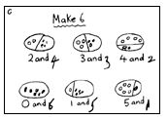
They use number lines and practical resources to support calculation and teachers demonstrate the use of the number line.

3 + 2 = 5
+1
+1

___________________________________________
0 1 2 3 4 5 6 7 8 9

Use of ‘addition machines’ such as:
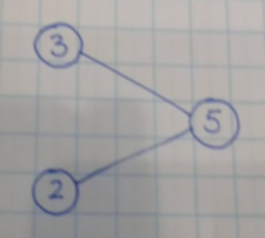

Year 1
Read, write and interpret mathematical statements involving addition (+) and equals (=) signs.
Represent and use number bonds within 20.
Add one digit and two digit numbers to 20, including zero.
Solve one step problems that involve addition using concrete objects and pictorial representations and missing number problems such as + 6 = 9.

Children will continue to use number lines and practical resources to support calculation.

Children then begin to use numbered lines to support their own calculations using a numbered line to count on in ones.

8 + 5 = 13
+1
+1
+1
+1
+1
0 1 2 3 4 5 6 7 8 9 10 11 12 13 14 15

Use of ‘Part, Part, Whole’ model:
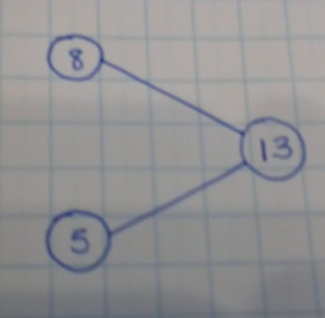

Bead strings or bead bars can be used to illustrate addition including bridging through ten by counting on 2 then counting on 3.

Children will then begin to use number lines starting with the larger number and counting on.

- First counting on in tens on a marked number line.

34 + 20 = 54

34 35 36 37 38 39 40 41 42 43 44 45 46 47 48 49 50 51 52 53 54

- Then counting on in ones and tens on an unmarked number line, starting with the ones, in preparation for adding the least significant digit first with more compact, formal methods.

34 + 23 = 57
+10
+10

+1
+1
+1

34 35 36 37 47 57
Year 2
Recognise the place value of each digit in a two digit number (tens, ones).
Solve problems with addition using concrete objects and pictorial representations, including those involving numbers, quantities and measures.
Solve problems with addition applying their increasing knowledge of mental and written methods.
Recall and use addition facts to 20 fluently and derive and use related facts up to 100.
Add numbers using concrete objects, pictorial representations, and mentally, including:
- a two-digit number and ones
- a two-digit number and tens
- two two-digit numbers
- adding three one-digit numbers.
Show that addition of two numbers can be done in any order (commutative).
Recognise and use the inverse relationship between addition and subtraction and use this to check calculations and solve missing number problems.

Children will continue to use number lines and practical resources to support calculation.

Following on from the end of Year 1, children will then move on to becoming more efficient by adding the ones in one jump (e.g. by using the known number fact 4 + 3 = 7).

TO + O
34 + 9 = 43
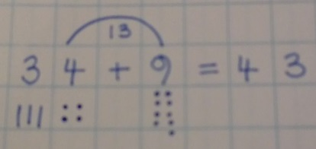

TO + T
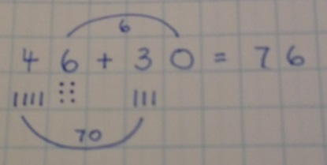

TO + TO
34 + 23 = 57
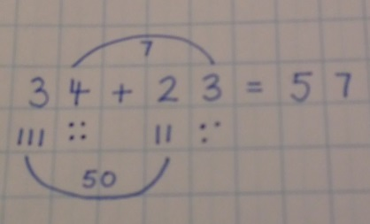
+20

+3

34 37 57
Children will begin to record addition in columns to support place value and prepare for formal written methods with larger numbers, adding the least significant digits first in preparation for ‘carrying’, but without crossing the tens boundary.

TO + TO

6 | 6
2 | 3 | + |  |  | This will be teacher modelled but not necessarily written by the children.
 | 9 |  | (6 | + | 3)
8 | 0 |  | (60 | + | 20)
8 | 9

Year 3
Recognise the place value of each digit in a three-digit number (hundreds, tens and ones)
Pupils should be taught to add numbers mentally, including:
- a three digit number and ones
- a three-digit number and tens
- a three-digit number and hundreds.
Add numbers with up to three digits, using formal written methods of columnar addition where appropriate.
Solve problems, including missing number problems, using number facts, place value and more complex addition.

Children will continue to use empty number lines for calculations such as HTO + O, as well as the method below, but not necessarily the number line for HTO + T.

138 + 9 = 147
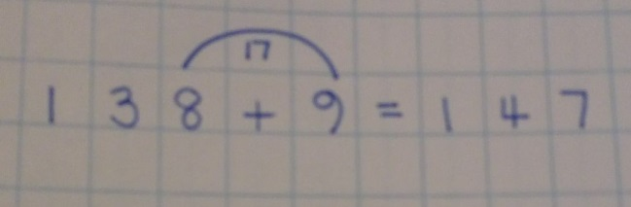
+7

+2

138 140 147

138 + 40 = 178
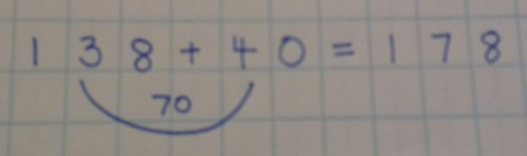

Children will develop their use of formal pencil and paper methods for addition by continuing to add the least significant digits first, but now crossing the tens boundary for TO + TO. When recombining, the children should once again start with the least significant digit.

6 | 7
  6 | 7
  2 | 4 | +
  9 | 1
  1
2 | 4 | + |  |  | This will be teacher modelled but not necessarily written by the children.
1 | 1 |  | (7 | + | 4)
8 | 0 |  | (60 | + | 20)
9 | 1
Children will also be expected to extend this method into HTO + TO, also crossing the boundaries and then moving this into the compact method, being shown how to carry below the line. At first, both versions of the calculation should be written side by side to each other, if needed, so that the children make the connections between the two and continue to develop their understanding of place value. Teachers will use their professional judgement to decide when the child is secure enough to write only the columnar method.
267 + 85 = 352

2 | 6 | 7 |  |  | 2 | 6 | 7
 | 8 | 5 | + |  |  | 8 | 5 | +
 | 1 | 2 |  |  | 3 | 5 | 2
1 | 4 | 0 |  |  | 1 | 1
2 | 0 | 0
3 | 5 | 2

367 + 285 = 652

3 | 6 | 7 |  |  | 3 | 6 | 7
2 | 8 | 5 | + |  | 2 | 8 | 5 | +
 | 1 | 2 |  |  | 6 | 5 | 2
1 | 4 | 0 |  |  | 1 | 1
5 | 0 | 0
6 | 5 | 2

Year 4
Recognise the place value of each digit in a four-digit number (thousands, hundreds, tens and ones)
Add numbers with up to 4 digits using the formal written method of columnar addition where appropriate.
Solve addition and subtraction two-step problems in context, deciding which operations and methods to use and why.
Solve simple measure and money problems involving decimals to two decimal places.

Children should continue to practise both mental methods and columnar addition with increasingly large numbers with fluency, continuing to use the number line for adding on ones or tens (eg 54 + 40), but using the columnar method for larger numbers.

As at Year 3, children should continue to see the relationship between the informal and the formal column method by writing the two calculations side by side, if needed. Teachers will use their professional judgement to decide when the child is secure enough to write only the columnar method.

1394 + 253

1 | 3 | 9 | 4
 | 2 | 5 | 3 | +
1 | 6 | 4 | 7
 | 1
2475 + 36 + 149

2 | 4 | 7 | 5
 | 1 | 4 | 9
 |  | 3 | 6 | +
2 | 6 | 6 | 0
 | 1 | 2

Using similar methods, children will:
- add several numbers with different numbers of digits;
- begin to add two or more three-digit sums of money, with or without adjustment from the pence to the pounds;
- know that the decimal points should line up under each other, particularly when adding or subtracting mixed amounts, e.g. £3.59 + 78p.

Year 5
Add whole numbers with more than 4 digits, including formal written methods (columnar addition).
Add numbers mentally with increasingly large numbers.
Solve addition and subtraction multi-step problems in contexts, deciding which operation and methods to use and why.

Children should continue to practise both mental methods and columnar addition with increasingly large numbers with fluency, continuing to use the number line/ mental strategies for adding on rounded numbers (eg. 12462 + 2300), but using the columnar method for more difficult numbers.

Children should extend the carrying method to numbers with more than four digits. Children should be confident to just use the columnar method.

12462 + 3629

1 | 2 | 4 | 6 | 2
 | 3 | 6 | 2 | 9 | +
1 | 6 | 0 | 9 | 1
 | 1 |  | 1

It is also very important the children are given lots of opportunities to use this method in context in multi-step problems, including problems that involve money or measures.





Knee socks
1 pair for £5.45
Trainer socks
5 pairs for £8.50
Ankle socks
3 pairs for £7.50

Kirsty buys 1 pair of knee socks and 3 pairs of ankle socks.
She pays with a £20 note.
How much change does she get?

£ |  | 5 | . | 4 | 5
£ |  | 7 | . | 5 | 0 | +
£ | 1 | 2 | . | 9 | 5

This would then be followed by the agreed method of subtraction for £20.00 - £12.95

Using similar methods, children will:
- add several numbers with different numbers of digits;
- begin to add two or more decimal fractions with up to three digits and the same number of decimal places;
- know that decimal points should line up under each other, particularly when adding or subtracting mixed amounts, e.g. 3.2 m – 280 cm.

Year 6
Solve addition and subtraction multi-step problems in contexts, deciding which operations to use and why.
Solve problems involving addition.

Children should extend the carrying method for numbers with any number of digits.

 | 7 | 6 | 4 | 8 |  |  |  | 6 | 5 | 8 | 4 |  |  |  |  |  | 4 | 2
+ | 1 | 4 | 8 | 6 |  | + |  | 5 | 8 | 4 | 8 |  |  |  | 6 | 4 | 3 | 2
 | 9 | 1 | 3 | 4 |  |  | 1 | 2 | 4 | 3 | 2 |  |  |  |  | 7 | 8 | 6
 | 1 | 1 | 1 |  |  |  |  | 1 | 1 | 1 |  |  |  |  |  |  |  | 3
 |  |  |  |  |  |  |  |  |  |  |  |  | + |  | 4 | 6 | 8 | 1
 |  |  |  |  |  |  |  |  |  |  |  |  |  | 1 | 1 | 9 | 4 | 4
 |  |  |  |  |  |  |  |  |  |  |  |  |  |  | 1 | 2 | 1

Using similar methods, children will
- add several numbers with different numbers of digits;
- add two or more decimal fractions with up to four digits and either one or two decimal places;
- know that decimal points should line up under each other, particularly when adding or subtracting mixed amounts, e.g. 401.2 + 26.85 + 0.71.

By the end of Year 6, children will have a range of calculation methods, mental and written. Selection will depend upon the numbers involved.

Children should not be made to go onto the next stage if:

- they are not ready.
- they are not confident.

Children should be encouraged to approximate their answers before calculating.
Children should be encouraged to check their answers after calculation using an appropriate strategy.
Children should be encouraged to consider if a mental calculation would be appropriate before using written methods.

Signed: S McClellan Chair of Governors

E Snowdon Head Teacher

Date: January 2018
Review Date: January 2020

