 | English Units  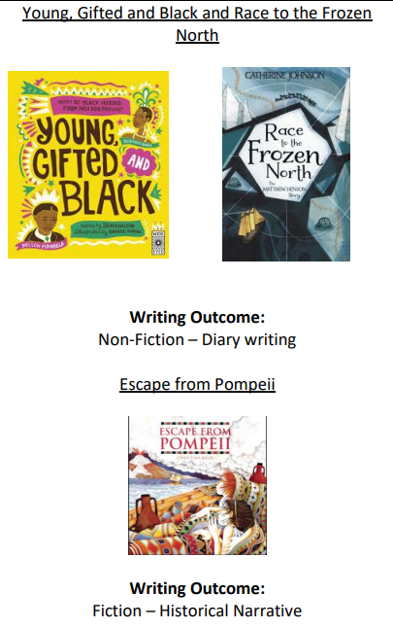  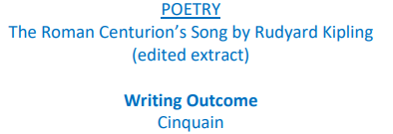  Reading Units  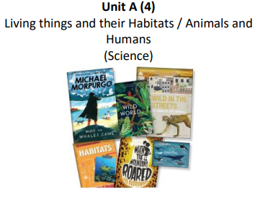 | English Units  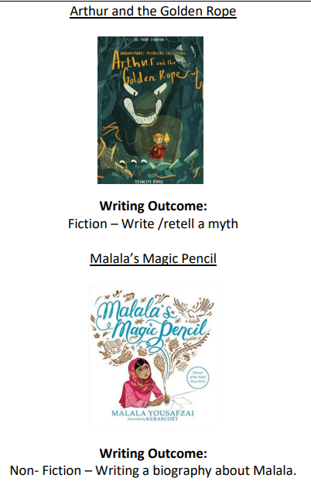  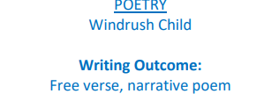  Reading Units  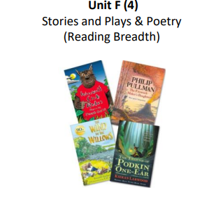 | English Units  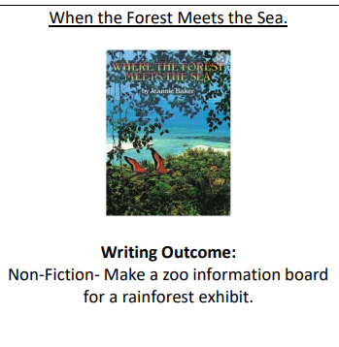  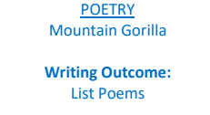  Reading units  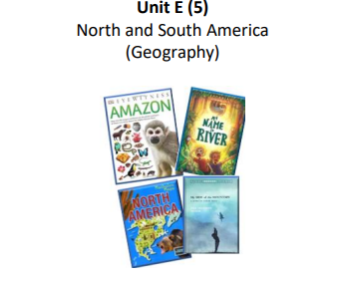
Reading knowledge and skills document: https://www.overstjohns.cheshire.sch.uk/page/english/5951

Writing and spelling knowledge and skills document: https://www.overstjohns.cheshire.sch.uk/page/english/5951

Mathematics | Place Value  Addition & Subtraction  Multiplication & Division  Measurement – Area | Fractions  Decimals  Measurement – mass & capacity  Measurement – Length & Perimeter | Measurement – Money Time Decimals  Geometry – Shape  Statistics  Position & Direction
Mathematics | Maths knowledge and skills document: https://www.overstjohns.cheshire.sch.uk/page/mathematics/1630
Science | States of Matter/Materials  Scientists in focus ‘working in role as a physics and chemist ‘  Sound  Scientists in focus ‘working in role as a physicist‘ | Earth and Space  Scientists in focus ‘working in role as an astronomer‘  Forces  Scientists in focus ‘working | Living things and their habitats  Scientists in focus ‘working in role as a biologist’  Animals, including humans  Scientists in focus ‘working in role as a biologist and dietician’
Science | Science knowledge and skills document: https://www.overstjohns.cheshire.sch.uk/page/science/128210
Computing | Computing Systems and Networks  Systems and Searching  Creating Media  Introduction to Vector Graphic  E Safety knowledge and skills | Programming 1  Repetition in Shapes  E Safety knowledge and skills | Data and Information  Flat File Databases  E Safety knowledge and skills
Computing | Computing knowledge and skills document: https://www.overstjohns.cheshire.sch.uk/page/computing/128482  E Safety knowledge and skills document https://www.overstjohns.cheshire.sch.uk/serve_file/17124902
History | What was the impact of the Roman Empire?  How does Winsford remember people from the war? | How did Ancient Greece influence the Western World? | Was the Anglo Saxon period really a dark age?
History | History knowledge and skills document: https://www.overstjohns.cheshire.sch.uk/page/history/128478
Geography | Local Area and Region | Volcanoes and Earthquakes | Year 4 –South America – The Amazon
Geography | Geography knowledge and skills document: https://www.overstjohns.cheshire.sch.uk/page/geography/128479
Art | Painting and Sculptural Plant Pots  Explore how we use drawing and ‘drawing’ with scissors to create sculpture. | Exploring Still Life  Explore artists working with the genre of still life, contemporary and more traditional. Create your own still life inspired art work. | Festival Feasts  How might we use food and art to bring us together?
Art | Art knowledge and skills document: https://www.overstjohns.cheshire.sch.uk/page/art-and-design/128209
DT | Food & Nutrition | Material/Structures and Textiles | Mechanisms
DT | DT knowledge and skills document: https://www.overstjohns.cheshire.sch.uk/page/design-and-technology/128207
RE | What do I think about Jesus and how is he portrayed in art from around the world? Why is the cross important to Christians?  How are the values of community and equality shown through the Sikh way of life? | How do Hindus worship in their daily lives?  What does Christian art teach people about the Trinity? | How do Jewish people demonstrate their faith through their communities?  What are some of the differences and similarities within Christianity locally and globally? What can we learn from Christian religious buildings and music?
RE | RE knowledge and skills document: https://www.overstjohns.cheshire.sch.uk/page/religious-education/114494
PE | Cricket  Dance  Gymnastics  Hockey | Dance  Handball  Gymnastics  Netball | Gymnastics  Rounders  Dance  Athletics
PE | PE knowledge and skills document: https://www.overstjohns.cheshire.sch.uk/page/physical-education/128194
Music | Sounds  Exploring Sounds  Our Community  Performance  Communication  Composition  Our Community  Performance | Time  Beat  Life Cycle  Structure  Ancient Worlds  Structure  Life Cycle  Structure | Around the World  Pitch  Keeping Healthy  Beat  Recycling  Structure  Keeping Healthy  Beat
Music | Music knowledge and skills document https://spaces.schoolspider.co.uk/uploads/28/page/25066171_page_file.pdf?ofn=music-subject-map.pdf
PSHE including RSE | Year 4  What I know now  Cycle Safety  Coming Home on Time  Anti Bullying Week  My Happy Minds  Year 5  Peer Pressure inc Adults views Children’s views  Looking out for others inc Adults views Children’s views  Anger  Anti Bullying Week  My Happy Minds | Year 4  What I know now  Jealousy  Healthy Living  My Happy Minds  Year 5  Smoking  Inclusion and acceptance inc Adults and Children’s Views  My Happy Minds | Year 4  What I know now  Breaking own Barriers  Chores at Home  First Aid Year 4  My Happy Minds  Year 5  Puberty inc Adults views Children’s views  Enterprise  First Aid Year 5
PSHE including RSE | PSHCE knowledge and skills document:

