English | 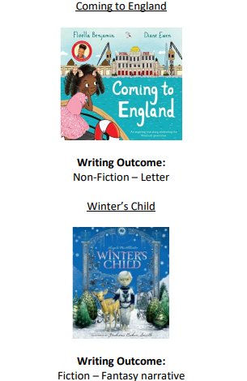  English Units    Reading Units  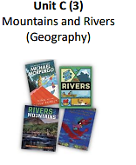 | English Units  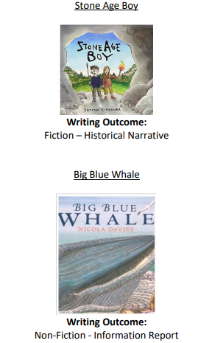  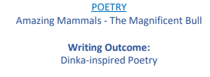  Reading Units  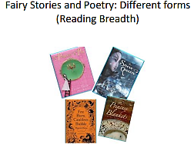 | English Units  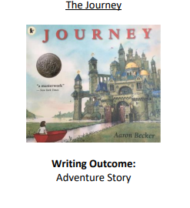  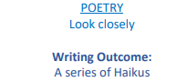  Reading units  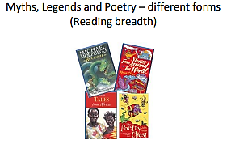
Reading knowledge and skills document and writing and spelling knowledge and skills document
Over St Johns CE Primary School: English

Mathematics | Place Value  Addition & Subtraction  Multiplication & Division  Measurement – Area | Multiplication & Division  Measurement – Length & Perimeter  Fractions Measurement – mass & capacity  Decimals | Fractions  Measurement – Money Time  Decimals  Geometry – Shape Statistics Position & Direction
Maths knowledge and skills document
Over St Johns CE Primary School: Mathematics

Science | Animals, including humans  Scientists in focus ‘working in role as a biologist and dietician’  Rocks  3 Scientists in focus ‘working in role as a ‘geologist, agronomist, and palaeontologist’ | Light  Scientists in focus ‘working in role as a physicist’  Forces and Magnets  Scientists in focus ‘working in role as a physicist’ | Plants  Scientists in focus ‘working in role as a botanist ‘  Living things and their habitats  Scientists in focus ‘working in role as a ‘biologist’
Science knowledge and skills document
Over St Johns CE Primary School: Science

Computing | Computing Systems and Networks  Connecting Computers  The Internet  E-safety  Health, well-being and lifestyle  Managing online information  Creating Media  Desktop Publishing  E-safety  Copyright and ownership  Privacy and security | Programming A  Sequencing Sounds  E-safety  Self-image and identity  Data and Information  Branching Databases  E-safety  Online relationships | Creating Media  Audio Production (4&3)  E-safety  Online Bullying  Programming B  Events and Actions (3&4)  E-safety  Online Reputation
Computing knowledge and skills document and E Safety knowledge and skills document
Over St Johns CE Primary School: Computing
History | Why should we remember the Maya?  What was the impact of war on animals?  Remembrance – the use of animals during the war. | What was new about the Stone Age? | How has the British monarchy changed over time?
History knowledge and skills document
Over St Johns CE Primary School: History
Geography | European Region- the Mediterranean | Rainforests | Rio& South Brazil
Geography knowledge and skills document
Over St Johns CE Primary School: Geography
Art | Gestural Drawing with Charcoal  Making loose, gestural drawings with charcoal, and exploring drama and performance. | Cloth, Thread, Paint  Explore how artists combine media to create work in response to landscape. Use acrylic and thread to make a painted and stitched piece. | Telling Stories through Drawing & Making  Explore how artists are inspired by other art forms – in this case how we make sculpture inspired by literature and film.
Art knowledge and skills document
Over St Johns CE Primary School: Art and Design
DT | Mechanisms | Material/Structure and Electrical Systems | Textiles
DT knowledge and skills document
Over St Johns CE Primary School: Design and Technology
RE | How can the Bible help a Christian with their way of life? | What do Muslims believe happened on ‘The Night of Power’ and how do they worship? | Baha’i
 | What does a Hindu believe about God and how is Diwali celebrated? | What can I learn from Christian art about Christian beliefs about Easter, Salvation and the Trinity? | How do Christians use symbols to explain what God is like?
RE knowledge and skills document
Over St Johns CE Primary School: Religious Education

PE | Cricket (coach)  Dance (coach)  Gymnastics (coach)  Hockey | Gymnastics (coach)  Netball  Dance (coach)  Handball  Handball (4) | Gymnastics (coach)  Rounders  Dance (coach)  Athletics
PE knowledge and skills document
Over St Johns CE Primary School: Physical Education

Music | Environment  Composition  Sounds  Exploring Sounds Poetry  Performance  Communication  Composition | In the Past  Pitch  Time  Beat Food and Drink  Performance  Ancient Worlds Structure | Building  Beat  Around the World  Pitch Singing French  Pitch  Recycling  Structure
Music knowledge and skills document
Over St Johns CE Primary School: Music
PSHE and Citizenship | Keeping/Staying Safe  Staying Safe  Who keeps us safe? Staying safe video – should James go with someone he does not know How to keep self-safe in range of scenarios  Leaning Out of Windows  Understanding of hazards in the home and outside How to react to hazards Understanding of warning signs  Assessment Summative  Consideration of combined elements of 3-year study. What is safe? You may also consider a visit to a Hazard unit here: http://www.safetycentre.co.uk/  Keeping/Staying Healthy  Medicine  Know, understand and be able to practise simple safety rules about medicine. Know who we can accept medicine from  Assessment Summative  Consideration of combined elements of 3-year study. What is healthy and unhealthy?  Also this term we will be celebrating ANTI BULLYING WEEK | Keeping/Staying Safe  Staying Safe  Who keeps us safe? Staying safe video – should James go with someone he does not know How to keep self-safe in range of scenarios  Leaning Out of Windows  Understanding of hazards in the home and outside How to react to hazards Understanding of warning signs  Assessment Summative  Consideration of combined elements of 3-year study. What is safe? You may also consider a visit to a Hazard unit here: http://www.safetycentre.co.uk/  Keeping/Staying Healthy  Medicine  Know, understand and be able to practise simple safety rules about medicine. Know who we can accept medicine from  Assessment Summative  Consideration of combined elements of 3-year study. What is healthy and unhealthy?  Also this term we will be celebrating ANTI BULLYING WEEK | Keeping/Staying Safe  Staying Safe  Who keeps us safe? Staying safe video – should James go with someone he does not know How to keep self-safe in range of scenarios  Leaning Out of Windows  Understanding of hazards in the home and outside How to react to hazards Understanding of warning signs  Assessment Summative  Consideration of combined elements of 3-year study. What is safe? You may also consider a visit to a Hazard unit here: http://www.safetycentre.co.uk/  Keeping/Staying Healthy  Medicine  Know, understand and be able to practise simple safety rules about medicine. Know who we can accept medicine from  Assessment Summative  Consideration of combined elements of 3-year study. What is healthy and unhealthy?  Also this term we will be celebrating ANTI BULLYING WEEK
PSHCE knowledge and skills document
Over St Johns CE Primary School: PSHE including RSE

French | Les Salutations – Greetings Noël – Christmas | Dans ma trousse – In my pencil case Les couleurs – Colours | Les animaux – Animals
French knowledge and skills document
Over St Johns CE Primary School: Modern Foreign Languages

