 | English Units  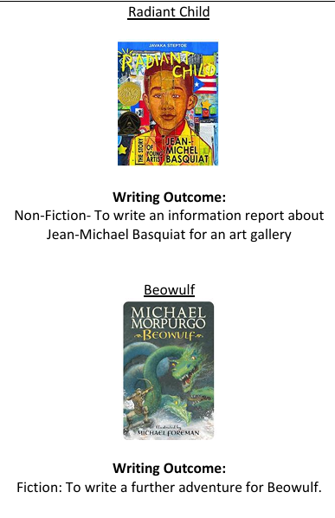  POETRY Viking Kennings & Spells  Writing Outcome: Songs and word play: good luck spells  Reading Units  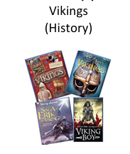 | English Units  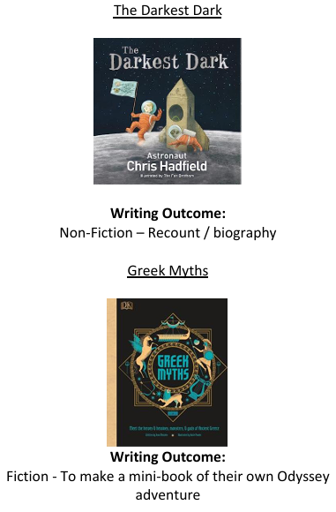  POETRY Our Wonderful World – Finding Magic Writing Outcome: Free Verse  Reading Units  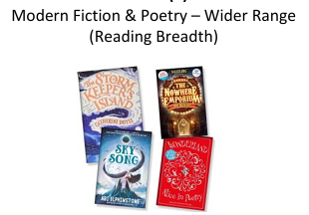 | English Units  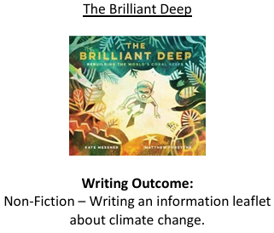  POETRY Animals of Africa Writing Outcomes: Puns and Word Play  Reading units  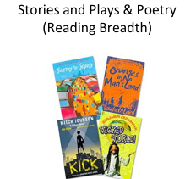
Reading knowledge and skills document 23290919 (overstjohns.cheshire.sch.uk)

Writing and spelling knowledge and skills document 3290760 (overstjohns.cheshire.sch.uk)

Mathematics | Place Value  Addition & Subtraction  Multiplication & Division  Measurement – Area | Fractions  Decimals  Measurement – mass & capacity  Measurement – Length & Perimeter | Measurement – Money Time Decimals  Geometry – Shape  Statistics  Position & Direction
 | Maths knowledge and skills document https://www.overstjohns.cheshire.sch.uk/serve_file/17559780
Science | States of Matter/Materials  Scientists in focus ‘working in role as a physics and chemist ‘  Sound  Scientists in focus ‘working in role as a physicist‘ | Earth and Space  Scientists in focus ‘working in role as an astronomer‘  Forces  Scientists in focus ‘working | Living things and their habitats  Scientists in focus ‘working in role as a biologist’  Animals, including humans  Scientists in focus ‘working in role as a biologist and dietician’
 | Science knowledge and skills document https://www.overstjohns.cheshire.sch.uk/serve_file/19691852
Computing | Computing Systems and Networks  Systems and Searching  E-safety  Health, well-being and lifestyle  Managing online information  Creating Media  Video Production  E-safety  Copyright and ownership  Privacy and security | Programming A  Repetition in Shapes  E-safety  Self-image and identity  Data and Information  Flat File Databases  E-safety  Online relationships | Creating Media  Introduction to Vector Graphics  E-safety  Online Bullying  Programming B  Selection in Quizzes  E-safety  Online Reputation
Computing knowledge and skills document https://www.overstjohns.cheshire.sch.uk/serve_file/17124899

E Safety knowledge and skills document https://www.overstjohns.cheshire.sch.uk/serve_file/17124902
History | What evidence of the Romans can we see?  Where can we go in Winsford to remember those that died in the war? | Can we thank the Ancient Greeks for anything in our lives today? | Were the Vikings brutal invaders?
 | History knowledge and skills document 27506730 (overstjohns.cheshire.sch.uk)
Geography | Mountains | Volcanoes and Earthquakes | Food and Farming
 | Geography knowledge and skills document https://www.overstjohns.cheshire.sch.uk/serve_file/17569628
Art | Storytelling Through Drawing  Explore how artists create sequenced drawings to share and tell stories. Create accordian books or comic strips to retell poetry or prose through drawing. | Exploring Pattern Exploring  How we can use colour, line and shape to create patterns, including repeating patterns. | Sculpture, Structure, Inventiveness & Determination  What can artists learn from nature?
 | Art knowledge and skills document https://www.overstjohns.cheshire.sch.uk/serve_file/17705461
DT | Food & Nutrition | Material/Structures and Textiles | Mechanisms
 | DT knowledge and skills document https://www.overstjohns.cheshire.sch.uk/serve_file/18701763
RE | How and why do Christians worship? What are the benefits for believers?  What do Gospel writers say about Christmas? | Why are the Five Pillars important to Muslims?  How do Humanists arrive at their views about the world? | Why do Christians want to share the worlds resources?  What is a World View?
 | RE knowledge and skills document 23047900 (overstjohns.cheshire.sch.uk)
PE | Dance  Netball  Gymnastics  Hockey | Dance  Cricket  Gymnastics  Football | Tennis  Dance  Athletics  Gymnastics
 | PE knowledge and skills document 20259945 (overstjohns.cheshire.sch.uk)
Music | Poetry - Performance  Solar System -Listening  Environment - Composition  Solar System - Listening | Singing Spanish - Pitch  At the Movies - Composition  In the Past - Notation  At the Movies Composition | Building - Beat  Celebration – Performance  Food and Drink - Performance  Celebration - Performance
 | Music knowledge and skills document 23855278 (overstjohns.cheshire.sch.uk)
PSHE and Citizenship | Year 4  Keeping/Staying Safe  Cycle Safety  Keeping/Staying Healthy  Keeping/Staying Healthy  First Aid  Anti Bullying Week  Computer Safety  Online Bullying  Year 5  Keeping/Staying Safe Peer Pressure  Keeping/Staying Healthy Smoking Inc. Adults views/Children’s views  First Aid Basic Life Support  Anti Bullying Week  Computer Safety | Year 4  Growing and Changing  Being Responsible  British Values  INDIVIDUAL LIBERTY  Year 5  Being Responsible Looking out for others inc Adults views Children’s views  The Working World Enterprise with Adults views Children’s views  British Values  CELEBRATING DIVERSITY/TOLERANCE | Year 4  The Working World  A World Without Judgement  Feelings and Emotions Anger  Money and Enterprise  Keeping track of Money  Saving and spending  Year 5  Growing and Changing Puberty inc Adults views Children’s views  Feelings and Emotions Adults and Children’s Views  A World Without Judgement Inclusion and acceptance with Adults views Children’s views  Money and Enterprise  Raising money – the benefits.  Careers in money
 | PSHCE knowledge and skills document https://www.overstjohns.cheshire.sch.uk/serve_file/17744960

