

Year 2
Computer Rules
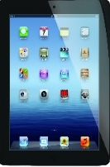

Using the Internet Safely - Key Stage 1

- I will look after all school computer equipment and use it properly.
- I will tell an adult if I see anything on a computer which worries or upsets me.
- I will only take a photograph or video of someone if they say it is alright.
- I will tell an adult if messages or boxes pop up on the screen.
- All messages I send on a computer will be kind.
- I will not open other people’s computer files without permission.

- I will not share my personal information or talk to people I do not know when using the internet.
- I understand that if I do not follow these
rules, I may not be allowed to use the
school computers or internet.
Think Before You Click!
Name.....................................................................................................

