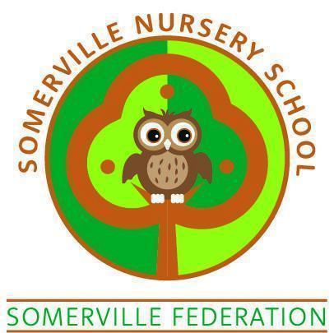

Food and Drink Policy

TO BE REVIEWED BY THE GOVERNING BODY
(May 2026)

Food and Drink Policy

The provider must promote the good health of the children, take necessary steps to prevent the spread of infection, and take appropriate action when they are ill – EYFS legal requirements

Aim of policy

Promote the good health of children through providing healthy, balanced and nutritious snacks and drinks in an environment that promotes healthy choices.

Procedure

- Somerville Nursery School is committed to being a Health Promoting Early Years Setting.

- All food hygiene matters will be included in staff induction and training for all staff.

- We will advise Ofsted immediately of any food poisoning affecting two or more children looked after on the premises.

- When parents register with the school, information will be taken which will include their child’s specific dietary needs, their likes and dislikes, any allergies which may be triggered by certain foods/drinks. Cultural and religious diets will be respected and valued.

- Staff will be given information about the specific dietary needs of the children in Somerville Nursery School. Whilst this information is confidential to Somerville Nursery School it is essential that everyone involved in the handling, preparation and serving of food ensures that each child’s specific requirements are met.

- Water is to be accessible throughout the day in Somerville Nursery School (both indoors and outdoors). Older children will be able to access the water independently. Younger children will be supported in accessing water by the staff. Toddlers will be offered drinks on a regular basis. We will ensure that children are rehydrated after exercise in hot weather, in addition to the regular drinks in the day. Care will be taken to ensure all children have regular drinks at all times.

- We will provide a healthy nutritious snack for the children attending Somerville Nursery School. Snacks will be developed with the support of health professionals, to ensure that we are promoting healthy eating in line with current guidance. We will ensure that religious / dietary needs are sourced and prepared appropriately. We will encourage the children to enjoy the variety of diets within our communities.

- Children will be encouraged, where appropriate, to help prepare foods for snack times. We will grow fruits and vegetables on the school site and give the children the opportunity to sample this produce.

- We will provide a mid morning snack, and an afternoon snack during the day. We will meet the nutritional needs of individual children at all times.

- The individual dietary needs of children will be met, through discussion with parents, prompting when changes to their child’s dietary needs will be implemented.

We will promote the Unicef Baby Friendly Initiative within the school. Mothers are welcome to breastfeed in the school. As appropriate, a quiet area will be arranged for them to do this.

- Snack time in the morning and the afternoon will consist of a drink of milk and/or water with fresh fruit being offered in addition to other healthy snacks.

- Staff will wash their hands before preparing any snacks, using the anti-bacterial hand wash provided. Only paper towels or hand-driers will be used in an attempt to minimise cross- infection. Staff will demonstrate good practice and be positive role models for the children, students and trainees. IF WEARING FALSE NAILS, STAFF SHOULD WEAR GLOVES WHEN PREPARING FOOD. Staff will use aprons and gloves in line with good environmental health practices and will tie hair back and /or use hairnets / hats when preparing and serving food.

- All children will wash their hands before snack, supported by staff where appropriate.

- The setting supports supervised toothbrushing and this takes place within each session (morning / afternoon)

- We will promote social eating when having snacks with all the children. Staff and children will sit together in small groups at tables within the playrooms. It may be appropriate for a number of playrooms to come together at snack time giving older children the opportunity to be positive role models for the younger children.

- When having snacks, plates and appropriate utensils will be provided. We will acknowledge the differences in eating within our local community. There is no requirement for children to use a knife, fork or spoon if not being used in their own home

- Children may be involved in preparing snack, with staff using appropriate opportunities to promote skills such as matching, sorting, counting, etc.

- Children will be offered choices at snack time to encourage developing skills of independence and confidence.

- We will celebrate special occasions and birthdays and food may be part of these celebrations. Any food for such occasions will be provided by the school. Where parents provide cakes for birthdays these will be distributed at home time, with parents / carers being made aware of ingredients - because some of our children may be allergic or sensitive to ingredients.

- Parents should discuss their child’s individual needs with staff.

- We will not use food as a reward or a sanction.

- Tables and chairs will be wiped over with appropriate cleaning materials before and after snack. The floor must be swept and mopped if needed following food consumption. This will be the role of one team member, allowing the remaining staff to care for the children.

- Only staff who have received Food Hygiene Level 2 training will be able to prepare snacks. Staff will be offered training to promote healthy eating as appropriate.

- Good hygiene will be practised in all areas of the school. The kitchen and food preparation area will meet the requirements of the Environmental Health Inspectorate, who may visit at any time to ensure compliance with their regulations.

- All food will be stored in accordance with Environmental Health Regulations, where required. Required records i.e. fridge/freezer temperatures will be kept daily and be available for inspection by the appropriate agency.

- Somerville Nursery School is committed to the hea;th promoting initiatives and we will work closely with the agencies to monitor and assure the quality of our service.

