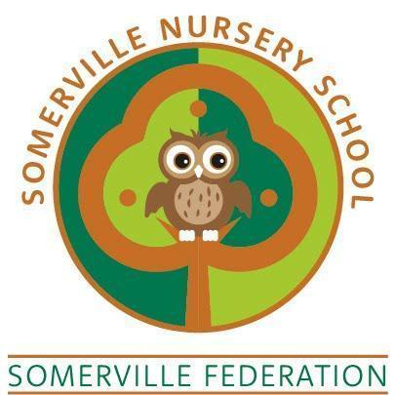

Dummy Policy

TO BE REVIEWED BY THE GOVERNING BODY (May 2026)

Dummy Policy

We understand that from time to time children may need their dummy to settle. The setting engages in a partnership with parents and carers at all times and will work with families to ensure children are happy and supported.

Research and advice from Speech and Language Therapists has provided us with the knowledge that children’s speech, language and communication can be significantly delayed by using dummies for extended periods. With this in mind we have written the following dummy guidelines. We will always talk with families about the needs of individual children and will respect parent’s wishes. Information about the impact of dummy use and speech is shared with parents / carers and support offered to reduce / stop the use of dummies.

Guidance for dummy use for adults working with children.

Aim

To work in partnership with parents and carers to discourage the use of dummies for extended periods, always ensuring that the individual child’s needs are being met.

Procedures

- Dummies will be stored in children’s bags.

- If parents/carers wish us to use a dummy, we will do so if the child is upset or is unable to settle.

- Dummies are not to be shared amongst children and parents will be advised to only provide one dummy per child.

- Staff will not dip a child’s dummy into anything.

Where to go for further advice

Further advice is available from the Speech & Language Therapy Children’s Department (0151 514 2334).

The Literacy Trust website has information about research on dummy use and some useful advice on strategies to reduce dummy sucking. https://literacytrust.org.uk/resources/dummies-and-learning-talk/

