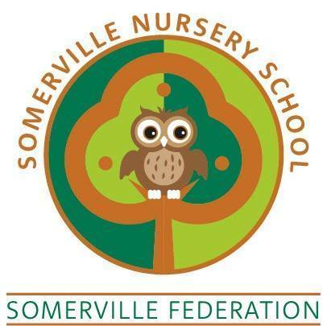

Sustainability Policy

TO BE REVIEWED REGULARLY BY THE GOVERNING BODY (May 2026)

Somerville Nursery School
“Aiming High Together”

Sustainability Policy

At Somerville Nursery School we know we have a duty of care to educate the next generation about environmentally friendly issues. Therefore we are considerate to issues affecting our world and strive to be positive role models for the children in our care.
We are committed to directly and indirectly educating children about environmentally friendly habits such as recycling, reduced plastics and waste. We will look for opportunities to demonstrate environmentally friendly procedures to children & families and emphasise the importance of looking after our world. (This policy links directly with the setting’s ECO Schools & Forest Schools work.)
Policy intention:
- To demonstrate environmentally friendly habits to the next generation
- To educate children & stakeholders about the importance of habits to protect the world in which we live
- Change perspectives around the use of plastics and waste
- Challenge and review current systems and processes that do not reflect a positive and sustainable ethos
The Nursery will:
- Take every opportunity to educate children around issues of sustainability, recycling and waste
- Demonstrate positive role modelling around sustainability, recycling and waste
- Use recycling bins throughout the setting
- Use a compost bin to reduce the amount of ‘general waste within the setting
- Use water butts across the site
- Aim to use recycled materials where possible for activities e.g. junk modelling,
- Aim to only buy products from sustainable sources or recycled products
- Grow our own fruit and vegetables
- Purchase fruit and vegetables which are locally sourced and do not use plastic packaging
- To reduce the use of plastics in our setting. We will:
- Encourage the use of recycled materials and natural resources
- Ensure that items are only laminated when absolutely necessary
- Purchase ECO friendly / biodegradable items wherever possible
- Use recycled plastics rather than buying more plastic resources
- Discourage packaged snacks and encourage provision of fresh fruit
- Reuse plastic resources, upcycle items to continue using them

This policy reflects an ongoing ethos in our setting to support sustainability. We have started making now and will plan for further improvements through continued engagement in the ECO Schools project & Forest Schools.

