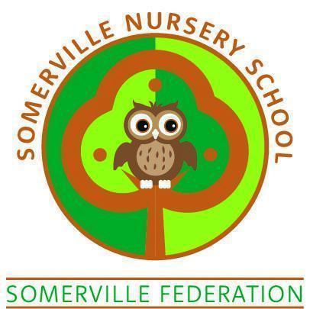

CHARGING POLICY
(January 2026)

SOMERVILLE NURSERY SCHOOL CHARGING POLICY

PAID SESSIONS TERMS AND CONDITIONS

- A session consists of 3 hours, either 9.00 a.m. – 12.00 noon or 12.30 – 3.30 p.m. available term time only.

- The cost per session is £22.50 (from September 2024) and does NOT include a school lunch. If your child’s session means they are here for the day, please ensure they bring a packed lunch with them, unless your child qualifies for free school meals. Sessions are subject to availability

- Children who access 30 hour provision can attend 9.00am-3.30pm Monday to Thursday and 9.00am - 1pm on Fridays. Children wishing to stay for the full afternoon session (until 3.30pm) on a Friday will need to pay £12.50 per week

- Payment for extra sessions / additional hours is required on a weekly basis in advance every Monday.

- Payment can be made up to 1 month in advance.

- Payment can be made by Arbor.

- If payments fall into arrears the place will be suspended until the full arrears are settled.

- There is no facility to offer credit.

- Sessions are offered in addition to the FREE Government funding 30 or 15 hour per week places.

- Sessions will be offered at times opposite to the child’s usual daily 3 hour session.

- There are a limited number of places available per session.

- Changes must be notified at least one week in advance so that staff can plan for the children.

- If a child is absent for any reason, payment must still be made for missed sessions.

- Somerville Nursery School reserves the right to terminate the contract immediately if fees are outstanding for fourteen days or more.

- Children cannot be brought into nursery before the session times stated.

- The governing body reserves the right to amend the fees and conditions, where appropriate. The decision of Somerville Nursery School remains final at all times.

- Parents/carers will be given at least one month's notice of fee increases.

- This contract may be terminated by not less than two weeks notice from either party.

- A child will only be released into the care of his/her parents/carers or nominated adults (see Arrival & Collection Policy). The school reserves the right to ask for photographic ID and can only let the child go with a suitable adult over the age of 16 years

- It is the parent/carer's responsibility to inform the nursery staff of any changes to personal details, address, and telephone numbers in the case of emergencies.

I have read and fully understood the charges' terms and conditions.

Signed Parent A …………………………….Name…………………………….

Parent B ……………..………………Name…………………………….

Child’s Name …………………………….……Date ……………………………..

