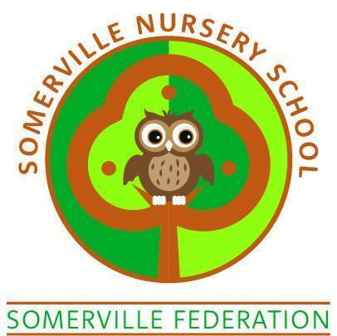

Sun Policy

TO BE REVIEWED BY THE GOVERNING BODY (June 2025)

The provider must promote the good health of the children, take necessary steps to prevent the spread of infection, and take appropriate action when they are ill – EYFS legal requirements

Aims of policy

To protect children in our care and develop their understanding of how to protect themselves

Procedures

- Parents will be requested to apply a long lasting high factor sun block to the exposed areas of the children’s bodies before they come into school. (Not forgetting ears, noses, necks, shoulders and tops of feet etc.)

- All children will be required to bring or wear a sun hat when playing outdoors. (the setting have a supply of legionnaire style hats which can be worn)

- Children are encouraged to wear tops that cover their shoulders (vests, sundresses and strappy tops are discouraged). Should a child attend school wearing a vest, strappy top or sundress, they will remain indoors with a member of staff for their own protection from the sun’s rays or provided with a suitable top to cover their shoulders / arms.

- Children are encouraged to wear suitable footwear. Open-toed sandals or Crocs are not suitable.

- Careful consideration will be given to the timing, length, location and nature of activities during the sunny weather in order to prevent over-exposure to the sun.

- All children will have access to drinking water.

- All staff should ensure that they apply appropriate sunblock and wear appropriate clothing. This will provide protection for them and provide good role models for the children in our care.

- Opportunities will be taken to talk to children about the need to protect ourselves from the sun’s rays.

