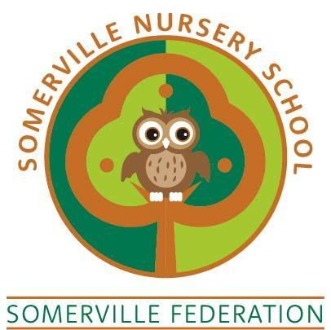

Nut Free Policy

TO BE REVIEWED REGULARLY BY THE GOVERNING BODY (June 2025)

Somerville Nursery School
“Aiming High Together”

Nut Free Policy

Somerville Nursery School is a nut free Nursery. This means no food products containing nuts are brought into the building. We hope this will reduce the risk of any child or adult with a nut allergy from coming into contact with a food product which could potentially be very harmful to them.
We realise that many foods are labelled as having ‘traces of nut’ or ‘cannot guarantee nut free’ which are very difficult to avoid. We will speak to the parents of any children who join the setting who have a nut allergy to establish the severity of the allergy and will put in place an Individual Health Care Plan and a risk assessment as appropriate.
In order to reduce the risk of an allergic reaction for child in our care:
The Nursery will:
- Make sure cooking ingredients do not include nuts
- Inform all new parents of this policy
- Place a copy of the policy on the school website
- Remind families periodically in Newsletters / updates
- Staff will not bring food containing nuts into the nursery
We ask parents:
- When preparing packed lunches to not include any food containing nuts (e.g. cereal bars, peanut butter), if they do, these are not offered to the child, but left in their lunch boxes and parents/carers are telephoned to remind them of our policy
- We ask that parents do not bring in birthday cakes as we are a Healthy Eating Setting and also because some of our children may be allergic or sensitive to ingredients.

