



USER GUIDE

Section 1: Register

1. Sign Up
Go to : yourprovidername.ipalbookings.com If you are not sure their link go to:
https://findipal.ipalbookings.com/ and search for their name here.

2. Click Register
To register you will need a live email address and your password must be at least 8 characters and contain each of the following;
1 Capital Letter
1 Lowercase Letter 1 Number
1 Special character

You will need to verify your email with a number code that will be emailed to you. Then complete your profile.

Please note the first part of your address to log in will be the name of your nursery / business / school or service i.e;
s4yc.ipalbookings.com

3. Adding your children.

Please note, if you have logged out during initial registration or are registering on additional childcare you will need to click on Profile and Add Children. (on mobile this is under the menu icon)

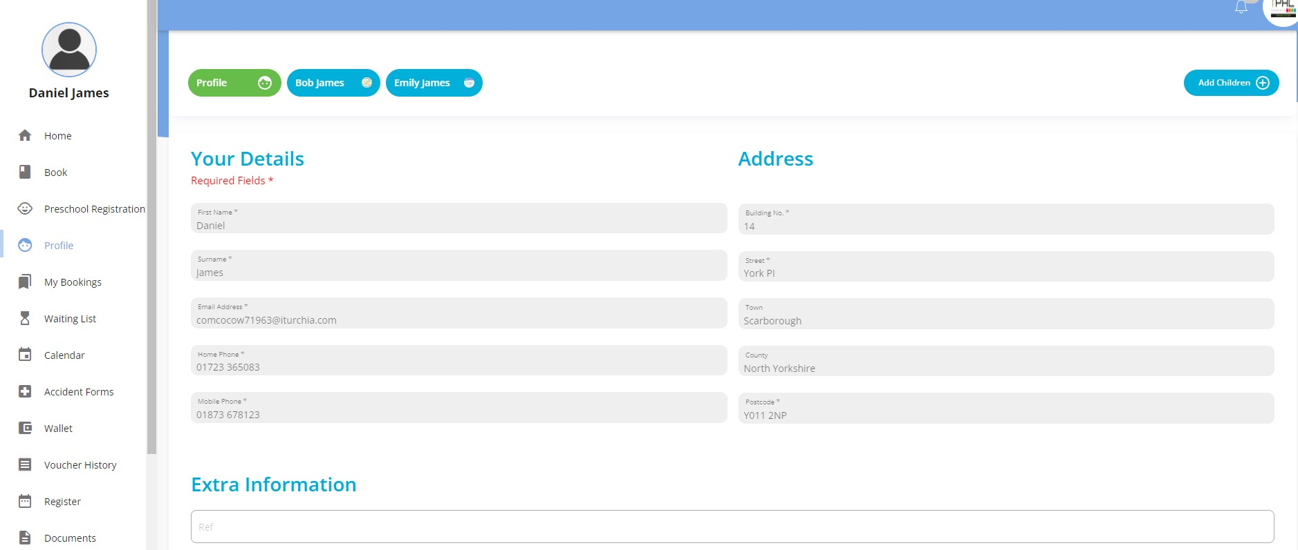

To edit any children after adding them, proceed to the same area and click the child’s name. Edit as required then click Save Changes.
Common mistakes:
Make sure you have put your child into the correct school, year group and their date of birth is correct. The club may have set restrictions to who can book based on age, year group or school to ensure people don’t book the wrong club.

If you see “no clubs found” when making a booking this will be the reason.

Section 2: Navigating iPAL

1. Home
Your Home page is your initial landing page when logging into your iPAL account, this provides you with an overview of your bookings, upcoming payment and a snapshot of your wallet balance – credit you have in the system and how it’s made up.

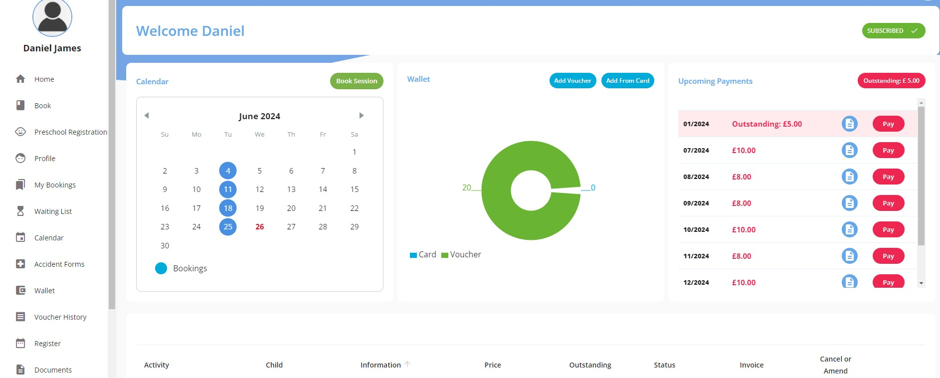

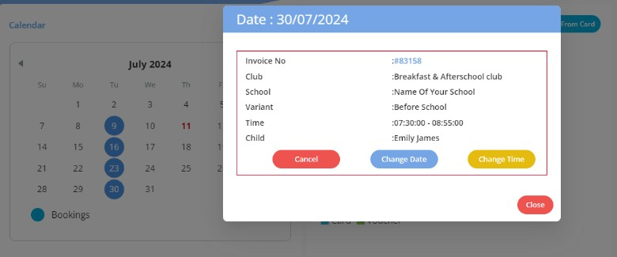
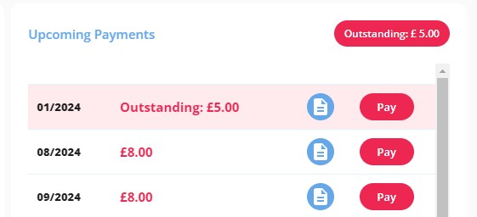
Clicking on the dates you have a booking, you can cancel or amend it depending on the rules set for the club.

Clicking on the outstanding total button you will be taken to the “My Bookings” page with it filtered to the invoices you need to pay currently.

2. Book
You can either click on Book from the nav bar or Book Session from the calendar to get to making a booking.
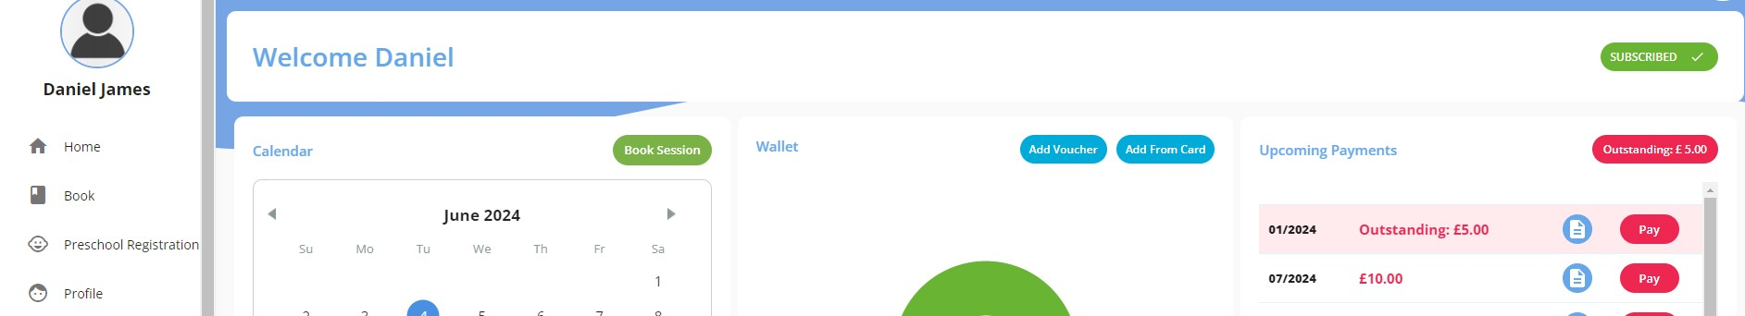

Select the tile for the club you are wanting to book. You can click View to see the info about the clubs to check you have the right option selected as well as age restrictions etc.
Please note that if you are in debt to the club you will not be able to book.
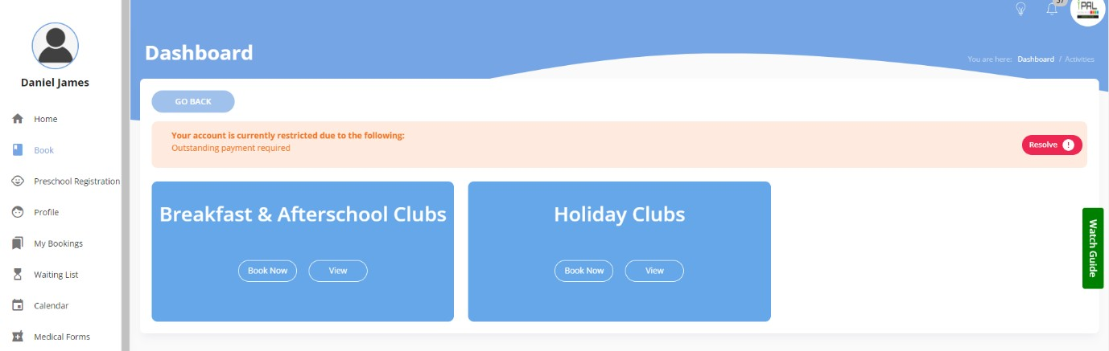

Select your child, school/venue and then club that you want to book. The dates you can book will show in the calendar in green, if no places are available that day you can join the waiting list. Clubs may run in 1 of 3 ways;
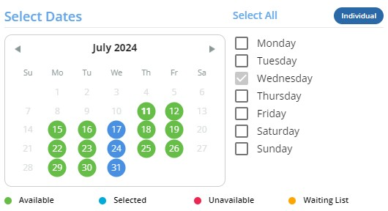
- Contract – This means you need to use the day picker at the side e.g. all Mondays
- Block – This means you do not have a choice of dates, you must book all available dates
- Individual – This means you can either use the day picker for all Mondays or individual dates.

If you are struggling try watching the watch guide on the right of your screen.

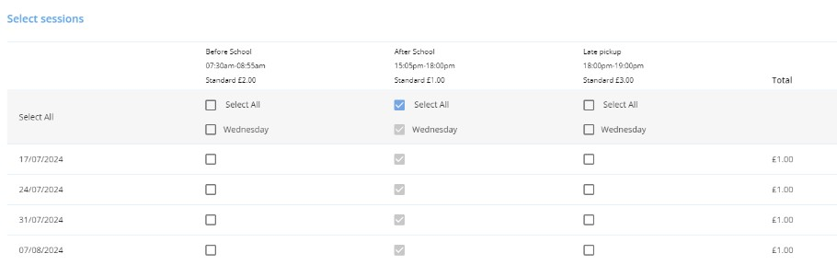
Once you have selected your dates select the booking option you want and click create booking.

At checkout you have a variety of options depending on the rules set by your club provider.
If they allow you to pay at a later date or monthly, simple click confirm booking or to pay immediately, click “Confirm Booking”
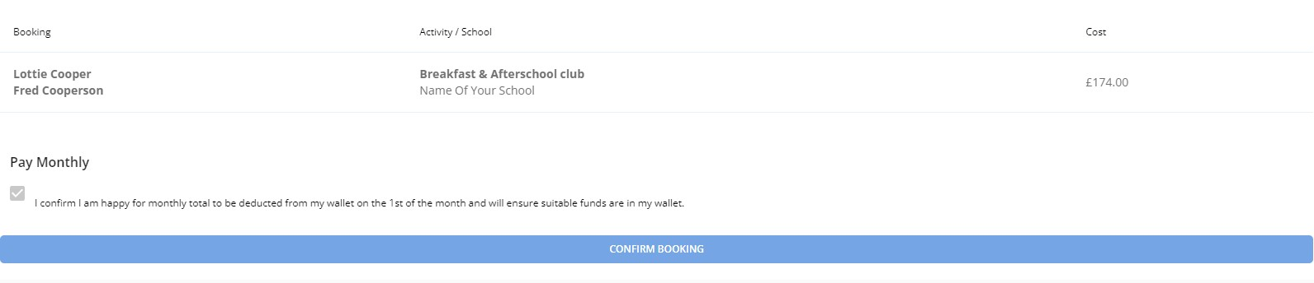
If card payments are accepted by the club you can click pay by card and fill in your information. To pay by voucher or other methods when applicable, you need to click “Pay by voucher and other payment methods” or to use credit in your account, use the pay by wallet function.
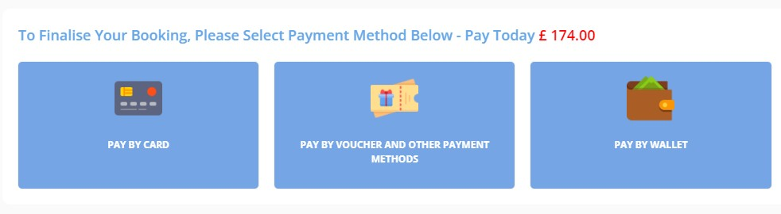

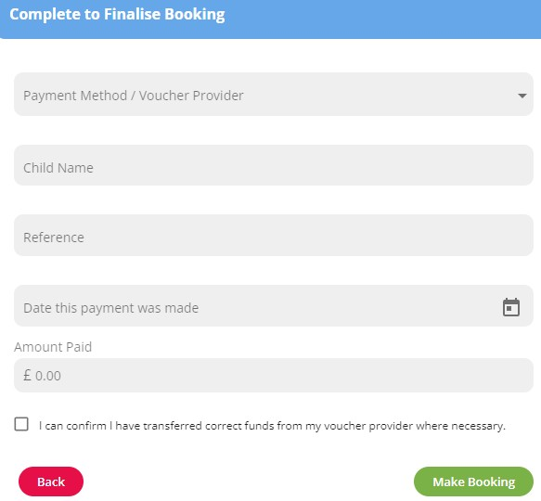
When paying by voucher or other payment methods. Using the drop down menu you can select the voucher pre-populated by your provider and complete the rest of the information.

Please ensure to use your reference number to help identify your payment.
You will need to process the payment with your chosen method of payment to avoid any issues.




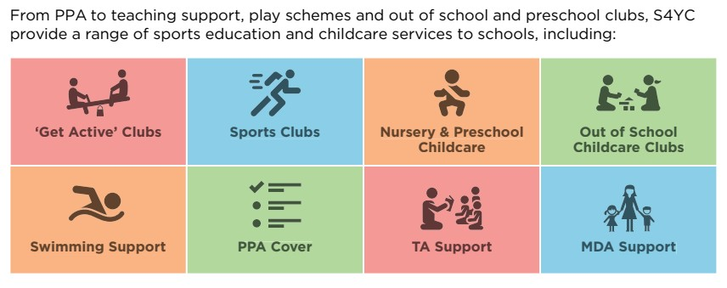

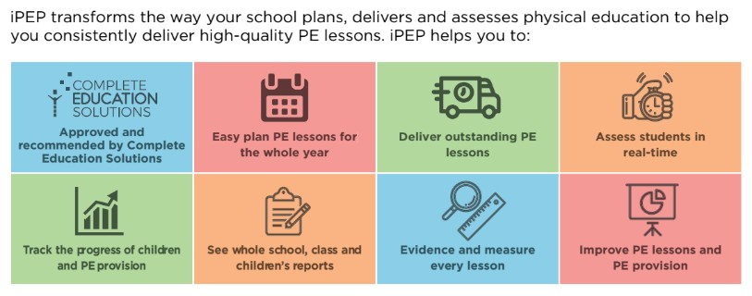

A child or parent no longer uses my services, how do I remove
them?

