Thursday 2nd April

- Look at the front cover. Can you predict what the book will be about? Write at least two sentences explaining your ideas.

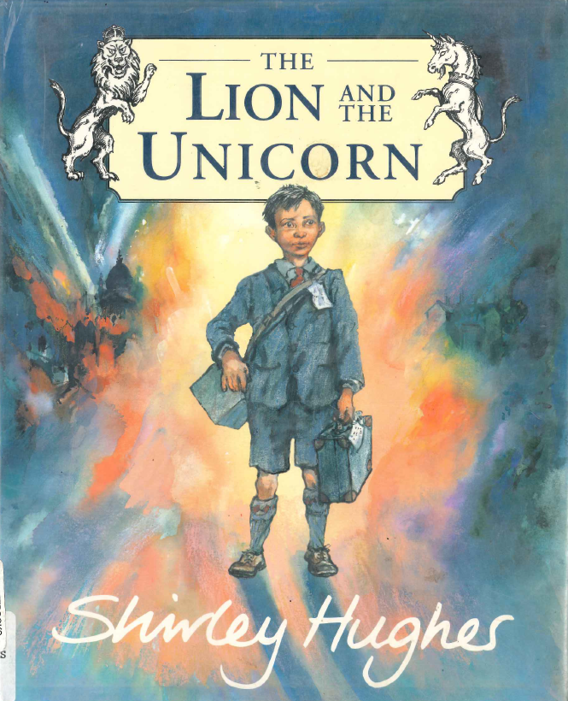

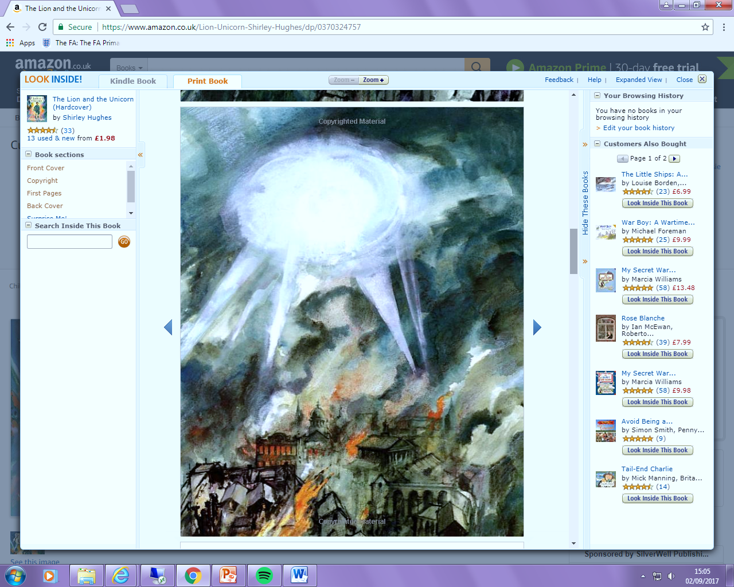
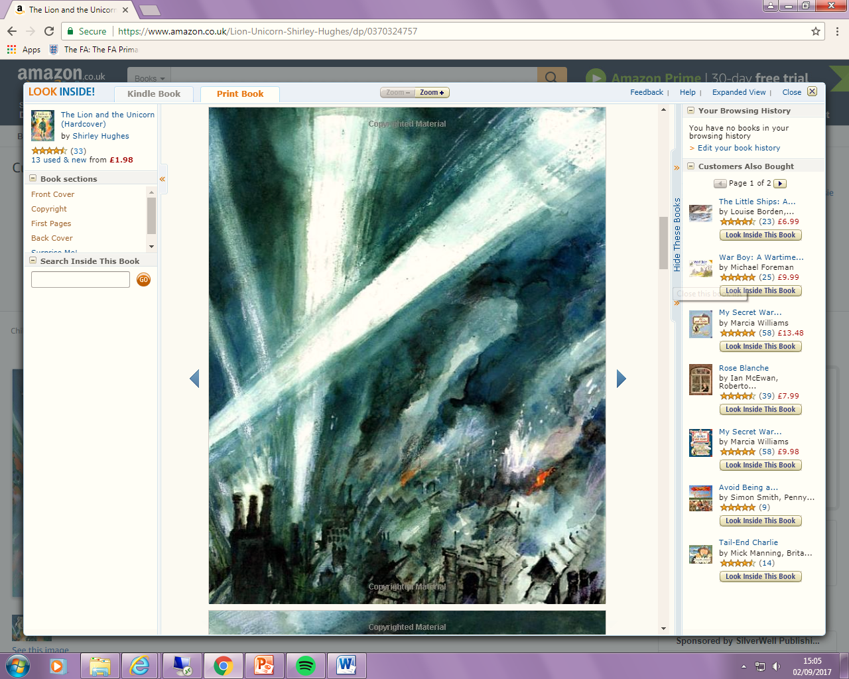

2) How does this picture make you feel?
3) Read the first page. What do you think was happening in London at that moment in time? Use evidence from the text to support your ideas.
4) Which words help the reader to understand what kinds of sounds (onomatopoeia) were being heard in London at this time?
5) At what time of day were the bombings taking place?
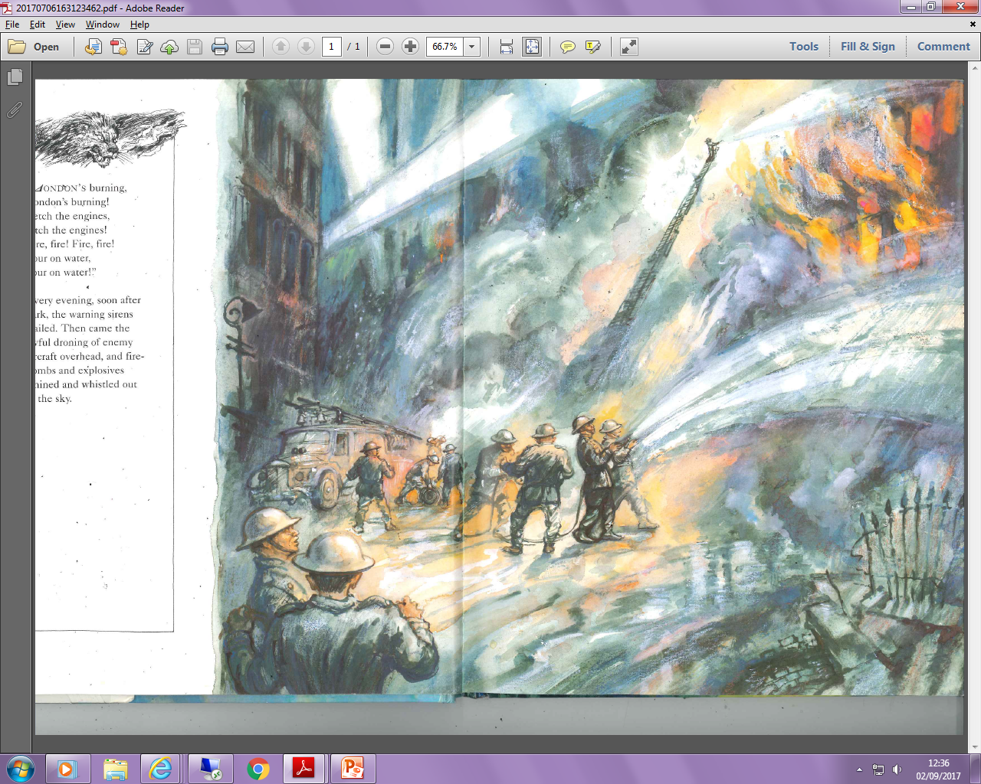
London’s burning,
London’s burning!
Fetch the engine,
fetch the engines!
Fire, fire! Fire, fire!
Pour on water,
pour on water!

Every evening, soon after dark, the warning sirens wailed. Then came the awful droning of enemy aircraft overhead and fire -bombs and explosives whined and whistled out of the sky.
1
2

6) What word choices does the author use to show that the family was afraid?
7) What was Lenny holding? Why was it special to him?
8) What does the text suggest that a Lion symbolises?
9) What does ‘stood’ mean in this context?
10) Based on the pictures, what sort of relationship do you think Lenny has with his mum? Give reasons for your answer.

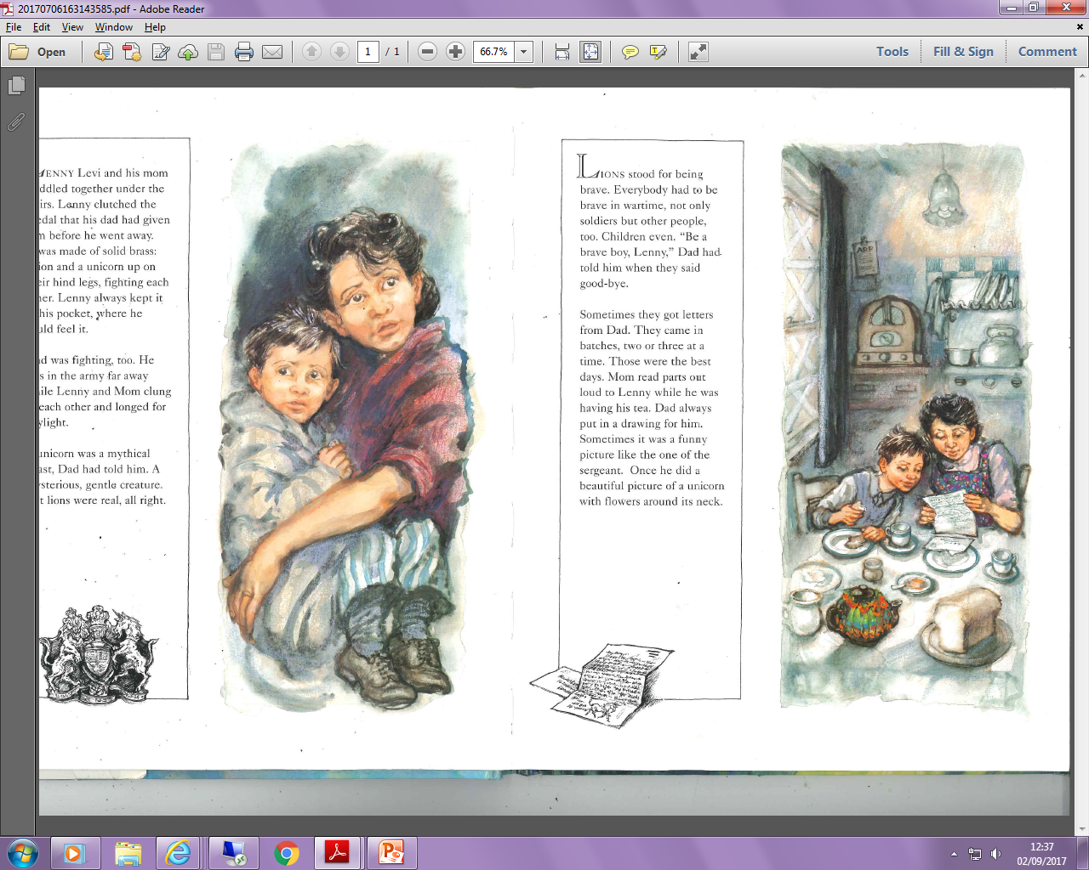
3
4
Lenny Levi and his mom huddled together under the stairs. Lenny clutched the badge that his dad had given him before he went away. It was made of solid brass; a lion and a unicorn up on their hind legs, fighting each other. Lenny kept it in his pocket always where he could feel it.

Dad was fighting too. He was in the army far away while Lenny and Mom clung to each other and longed for daylight.

The unicorn was a mythical beast, Dad had told him. A mysterious, gentle creature. But lions were real, all right.

