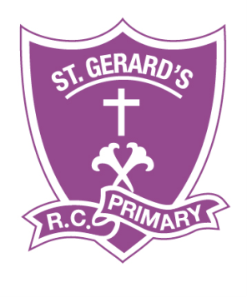
St Gerard’s Catholic Primary
St Gerard’s Catholic Primary and Nursery School

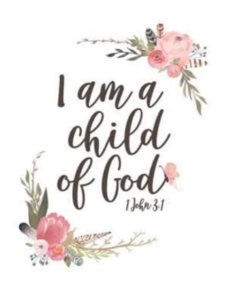

Music Policy 26-27
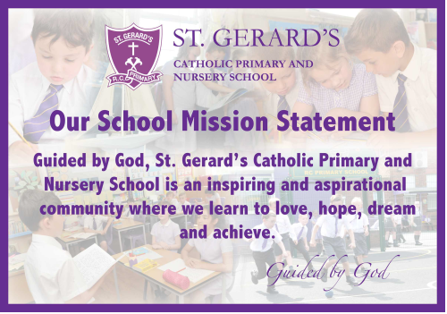

SAFEGUARDING STATEMENT
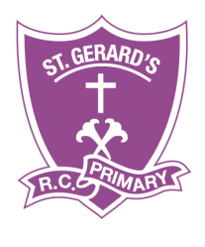

“St Gerard’s Catholic Primary and Nursery School is committed to safeguarding and promoting the welfare of children
and young people and expects all staff and volunteers to share this commitment”.

Music Policy 2026-27
“Music is a moral law. It gives soul to the universe, wings to the mind, flight to the imagination, and charm and gaiety to life and to everything.”
Plato
Policy Date: September 2025
Policy Status: Statutory
Policy Review Cycle: Annual
Next Review Date: September 2026

The Subject Leadership role of Music at St Gerard’s is central to improving outcomes for our children. Subject Leaders at St. Gerard’s have high expectations of themselves and our children, and are passionate about their specialisms. The lead for Music shall ensure that the children thoroughly enjoy and safely partake in multiple experiences of music. The Role of the Music lead is to:
- lead the development of music in school;
- provide guidance to individual members of staff;
- keep up to date with local and national developments in music and disseminate relevant information;
- review and monitor the success and progress of the planned units of work;
- ensure resources or instruments linked to the planned units of work at the end of each term are available and in good order;
- be responsible for the organisation and maintenance of music resources;
- co-ordinate any display of music work.

Responsible to:
Governors, Head Teacher, Deputy Head Teacher

Introduction:
Music is a unique way of communicating that can inspire and motivate children. It is a vehicle for personal expression and it can play an important part in the personal development of people. Music reflects the culture and society we live in, and so the teaching and learning of music enables children to better understand the world they live in. Besides being a creative and enjoyable activity, music can also be a highly academic and demanding subject. It also plays an important part in helping children feel part of a community. We provide opportunities for all children to create, play, perform and enjoy music, to develop the skills to appreciate a wide variety of musical forms, and to begin to make judgements about the quality of music.
Music reflects our culture and society and so the teaching and learning of music enables children to better understand the world they live in. Besides being a creative and enjoyable activity, music can be a highly academic and demanding subject. It is also important in helping children feel part of a community. Although direct reference to British Values is not
continuously made, the policy has been written with full awareness of our responsibility and commitment to this purpose.

The aims of music teaching are to enable children to:
- perform, listen to, review and evaluate music across a range of historical periods, genres and cultures.
- use their voices, to create and compose music on their own and with others, have the opportunity to learn a musical instrument.
- use technology appropriately and have the opportunity to progress to the next level of musical excellence.
- understand and explore how music is created, produced and communicated, including pitch, duration, dynamics, tempo, timbre, texture and structure

Teaching and learning style

At St. Gerard’s Catholic Primary and Nursery School, we make music an enjoyable learning experience. We encourage children to participate in a variety of musical experiences through which we aim to build up the confidence of all children. Singing lies at the heart of good music teaching. Our teaching focuses on developing the children’s ability to sing in tune and with other people. Through singing songs, children learn about the structure and organisation of music. We teach them to listen and to appreciate different forms of music. As children get older, we expect them to maintain their concentration for longer and to listen to more extended pieces of music. Children develop descriptive skills in music lessons when learning about how music can represent feelings and emotions. We teach them the disciplined skills of recognising pulse and pitch. We often teach these together. We also teach children how to work with others to make music and how individuals combine together to make sounds. We also teach them musical notation and how to compose music.

We recognise that there are children of widely different musical abilities in all classes, so we provide suitable learning opportunities for all children by matching the challenge of the task to the ability of the child. We achieve this in a variety of ways by:
- setting common tasks which are open-ended and can have a variety of responses;
- setting tasks of increasing difficulty (not all children complete all tasks);
- grouping children by ability in the room and setting different tasks to each ability group;
- providing resources of different complexity depending on the ability of the child;
- using classroom assistants to support the work of individuals or groups of children

Music curriculum planning
Our school uses the National Curriculum descriptors for music as the basis for its curriculum planning. We have adapted the national scheme so that the topics that the children study in music build upon prior learning. While there are opportunities for children of all abilities to develop their skills and knowledge in each teaching unit, the planned progression built into the long term plans which means that the children are increasingly challenged as they move through the school.

We carry out the curriculum planning in music in three phases (long-term, medium-term and short-term). The long-term plan maps the music topics studied in each term during the key stage. Sometimes the children study music topics in conjunction with other subjects, particularly at Key Stage 1. Through this programme of study, we teach the knowledge, skills and understanding set out in the National Curriculum. The subject Lead has access to all plans which are also available on the school website for public viewing.
The medium-term plans give details of each unit of work for each term. The class teacher is responsible for keeping and reviewing these plans. A copy is available to the subject leader.
Music is included in the foundation weekly plans (short term planning). This will outline the objective and expectations of the lesson being delivered.
Our music planning is geared to three aspects of progress:
- increasing breadth and range of musical experiences;
- increasing challenge and difficulty in musical activities;
- increasing confidence, sensitivity and creativity in the children’s music making.

EYFS

We teach music in reception classes as an integral part of the topic work covered during the year. As the reception class is part of the EYFS in the National Curriculum, we relate the musical aspects of the children’s work to the objectives set out in the Early Learning Goals (ELGs) which underpin the curriculum planning for children aged three to five. Music contributes to a child’s personal and social development. Counting songs foster a child’s mathematical ability and songs from different cultures increase a child’s knowledge and understanding of the world.

The contribution of music to teaching in other curriculum areas English
Music contributes significantly to the teaching of English in our school by actively promoting the skills of reading, writing, speaking and listening. Children develop their language skills through singing songs, with attention to diction, meaning, rhythm and rhyme. They use reference books and develop research skills when finding out about the history of music and
musicians. Music is also used to stimulate discussion or creative writing. Through working with others in a musical setting, children develop their ability to communicate ideas effectively.

Mathematics
Music contributes to the teaching of mathematics in that children who study the structure of music are observing patterns and processes. Talent in music is often linked with talent in mathematics, as the rhythm and structure of music is mathematically based.

Computing
ICT is used in music where appropriate. Children use computer programmes to compose music on iPads, laptops and chromebooks. They also use ICT in music to enhance their research skills through the Internet. They listen to music on various apps and they also record their own compositions to send to other schools electronically. Children improve the presentation of their work using ICT.

Personal, social and health education (PSHE) and citizenship
Music contributes significantly to the teaching of personal, social, citizenship and health education. Through the common goal of making music, children learn to work effectively with other people and build up good relationships. Music is the basis of many social activities and has an important role to play in the personal development of many young people. It has a vital role to play in building self-confidence. Participation in successful public musical performances is sometimes one of the most memorable things young people do at school.

Spiritual, moral, social and cultural development
Listening, creating or performing music can sometimes be a moving and even spiritual experience. We encourage children to reflect on the important effect that music has on people’s moods, senses and quality of life. Children at St. Gerard’s Catholic Primary and Nursery School have the opportunity to encounter music from many cultures and, through their growing knowledge and understanding of the music, they develop more positive attitudes towards other cultures and societies.

Teaching music to children with SEN
We teach music to all children, whatever their ability, in accordance with the school curriculum policy of providing a broad and balanced education to all children. Teachers provide learning opportunities matched to the needs of children with learning difficulties, and our work in music takes into account the targets set for individual children in their Support Plans.

Assessment and recording
Teachers and specialist external teachers work together to assess children’s work in music by making informal judgements as they observe them during lessons. At the end of the year, the teacher makes a summary judgement about the work of each pupil in relation to the
National Curriculum ARE attainment and records their progress and attainment based on the agreed descriptors and criteria. We use this as the basis for assessing the progress of the child and we pass this information on to the next teacher at the end of the year.
The music subject leader keeps samples of children’s work in an electronic portfolio. The class teacher/support teacher keeps examples of photographic or other evidence of musical opportunities within the class and through Twitter feeds.

Monitoring and review
The monitoring of the standards of children’s work and of the quality of teaching and learning in music is the responsibility of the SLT and subject leader. The work of the subject leader also involves supporting colleagues in the teaching and implementation of music and being informed about current developments in the subject.

Accountability
An annual action plan and termly summary report is produced for the Leadership team. These are then summarised by the Leadership team member with responsibility for the curriculum and shared with the Governing Body.

Agreed by Governing Body:
Date of next Review: September 2027

