
Ensuring Effective Implementation and Monitoring of the Pupil Premium Strategy

Leadership Actions to Implement and Monitor the Strategy
- Clear Leadership and Accountability
- The Headteacher and designated Pupil Premium Lead take ownership of the strategy’s delivery and outcomes.
- Governors regularly review pupil premium progress and hold leaders accountable through dedicated meetings and reports.
- An implementation team is established, including SENCo, designated safeguarding lead, and key teaching staff, to oversee delivery and problem-solving.
- Ongoing High-Quality Training and Professional Development
- Leaders organise regular training sessions focused on evidence-informed teaching practises that address the specific needs of St Gerard’s disadvantaged pupils, such as language development for EAL pupils (38.75%) and literacy interventions for those with low starting points.
- Teaching assistants and support staff receive targeted coaching to deliver interventions effectively, ensuring consistency and quality.
- New staff receive induction on the pupil premium strategy, embedding understanding and commitment from the start.
- Training is linked to whole-school priorities and the school improvement plan, reinforcing a collective responsibility ethos.
- Robust Monitoring and Data-Driven Review
- Leaders implement a data tracking system that monitors the academic progress, attendance, and engagement of disadvantaged pupils (51.23% FSM, including those with social worker involvement).
- Regular pupil progress meetings focus on disadvantaged pupils, reviewing the impact of interventions and adjusting provision as needed.
- Learning walks and book looks include a focus on how well teaching meets the needs of disadvantaged pupils.
- Staff are given time and opportunities to reflect on data and feedback, fostering a culture of continuous improvement.
- Supporting Staff Wellbeing and Engagement
- Leaders actively support staff wellbeing during the implementation phase by involving them in decision-making and providing collaborative planning time.
- Realistic goals are set to manage workload and maintain motivation.
- Ongoing communication reinforces the importance of the strategy and how every staff member contributes to closing the attainment gap.
- Integration with Curriculum and Whole-School Approach
- Targeted support is scheduled to avoid pupils missing core curriculum content.
- The pupil premium strategy is aligned with other school improvement documents to ensure a coherent approach.
- Leaders promote a whole-school culture where addressing disadvantage is a shared responsibility.
- Engagement with External Partners
- Where appropriate, leaders consult external partners such as the Virtual School Head and local authority services to support pupils with additional needs (e.g., LAC, pupils with social workers).
- This ensures that the strategy is responsive to the broader needs of disadvantaged pupils.

Summary
Year |  | Cohort Size | School Disadvantaged % | National Disadvantaged % | National Distribution Banding | National Non-Disadvantaged % | Gap (School vs Non-Disadvantaged) | Gap Trend | Year Group Context
3-year | 51 |  | 61% | 46% | Above (significant positive) | 68% | -7 | Not applicable | Not applicable
2025 | 17 |  | 65% | 47% | Above (non-significant) | 69% | -4 | Widening | High FSM
2024 | 21 |  | 67% | 46% | Above (non-significant) | 67% | -1 | Narrowing | High FSM, High SEN
2023 | 13 |  | 46% | 44% | Close to average (non-significant) | 66% | -20 | Not available | -
At St Gerard’s Catholic Primary and Nursery School leaders ensure the pupil premium strategy is effectively implemented and monitored by combining clear accountability, high-quality ongoing training, robust data monitoring, staff wellbeing support, curriculum coherence, and external collaboration. This approach aligns with the DfE’s statutory guidance and is tailored to the school’s context, including its high proportion of disadvantaged and EAL pupils.

Disadvantaged Pupils - Reading, Writing, and Mathematics Expected Standard
Key Points:
- Over the last three years combined, disadvantaged pupils have performed above the national disadvantaged average, with a significant positive banding.
- In 2025, the school’s disadvantaged pupils scored 65%, above the national disadvantaged average of 47%, but still 4 percentage points below the national non-disadvantaged average. The gap is widening.
- In 2024, the disadvantaged pupils scored 67%, again above the national disadvantaged average, with a narrowing gap of just 1 percentage point compared to national non-disadvantaged pupils.
- In 2023, disadvantaged pupils scored 46%, close to the national disadvantaged average of 44%, but 20 points below the national non-disadvantaged average, with no gap trend data available.
- The context notes a high proportion of pupils eligible for Free School Meals (FSM) and a high percentage of pupils with Special Educational Needs (SEN) in some years.

Pupil Premium Data:

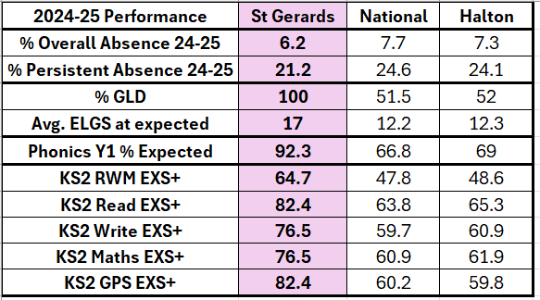

EAL Data:

