l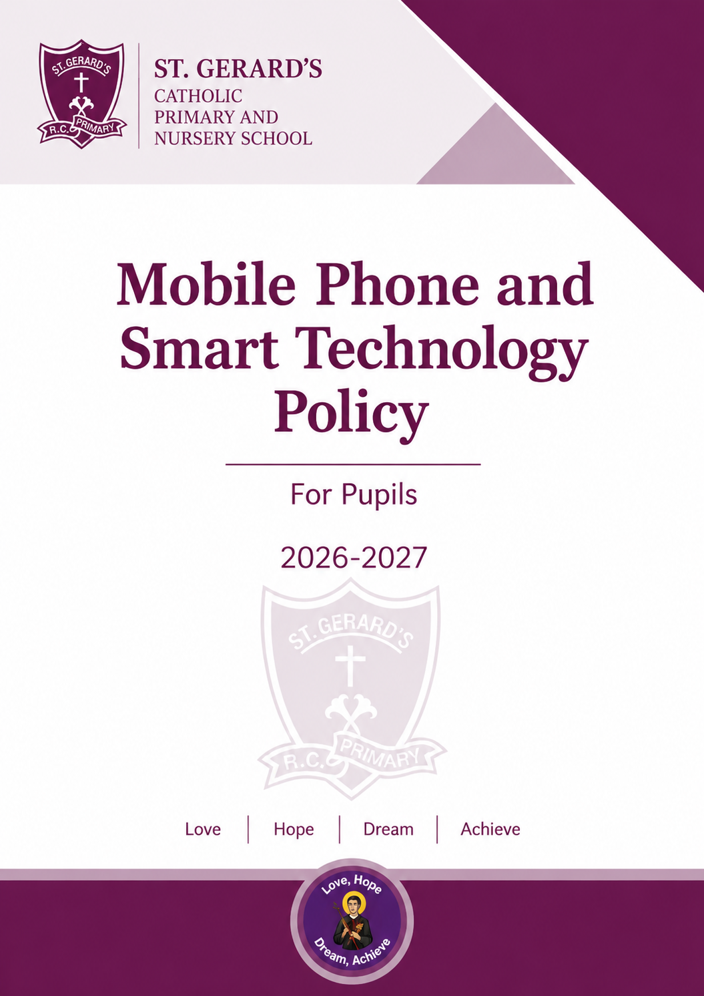


SAFEGUARDING STATEMENT

“St Gerard’s Catholic Primary and Nursery School is committed to safeguarding and promoting the welfare of children and young people and expects all staff and volunteers to share this commitment”.

MOBILE PHONE AND SMART TECHNOLOGY POLICY
For pupils | 2026–2027
St Gerard’s Catholic Primary and Nursery School, Widnes
Policy information
SAFEGUARDING STATEMENT
“St Gerard’s Catholic Primary and Nursery School is committed to safeguarding and promoting the welfare of children and young people and expects all staff and volunteers to share this commitment.”
1. Introduction
St Gerard’s Catholic Primary and Nursery School is a mobile phone-free environment by default. This policy sets out how the school prohibits pupils’ use of mobile phones and other smart technology throughout the school day, while allowing carefully managed exceptions where required for disability, medical need, safeguarding or other individual circumstances.
The policy has been updated to reflect the Department for Education’s statutory guidance ‘Mobile phones in schools’, which schools should follow from 1 September 2026.
2. Aims
protect pupils’ safety, privacy and wellbeing;
reduce distraction, disruption, bullying and inappropriate online activity;
support calm, purposeful learning and positive relationships;
make expectations clear and consistent for pupils, parents, carers and staff;
ensure lawful and proportionate arrangements for pupils who need access to a device.
3. Scope and definitions
This policy applies to all pupils, including Nursery and the two-year-old provision, while pupils are on the school site, during the school day, on school-organised transport and on educational visits unless a visit-specific arrangement has been approved.
In this policy, ‘mobile phone’ also includes smart watches and other personal communication or smart devices capable of sending or receiving calls, messages or notifications, accessing the internet, or recording audio, photographs or video. School-owned devices used under staff supervision are not covered by the prohibition.
4. Core rule: no pupil access during the school day
Pupils must not use or have access to a mobile phone or included smart device at any point during the school day. This includes before registration once on the school site, lessons, movement between activities, assemblies, breaktimes, lunchtimes, clubs taking place immediately after school, and dismissal until the device has been returned.
Pupils should not normally bring a mobile phone or smart device to school.
A device may only be brought in where the school has agreed a specific need, normally because a pupil travels to or from school independently, or because an approved exception applies.
Any permitted device must be switched off before the pupil enters the school grounds and handed to the school office or designated senior member of staff immediately on arrival.
Devices will be stored securely and must not remain in a pupil’s bag, pocket, coat or classroom tray.
The device will be returned only at the agreed collection point at the end of the school day.
Pupils must not use smart watches for calls, messaging, notifications, internet access, photography, audio or video recording. Where a watch cannot be placed in an appropriate school mode, it must be handed in with mobile phones.
5. Exceptions and reasonable adjustments
Exceptions are considered individually and must be authorised by the Headteacher or a delegated senior leader. An exception does not create unrestricted access: the school will agree the purpose, time, place, supervision and storage arrangements.
Disability or special educational need, where access is a reasonable adjustment.
Medical need, including technology linked to monitoring or managing a condition, such as continuous glucose monitoring.
Safeguarding, young-carer or exceptional family circumstances.
A short, supervised activity specifically approved by a member of staff.
Where possible, agreed arrangements will be recorded in the pupil’s individual healthcare plan, SEND support plan, safeguarding plan or other relevant school record and reviewed regularly.
6. Contact between home and school
Parents and carers must contact the school office if they need to pass an urgent message to a pupil. Pupils who need to contact home must speak to a member of staff and use the school’s communication arrangements. Parents should not call, message or track pupils through a personal device during the school day.
7. Photography, recording and online conduct
Pupils must not photograph, film or record any person on the school site using a personal device.
Pupils must not use a personal device to access social media, games, messaging, artificial intelligence services or online content during the school day.
Any concern involving images, recordings, sexual content, bullying, harassment, harmful content or suspected criminal behaviour will be managed under safeguarding, behaviour and online-safety procedures and may be referred to external agencies.
8. Breaches, confiscation and sanctions
The school will respond consistently, proportionately and in line with the Behaviour Policy. Staff may confiscate a device where a pupil breaches this policy.
The device will be switched off, stored securely and normally returned to a parent or carer rather than directly to the pupil.
For a first or minor breach, the school will record the incident, remind the pupil of expectations and contact home where appropriate.
Repeated, deliberate or serious breaches may lead to loss of permission to bring a device, a parental meeting and further sanctions under the Behaviour Policy.
The school may retain a device for a reasonable period where this is necessary to investigate a safeguarding or behaviour concern.
Where staff reasonably suspect that a prohibited item or evidence of a serious incident is present, any search will be carried out only by authorised staff and in accordance with the school’s Behaviour Policy and current statutory guidance.
The school will not routinely search the digital contents of a device. Advice will be sought where there is a safeguarding concern, suspected crime or risk of harm.
9. Loss, damage and security
Personal devices are brought to school at the owner’s risk. The school will take reasonable care of devices handed in under this policy, but cannot accept responsibility for loss, theft, damage or data charges except where liability arises under law. Devices should be clearly labelled and protected by a case. Parents should ensure that suitable insurance and security settings are in place.
10. Roles and responsibilities
The Governing Body will:
approve and monitor this policy and ensure it aligns with statutory duties;
support consistent implementation and review.
The Headteacher and senior leaders will:
publish and communicate the policy, including exceptions and sanctions;
ensure secure collection, storage and return arrangements;
authorise and review individual exceptions;
ensure staff apply the policy consistently.
Staff will:
model professional behaviour and avoid personal mobile phone use in front of pupils during the school day, except where authorised for work, safeguarding, medical or emergency purposes;
challenge breaches consistently and follow agreed confiscation and safeguarding procedures;
use school-approved equipment and systems for photographs, recordings and communication wherever required.
Parents and carers will:
support the mobile phone-free approach and discuss the rules with their child;
apply for permission before a pupil brings a device to school;
avoid contacting or tracking their child through a device during the school day;
collect a confiscated device when requested and inform the school of relevant medical, disability or safeguarding needs.
Pupils will:
follow the core rule and hand in any authorised device immediately on arrival;
never use another pupil’s device or bring an undeclared device;
report concerns about mobile phones, recordings, messages or online behaviour to a trusted adult.
11. Education and prevention
The school will teach age-appropriate online safety through the curriculum and wider safeguarding work. Teaching will include privacy, consent, image sharing, cyberbullying, harmful content, scams, screen time, digital wellbeing, reporting concerns and the effect of online actions on others.
12. Communication, publication and review
The policy will be published on the school website and communicated to pupils, parents, carers and staff. Expectations and consequences will be revisited at the beginning of each academic year and at appropriate intervals. The policy will be reviewed annually, after a significant incident, or when legislation or statutory guidance changes.
13. References
Department for Education, Mobile phones in schools (statutory guidance, updated 29 June 2026; to be followed from 1 September 2026).
Department for Education, Behaviour in schools.
Department for Education, Keeping children safe in education 2026.
Department for Education, Supporting pupils at school with medical conditions.
Equality Act 2010 and Children and Families Act 2014.
Parent/carer request for a pupil to bring a mobile phone
This form is required only where a pupil needs to bring a mobile phone to school. Permission is not automatic and may be withdrawn if the policy is not followed.
I/We confirm that:
☐ the device will be switched off before entering the school grounds;
☐ the pupil will hand the device to the school office/designated member of staff immediately on arrival;
☐ the pupil will not access or use the device during the school day unless an approved exception applies;
☐ the device is brought to school at the owner’s risk;
☐ the school may confiscate the device and require collection by a parent/carer if the policy is breached;
☐ I/We will inform the school promptly if the need or device details change.
St Gerard’s Catholic Primary and Nursery School | Lugsdale Road, Widnes, WA8 6DD | 0151 424 2879

