
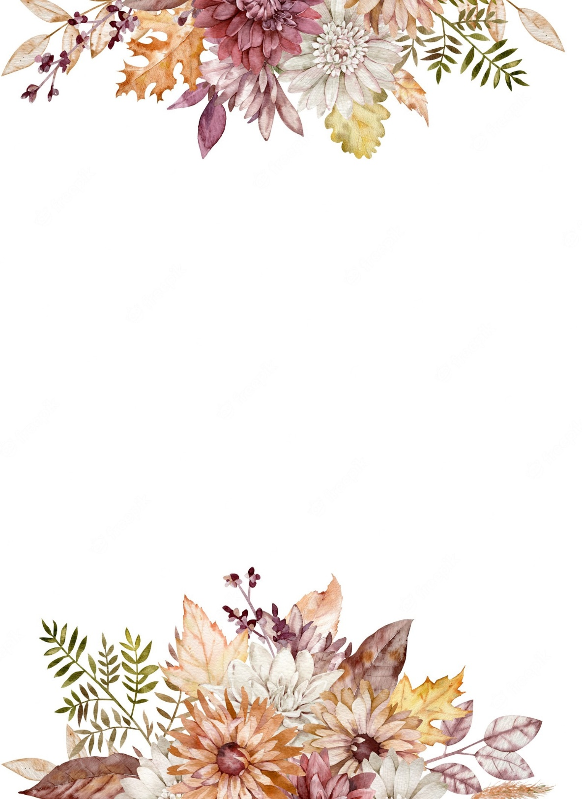
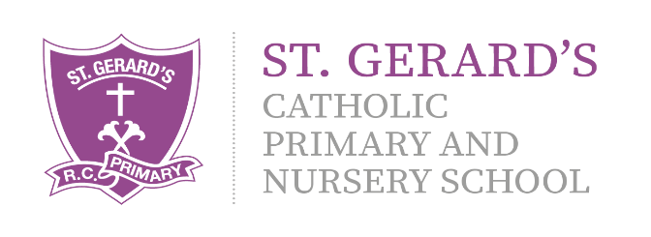


Art and DT
During Autumn 1, children will learn about the work of artist, LS Lowry. We will explore his work and use his techniques to develop our own piece. Autumn 2 will give children the opportunity to enhance skills within Design and Technology, exploring the work of British Inventors.
Important Information:
Multiplication Check – June 2027. In Year 4, children will take part in a ‘Multiplication Check’ in Summer term. Alongside lessons in class, children will be set a piece of homework focusing on their times tables. Children can also use a variety of websites at home to develop their fluency.
https://ttrockstars.com/ https://www.topmarks.co.uk/

B
Religious Education – RED:
This term we will be starting our journey in RE within the‘Religious Education Directory’ (RED Curriculum) Our branches of study are ‘Creation and Covenant’ and ‘Prophecy and Promise’.

Computing:
E-Safety is a focus in all Computing lessons. It is important that the children understand the safety rules both at school and at home. ICT will be used through all the subject areas, using the laptops and iPads to enhance skills and learning. This term, our topics are My Online Life and Wizard School.

Year 4 Curriculum Information

Autumn Term 2026

"Our school is a place of learning within a loving and Christian community. We achieve this through our mission statement: "Guided by God, St Gerard's is an inspiring and aspirational community where we learn to love, hope, dream and achieve. All staff, children, governors and parents contribute to school life and share in its growth and well-being."

Mrs Hanna (Class Teacher)
Mrs Long (Classroom Assistant)

We are looking forward to an exciting term with fantastic learning and opportunities!
If you have any questions or queries regarding this curriculum leaflet, please feel free to contact us on Dojo.
Mrs Hanna & Mrs Long
Science:
We will be investigating ‘Eating and Digestion’, focusing on the Digestive System, as well as living things and their habitats. We will also explore ‘States of Matter’, focusing on properties of materials and their changes.




Geography:
Children will explore the topic of ‘Countries of the World’ in Autumn 1. Within this, children will build on their mapping skills, as well as developing their understanding of human and physical geography elements within the world.
PSHE, RSHE & British Values:
During Autumn Term, we will focus on two topics within our PSHE lessons: Me and My Relationships, which explores healthy relationships with ourselves and others, and Valuing Difference, exploring how we respect and celebrate our differences and understanding and challenging stereotypes.

English:
Throughout the Autumn term, we will be incorporating vocabulary, grammar, punctuation and spelling into all lessons using the Pathways to Write scheme. We will explore two texts: ‘Counting on Katherine’, which focuses on developing information and recount writing, followed by ‘Leon and the Place Between, which focuses on writing diary entry.

History:
The children will explore the topic of British History Heroes’ in Autumn 2. This will enable the children to identify and develop understanding of a range of significant figures who have made an impact in our lives.

Music:

Throughout the Autumn term, children will develop their musical skills within the Kapow Music Curriculum. This term, the children will explore Musical Motifs and the Sounds of China.

Physical Education:
Children will take part in a PE lesson each week with Mr Firkins, our PE coach. This term, the children will be developing their skills in rugby, netball and hockey.

Mathematics:
Throughout Autumn term, we will focus on key areas such as Number and Place Value, Addition, Subtraction, Multiplication and Division. Children will be constantly applying their learning using problem-solving in real life contexts in order to developing a mastery approach to Mathematics.

