

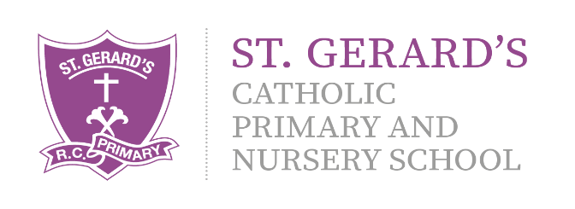
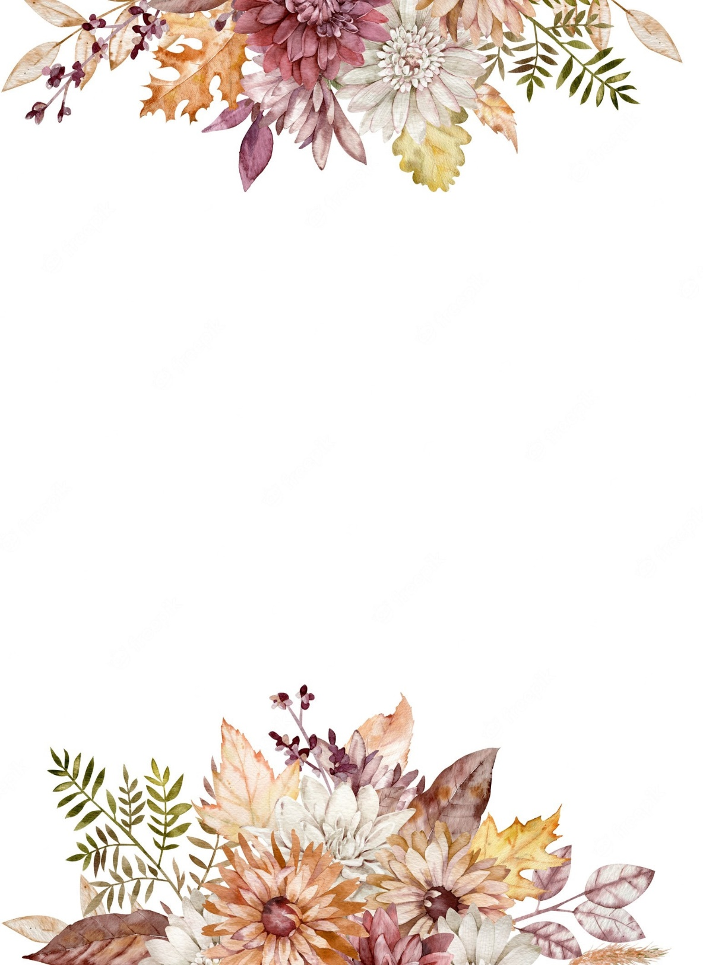
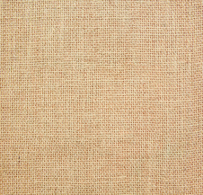
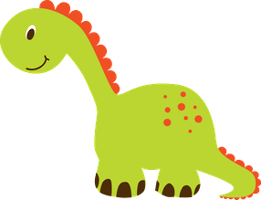
Art & Design
- Colour Creations – to identify different colours, including primary and secondary, mixing colours to make others. To create work based on Kandinsky’s work.
- Puppets – to design and make a puppet for a purpose, using basic sewing skills.

Physical Education

- PE will take place with Mr Firkins each Wednesday. Please ensure your child has the appropriate school kit and water bottle.

Religious Education:

We are beginning the new Liverpool Archdiocese RED programme this term! Branch 1 is all about ‘Creation and Covenant,’ the children will be learning all about Noah’s Ark and how we can be stewards of creation. In Autumn 2 we will focus on ‘Prophecy and Promise’ and the season of Advent!

Year 2 Curriculum Information

Autumn Term

"Our school is a place of learning within a loving and Christian community. We achieve this through our mission statement: "Guided by God, St Gerard's is an inspiring and aspirational community where we learn to love, hope, dream and achieve. All staff, children, governors and parents contribute to school life and share in its growth and well-being."

Mrs Johnson and Mrs Farrell (Class Teachers)
Mrs Scott (Classroom Assistant)

Homework will be set via MyMaths every Friday and is to be completed by the following Thursday. Reading books are to be read 3 times before they are changed. Please send them in every Friday to be changed. We will keep you updated via X (Twitter) and Class Dojo. Please ensure that you are connected on Class Dojo and that you check it for updates regularly. If you have any questions, then please do not hesitate to ask!

Computing

- My online life (Digital Literacy), linking to E-safety and using internet linked devices with confidence.
- Code a story – coding using the Scratch app

Geography
- Our topic for the Autumn term is ‘Map Makers’ in which we will be looking at a range of geographical images, atlases and software as well as going on local area walks and recognising the Geography around us.
- Use of ICT software (such as Google Maps), the symbols they use, aerial pictures.
We have lots of exciting learning taking place in the Autumn term, detailed in this leaflet, as well as some fantastic extra experiences including theatre trips, a visit to Chester Zoo, a Lego workshop and our annual Harvest festival celebration which Y2 will be leading!




Music

- Music from South Africa, freedom songs
- Listening and appraising – how does music make us feel? What do we notice?
- Performing and sharing music with others.
- Winter time, festivals and Christmas time

Science
- Materials – naming a range of different materials and describing their properties, considering why they have been picked.
- Material suitability considering properties and purpose.
English
Daily Read Write Inc phonics reading sessions and guided reading will take place each morning!

We will be following the Pathways to Write programme, using the texts ‘Troll Swap’ to write exciting narrative stories with a focus on expanded noun phrases. We will then look at writing non chronological reports using the text ‘The Owl Who was Afraid of the Dark.’
History
- Our History topic for the term is ‘The Gunpowder Plot’ and the story of Guy Fawkes!
- Events, people and changes – comparing past and present, how have our lives changed?
- Chronology - putting key events into order.
- Florence Nightingale – timelines
- Mary Seacole – timelines

PSHE, RSHE & British Values

- E-safety
- Understand what diversity is
- Understand how we share the world with others
- Friendship and equality
- Who we are matters and what we do matters
- Cycle of life- we are created by God
Mathematics:

- Number, specifically addition and subtraction with numbers up to 100. We will use lots of resources to support us!
- The Number System – portioning and place value, recognising the value of digits, tens and ones.
- Active Maths through PE

