
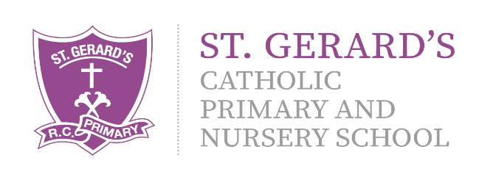
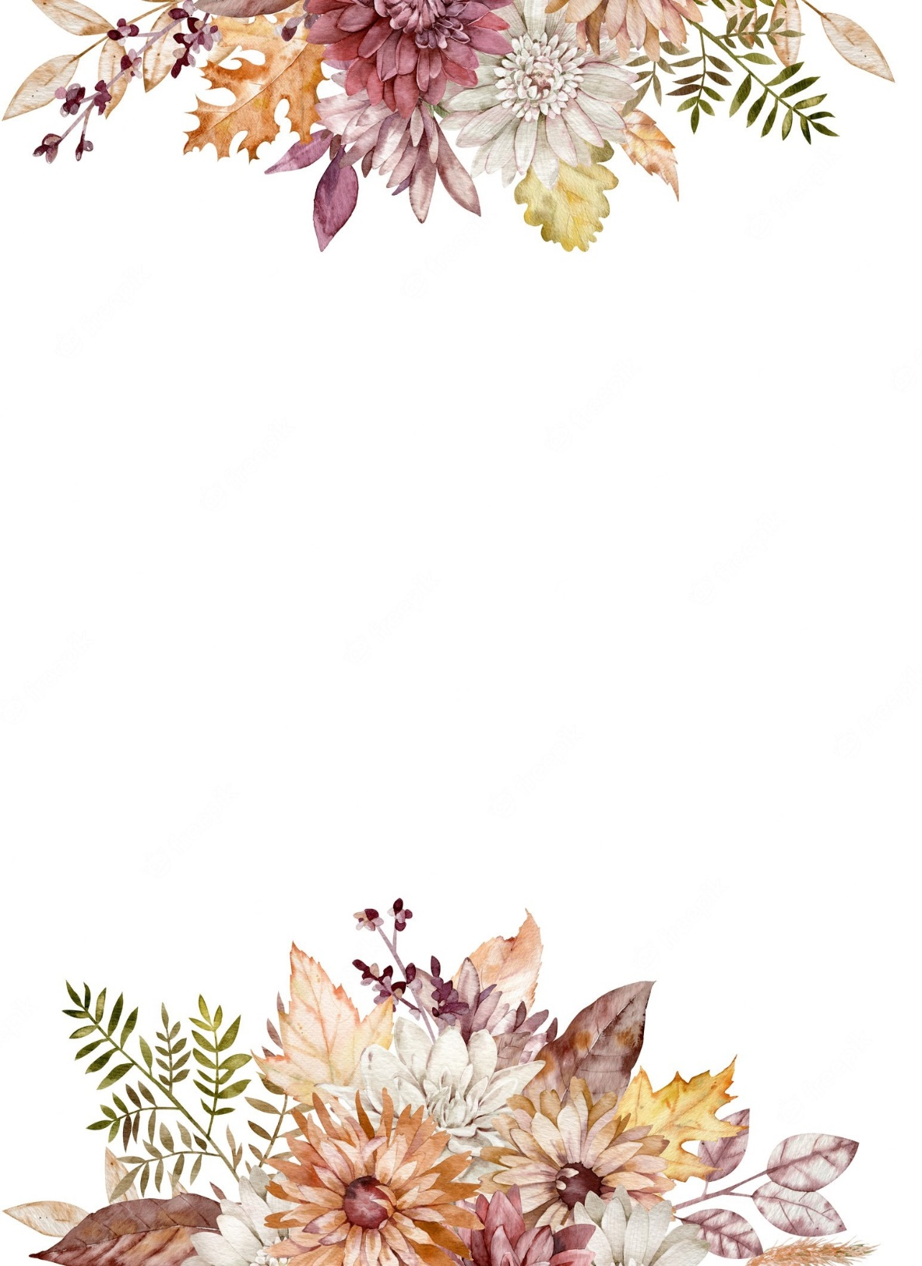


Art & Design

- Andy Goldsworthy – developing children’s understanding of art in NATURE! We will be doing outdoor learning within this topic.
- DT – Perfect Pizzas – developing children’s food handling skills, understanding of healthy eating and chopping, peeling and cooking skills.

Computing

- Introducing AI – developing children’s understanding of artificial intelligence and its role in our lives.
- Online Buddies – reinforcing internet safety.

Religious Education:

This year, we begin the brand new 'To Know You More Clearly' Religious Education Directory. This term, we are looking at the fourth and fifth branches, looking at the theme of Easter and Pentecost.
As always, we will continue our daily prayer and liturgy sessions. These will take place both in class, and together as a KS1 family - gathering together to spend time listening to God's special word.

Physical Education

- PE will take place with Mr Firkins each Wednesday. Please ensure your child has the appropriate school kit and water bottle.
Swimming is in SUMMER 1, every TUESDAY!

Homework will be set via MyMaths every Friday and is to be completed by the following Thursday. Reading books are to be read 3 times before they are changed. Please send them in every Friday to be changed. We will keep you updated via X (Twitter) and Class Dojo. Please ensure that you are connected on Class Dojo and that you check it for updates regularly. If you have any questions, then please do not hesitate to ask!

Year 2 Curriculum Information

Summer Term 2026

"Our school is a place of learning within a loving and Christian community. We achieve this through our mission statement: "Guided by God, St Gerard's is an inspiring and aspirational community where we learn to love, hope, dream and achieve. All staff, children, governors and parents contribute to school life and share in its growth and well-being."

Mrs Johnson and Mrs Farrell (Class Teachers)
Mrs Scott (Classroom Assistant)

We have lots of exciting learning taking place in the Summer term, detailed in this leaflet, as well as some fantastic extra experiences including our annual Infant Music Festival trip and Outdoor Learning provision! We will provide more information on this as the term goes on.
Geography
- Our topic for the Summer term is ‘Seas and Coasts’ We will be looking at the continents and oceans, identifying their locations on maps. Comparing Britain to a non-European location and recognising how to use a compass.

Music

- Using our Charanga Programme, we will be looking at the units ‘Friendship Song’ and ‘Reflect, rewind and replay.’ We will be developing our understanding of playing tuned and untuned instruments and concentrating and understanding a range of recorded music, experimenting and creating using different sounds.

History
- Our History topic for the term is ‘Seaside Holidays in the Past.’
- We will be focusing on comparing the past to the modern day, recognising similarities and differences and looking at how life has changed. We will be finding out what seaside holidays were like 100 years ago!
Science
- Plants
- We will be participating in outdoor learning with Mrs Scott, growing our own plants from seed and working in our garden area. We will be developing our understanding of what plants need to grow and thrive.
English
Daily Read Write Inc phonics reading sessions and guided reading will take place each morning!

We will be following the Pathways to Write programme, using the texts ‘Tidy’ by Emily Gravett and ‘The Tempest’ by Shakespeare. We will be writing a range of different genres, developing our spelling and grammar skills as we go along.
Mathematics:
We will continue to use the PowerMaths programme to develop our skills in:

- Multiplication and division and using these schools to solve problems, relating them to our times tables.
- Developing our understanding of money, length, height, mass, temperature and capacity as well as also looking at time.
- Active Maths through PE

PSHE, RSHE & British Values

- E-safety
- Being My Best – looking at how we can approach challenging learning experiences with positivity, thinking about choices, being healthy and hygienic and the functions of our organs.
- Growing and Changing – recognising the scientific names for body parts and their functions, how we grow and change over time and body safety rules.

