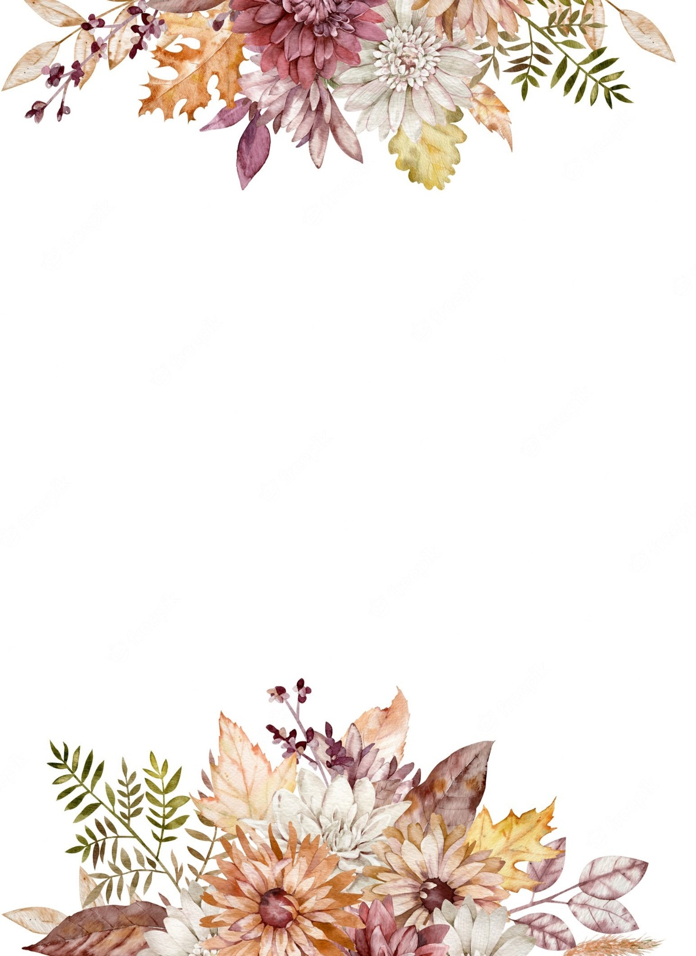
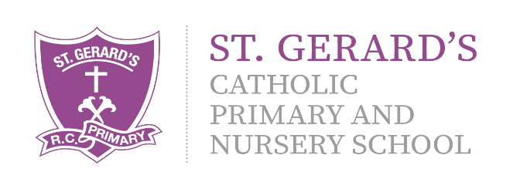


Important Information:
Multiplication Check – June 2026. In Year 4, children will take part in a ‘Multiplication Check’ in Summer term. Alongside lessons in class, children will be set a piece of homework focusing on their times tables. Children can also use a variety of websites at home to develop their fluency.
https://ttrockstars.com/ https://www.topmarks.co.uk/

B
Religious Education – RED:
This term, we will be continuing to explore our skills and knowledge in the RED curriculum. Branch 5 is To the Ends of the Earth and Branch 6 is Dialogue and Encounter.

Computing:
E-Safety is a focus in all Computing lessons. It is important that the children understand the safety rules both at school and at home. ICT will be used through all the subject areas, using the laptops and iPads to enhance skills and learning. This term, our topics are Real or Fake Online and Game Designers.

Art and DT
During Summer 1, children will learn about Pop Art. We will be learning about Andy Warhol, and the impact his work had on our society. Summer 2 will give children the opportunity to enhance skills within Design and Technology, exploring Mini Greenhouses.

Year 4 Curriculum Information

Summer Term 2026

"Our school is a place of learning within a loving and Christian community. We achieve this through our mission statement: "Guided by God, St Gerard's is an inspiring and aspirational community where we learn to love, hope, dream and achieve. All staff, children, governors and parents contribute to school life and share in its growth and well-being."

Mrs Hanna (Class Teacher)
Mrs Mousdell (Classroom Assistant)

We are looking forward to an exciting term with fantastic learning and opportunities!
If you have any questions or queries regarding this curriculum leaflet, please feel free to contact us on Dojo.
Mrs Hanna and Mrs Mousdell
Science:
We will be investigating ‘Living things and their habitats’, exploring different groups of species and where they live. In Summer 2, we will find out about different types of scientists in our topic of ‘What Do Scientists Do?’


PSHE, RSHE & British Values:
During Summer Term, we will focus on two topics within our PSHE lessons: Being My Best and Growing and Changing.

English:
Throughout the Summer term, we will be incorporating vocabulary, grammar, punctuation and spelling into all lessons using the Pathways to Write scheme. We will explore two texts: Where the Forest Meets the Sea, which focuses on non-chronological report writing followed by Julius Caesar, which focuses on developing a play script.

Geography:
Children will explore the topic of ‘Save the Orangutan in Summer 1. This topic will focus on the species of the orang-utan, and the effect that we, and society, have on their habitats and ecosystem.
History:
The children will explore the topic of ‘Anglo-Saxons and Celts’ in Summer 2. This will enable the children to identify and develop understanding of this period of history and the impact it had on the world.

Music:

Throughout the Summer term, we will continue to work with Mrs McElroy from the Archdiocese Singing Programme. During our weekly lessons, we will explore different musical vocabulary and knowledge.

Physical Education:
Children will take part in a PE lesson each week with Mr Furkins, our PE coach. This term, the children will be developing their skills in Athletics and Strike and Field.

Mathematics:
Throughout Summer term, we will focus on key areas such as Decimals, Time, Money and Shape. Children will be constantly applying their learning using problem-solving in real life contexts in order to developing a mastery approach to Mathematics.

