
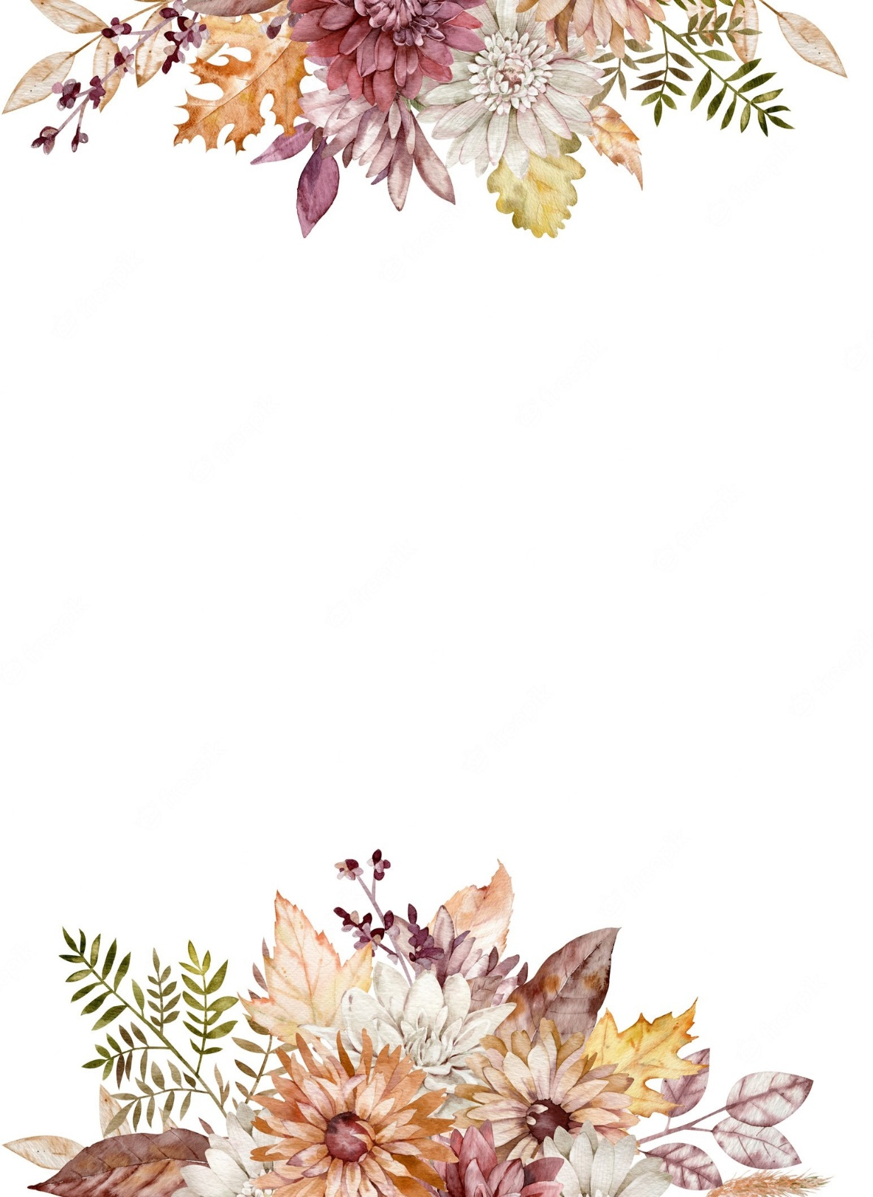
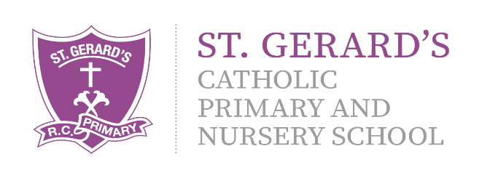


Important Information:
Multiplication Check – June 2026. In Year 4, children will take part in a ‘Multiplication Check’ in Summer term. Alongside lessons in class, children will be set a piece of homework focusing on their times tables. Children can also use a variety of websites at home to develop their fluency.
https://ttrockstars.com/ https://www.topmarks.co.uk/

B
Religious Education – RED:
This term, we will be continuing to explore our skills and knowledge in the RED curriculum. Branch 3 is Galilee to Jerusalem and Branch 4 is Desert to Garden.

Computing:
E-Safety is a focus in all Computing lessons. It is important that the children understand the safety rules both at school and at home. ICT will be used through all the subject areas, using the laptops and iPads to enhance skills and learning. This term, our topics are Dinosaurs and Wizard School.

Art and DT
During Spring 1, children will learn about Roman Mosaics. We will explore line, pattern and colour and use these techniques to develop our own piece. Spring 2 will give children the opportunity to enhance skills within Design and Technology, exploring Seasonal Food.

Year 4 Curriculum Information

Spring Term 2026

"Our school is a place of learning within a loving and Christian community. We achieve this through our mission statement: "Guided by God, St Gerard's is an inspiring and aspirational community where we learn to love, hope, dream and achieve. All staff, children, governors and parents contribute to school life and share in its growth and well-being."

Mrs Hanna (Class Teacher)
Mrs Mousdell (Classroom Assistant)

We are looking forward to an exciting term with fantastic learning and opportunities!
If you have any questions or queries regarding this curriculum leaflet, please feel free to contact us on Dojo.
Mrs Hanna and Mrs Mousdell
Science:
We will be investigating ‘Sound’, focusing on vibrations and how sound is created. We will also explore Electricity in Spring 2.




PSHE, RSHE & British Values:
During Spring Term, we will focus on two topics within our PSHE lessons: Keeping Safe and Rights and Respect.

English:
Throughout the Spring term, we will be incorporating vocabulary, grammar, punctuation and spelling into all lessons using the Pathways to Write scheme. We will explore two texts: Escape to Pompeii, which focuses on historical narrative writing followed by Wisp, which focuses on developing recount writing.

Geography:
Children will explore the topic of Volcanoes in Spring 1. Within this, children will build on their mapping skills, as well as developing their understanding of human and physical geography elements within the world.
History:
The children will explore the topic of ‘The Romans’ in Spring 2. This will enable the children to identify and develop understanding of the Roman Empire and the impact it had on world history.

Music:

Throughout the Spring term, children will develop their musical skills within the genre of pop through ‘Stop’ and ‘Lean on Me’, as well as building their confidence in reading and performing pieces of music on instruments such as glockenspiels.

Physical Education:
Children will take part in a PE lesson each week with Mr Furkins, our PE coach. This term, the children will be developing their skills in invasion games and OAA.

Mathematics:
Throughout Spring term, we will focus on key areas such as Multiplication and Division, Length and Perimeter and Fractions. Children will be constantly applying their learning using problem-solving in real life contexts in order to developing a mastery approach to Mathematics.

