
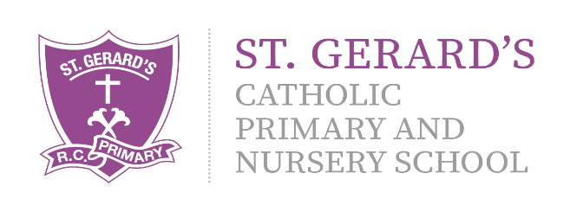
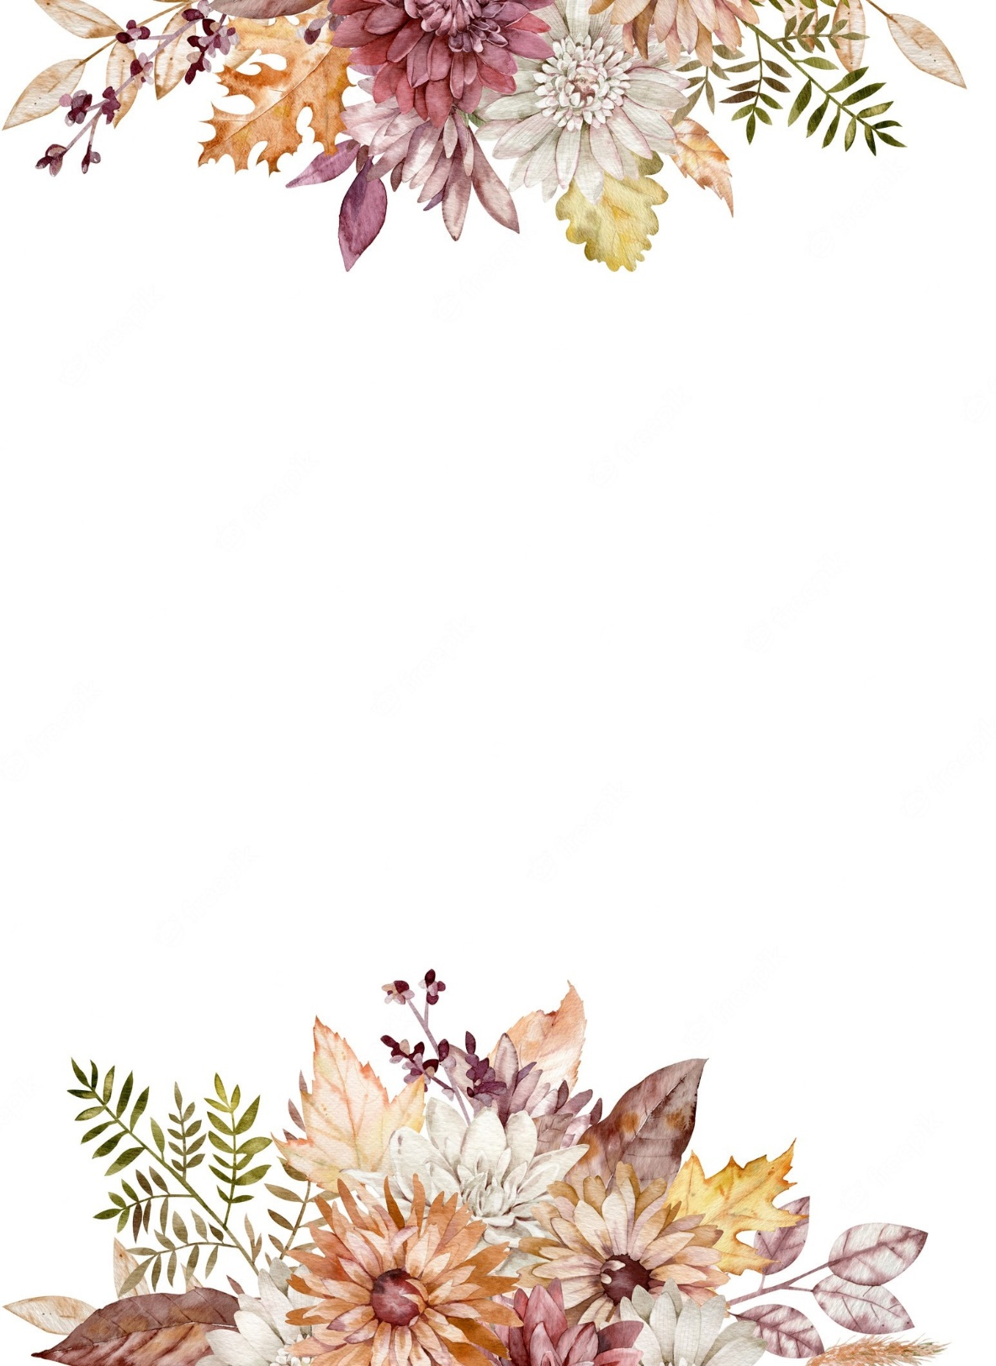
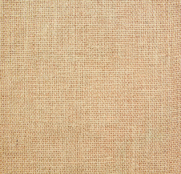

Religious Education:

This year, we begin the brand new 'To Know You More Clearly' Religious Education Directory. This term, w are looking at the third and fourth branches. The third branch topic is 'Galilee to Jerusalem.' The children will be encouraged to explore their personal faith through a wide range of creative and engaging activities that allow them to be curious and reflect and connect with their own spirituality.
As always, we will continue our daily prayer and litrugy sessions. These will take place both in class, and together as a KS1 family - gathering together to spend time listening to God's special word.

Physical Education

- PE will take place with Mr Firkins each Wednesday. Please ensure your child has the appropriate school kit and water bottle.

Computing

- Presenting and typing – developing children’s digital literacy skills, using powerpoint to edit, type, copy paste and save work.
- Make a Game – using Scratch Junior to create game programmes.

Homework will be set via MyMaths every Friday and is to be completed by the following Friday. Reading books are to be read 3 times before they are changed. Please send them in every Friday to be changed. We will keep you updated via X (Twitter) and Class Dojo. Please ensure that you are connected on Class Dojo and that you check it for updates regularly. If you have any questions, then please do not hesitate to ask!

Art & Design

- Australian Aboriginal Art – linking to our Geography topic, we will be looking at aboriginal art and the skills of cross hatching and dot style art.
- Puppets – creating socks puppets using textile skills to sew and stick materials together.

Year 2 Curriculum Information

Spring Term 2026

"Our school is a place of learning within a loving and Christian community. We achieve this through our mission statement: "Guided by God, St Gerard's is an inspiring and aspirational community where we learn to love, hope, dream and achieve. All staff, children, governors and parents contribute to school life and share in its growth and well-being."

Mrs Johnson and Mrs Farrell (Class Teachers)
Mrs Scott (Classroom Assistant)

Geography
- Our topic for the Spring term is ‘Let’s Visit Australia!’ We will be looking at the Geography of Australia and its climate. We will compare this to the geography of the UK!
We have lots of exciting learning taking place in the Spring term, detailed in this leaflet, as well as some fantastic extra experiences including our annual class residential trip to Fox Howl in Delamere Forest! We will provide more information on this as the term goes on.

History
- Our History topic for the term is ‘Intrepid Explorers.
- We will be focussing on Christopher Columbus and Neil Armstrong, their achievements and the impact that this has had on the modern world.
- We will be going on our OWN adventure, exploring DELAMERE forest!

Music

- Using our Charanga Programme, we will be looking at the units ‘I want to play in a band’ and ‘Zoo time.’ We will be developing our understanding of rhythm, pulse, tempo and dynamics using our voices and playing tuned and un-tuned instruments.

Science
- Growth and survival.
- We will be looking at animals and their offspring including how humans grow from babies into adults. We will look at what we need to survive and how our environment affects this. We will look at how we can stay healthy through diet, exercise and safe use of medicines.
English
Daily Read Write Inc phonics reading sessions and guided reading will take place each morning!

We will be following the Pathways to Write programme, using the texts ‘The Dragon Machine’ to write exciting narrative stories with a focus on expanded noun phrases. We will then look at writing diary entry reports using the text ‘Major Glad, Major Dizzy.’
Mathematics:
We will continue to use the PowerMaths programme to develop our skills in:

- Multiplication and division and using these schools to solve problems, relating them to our times tables.
- Developing our understanding of money, length, height, mass, temperature and capacity.
- Active Maths through PE

PSHE, RSHE & British Values

- E-safety
- Understand what diversity is
- Understand how we share the world with others
- Friendship and equality
- Who we are matters and what we do matters
- Cycle of life- we are created by God

