Pupil premium strategy statement
Prospect Vale Primary School

This statement details our school’s use of pupil premium funding to help improve the attainment of our disadvantaged pupils.
It outlines our pupil premium strategy, how we intend to spend the funding in this academic year and the outcomes for disadvantaged pupils last academic year.

School overview
Detail | Data
Number of pupils in school | 218
Proportion (%) of pupil premium eligible pupils | 18%
Academic year/years that our current pupil premium strategy plan covers | 2024-2027
Date this statement was published | December 2025
Date on which it will be reviewed | December 2026
Statement authorised by | Luke Redfearn
Pupil premium lead | Luke Redfearn
Governor / Trustee lead | To discuss

Funding overview
Detail | Amount
Pupil premium funding allocation this academic year | £57,570
Pupil premium funding carried forward from previous years (enter £0 if not applicable) | £0
Total budget for this academic year  If your school is an academy in a trust that pools this funding, state the amount available to your school this academic year | £57,570 (increase in amount of spend per pupil)

Part A: Pupil premium strategy plan

Statement of intent
It is our intent that all children and succeed and make good progress at Prospect Vale Primary School. There is a more deliberate focus on ensuring that our disadvantaged pupils make accelerated progress and achieve these high expectations, regardless of their academic ability of background.
The three core aims in our pupil premium strategy’s intent are:
- Our disadvantaged children’s mental health and well-being is as secure as non-disadvantaged children.
- Our disadvantaged children have regular experiences in school which match those of our non-disadvantaged children outside of school. These experiences build their confidence and resilience so that they enter the next phase of their education at no disadvantage amongst their peers.
- Our disadvantaged children experience high-quality teaching, which is focussed on the areas that our disadvantaged need the most support in.

Challenges
This details the key challenges to achievement that we have identified among our disadvantaged pupils.
Challenge number | Detail of challenge
1 | A robust assessment system is not in place to accurately track progress made by our disadvantaged cohort.
2 | Assessments, observations, and discussions with pupils suggest disadvantaged pupils generally have greater difficulties with phonics than their peers. This negatively impacts their development as readers.
3 | Our observations and discussions with pupils and families have identified social and emotional issues for many pupils, notably due a lack of enrichment opportunities outside of school. These challenges particularly affect disadvantaged pupils, including their attainment.
4 | Our observations reveal that a consistently applied behaviour model is not employed in the school. Moving around school, unstructured playing at breaks times, collective activities like assemblies and the learning environment is observed to create anxieties in vulnerable children including disadvantaged children.
5 | Families who are eligible for pupil premium funding are not applying.

Intended outcomes
This explains the outcomes we are aiming for by the end of our current strategy plan, and how we will measure whether they have been achieved.
Intended outcome | Success criteria
Improved maths and reading attainment for disadvantaged pupils at the end of KS1 and KS2. | Maths and reading outcomes for children at key milestones (end of Reception, KS1 and KS2) of disadvantaged children all show positive progress measures.
All disadvantaged children start KS2 with a solid comprehension of phonics and how to read. | An embedded phonics scheme that matches the needs of our disadvantaged community. Disadvantaged outcomes on the phonics screening check is more in line with national average expectations.
Achieve and sustain improved wellbeing for all pupils in our school through meaningful, spiritually uplifting experiences. | Substantial increase in the participating of enriching experiences, particularly among disadvantaged pupils.  Opportunities are available to disadvantaged build their cultural capital.
Vulnerable children, including disadvantaged pupils, experience reduced anxiety during all aspects of the school day. | The school fosters a culture of acceptance and actively promotes making the right choices.  Positive and calm behaviours are celebrated, encouraging all pupils, including disadvantaged children, to maximise their learning opportunities.  Pupils demonstrate improved resilience, collaboration, and social skills, aligned with the school ethos, preparing them effectively for the next stage of their education.
Greater identification of children who fit this category. | There will be an increase in the amount of families on our PPG register.  Deputy Head to liaise with our data team to target families in deprived areas and check they eligible families are identified sooner.

Activity in this academic year
This details how we intend to spend our pupil premium funding this academic year to address the challenges listed above.

Teaching (for example, CPD, recruitment and retention)
Approximate budgeted cost: £20,000
Activity | Evidence that supports this approach | Challenge number(s) addressed
Purchase of standardised diagnostic assessment.  Pupil progress meetings to discuss impact of teaching. | Standardised tests can provide reliable insights into the specific strengths and weaknesses of each pupil to help ensure they receive the correct additional support through interventions or teacher instruction:  Standardised tests | Assessing and Monitoring Pupil Progress | Education Endowment Foundation | EEF | 1, 3
Have a new DfE validated Systematic Synthetic Phonics programme to secure stronger phonics teaching for all pupils across the school. | Phonics approaches have a strong evidence base that indicates a positive impact on the accuracy of word reading (though not necessarily comprehension), particularly for disadvantaged pupils:  Phonics | EEF (educationendowmentfoundation.org.uk) | 2
Positive behaviour strategies and policy outworked across the school. | Improving Learning Behaviour will mean that children are better prepared for their learning. Positive behaviour strategies will mean that children will self-regulate their learning which has proven to have a profound effect on their development.  https://educationendowmentfoundation.org.uk/education-evidence/guidance-reports/behaviour | 4
Extra adult support for intervention groups focussing improved outcomes in maths and reading. | Improving outcomes in reading and maths through focussed small group sessions aimed at accelerating academic impact.  https://educationendowmentfoundation.org.uk/education-evidence/teaching-learning-toolkit/small-group-tuition | 1
Zones of regulation used consistently in school. | Using targeted support for individual children has a profound effect according to EEF research.  https://d2tic4wvo1iusb.cloudfront.net/production/eef-guidance-reports/behaviour/EEF_Improving_behaviour_in_schools_Summary.pdf

Targeted academic support (for example, tutoring, one-to-one support, structured interventions)
Approximate budgeted cost: £ 20,000
Activity | Evidence that supports this approach | Challenge number(s) addressed
Additional phonics sessions targeted at disadvantaged pupils who require further phonics support. | Phonics approaches have a strong evidence base indicating a positive impact on pupils, particularly from disadvantaged backgrounds. Targeted phonics interventions have been shown to be more effective when delivered as regular sessions over a period up to 12 weeks:  Phonics | Toolkit Strand | Education Endowment Foundation | EEF | 2
Develop a library and create a reading model that travels through KS1 and KS2. | Reading comprehension strategies can improve a child’s learning by up to 6 additional months.  Reading comprehension Strategies EEF | 1
Additional maths sessions targeted at disadvantaged pupils who require support with maths in Year 3, Year 4, Year 5 and Year 6. | Additional tutoring in small groups can make significant difference to the progress in maths.  Small group tuition | Toolkit Strand | Education Endowment Foundation | EEF | 3

Wider strategies (for example, related to attendance, behaviour, wellbeing)
Approximate budgeted cost: £ 17,000
Activity | Evidence that supports this approach | Challenge number(s) addressed
School trips funded aimed at boosting children’s ‘cultural capital’. | Building the ‘cultural capital’ of our disadvantaged children through music is outlined in Ofsted’s inspection update. | 3
Establish outdoor learning for all age groups. | Forest schools offers a unique educational experience that builds children’s confidence, social skills, communication and motivation.  Forest School Research | 3, 4
Whole class programme of musical instrument instruction. | Building the ‘cultural capital’ of our disadvantaged children through music is outlined in Ofsted’s inspection update. | 3

Total budgeted cost: £ 57,000

Part B: Review of the previous academic year

Outcomes for disadvantaged pupils
KS2 Outcomes
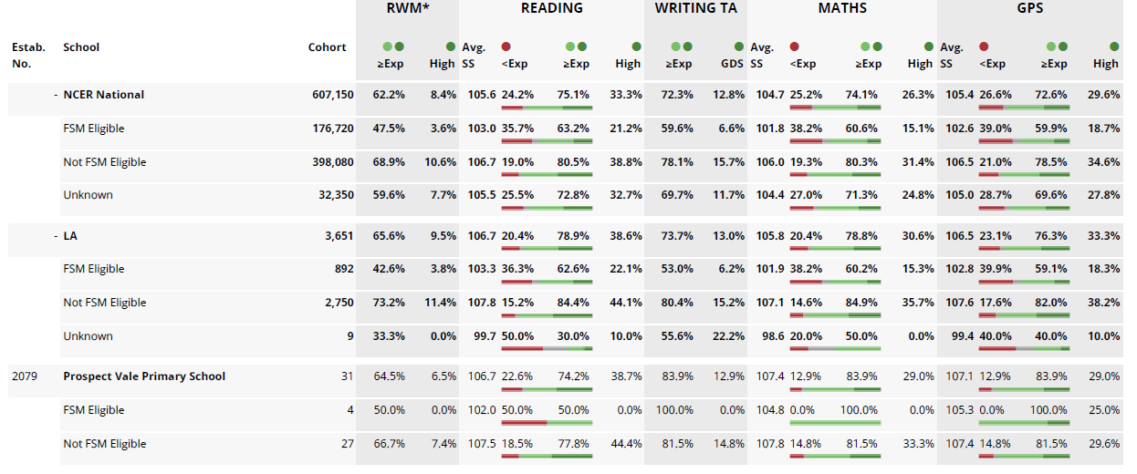
As there are only 4 children in the cohort that are registered as FSM, it is difficult to make statistically relevant conclusions based on such a small sample. However, in reading, we were below the national average for outcomes for reading and we were ahead in outcomes for maths, writing and GPS. We can also still make the following conclusions.
- there is still in a significant gap between the disadvantaged and non-disadvantaged in almost every curriculum area
- we have not fully identified all of our PPG cohort; there are families that are not applying that are likely to be eligible
In Year 3, there are 3 disadvantaged children and 1 made the expected standard in reading.
Phonics Outcomes – there was only one PPG child who sat the phonics screening and they didn’t pass.
EYFS Data – there were no PPG children in the Reception cohort.

