
Year 5 Home Learning: Summer 2 – Week 3
Working together to achieve success’

Hello Year 5, we hope you are all keeping safe and well. Here is our next timetable to continue to support your learning at home. We are really enjoying seeing all of the fantastic work you have been doing with your learning, so please continue to share with us via email at year-5@mossgate.lancs.sch.uk and we will share these on our school’s Facebook page every Tuesday. Thank you to all of the families for taking the time to do this at such a busy time. Please continue to use the email address if you have any questions about the learning as well.
Take care and keep safe.
Mrs Elwers and Mrs Massey.

Daily PE:
Start the day with 20-30 minutes of physical activity. Suggestions include: Joe Wicks Daily PE
lesson Natasha Butler Daily Workout / Just Dance videos in YouTube. Additional physical activity are
uploaded weekly onto our school website at:
https://lancashireschoolgames.co.uk/year-3-6-spar-lancashire-school-games-activity-timetable/

Daily Newsround:
Watch the 5 minute news summary daily at 12:15pm by going to https://www.bbc.co.uk/newsround and click
‘Watch Newsround’ in the top right hand corner. Discuss topical items in the news and research any aspects
which interest – this could be a topic, country or person. Newsround is updated daily. You could even produce
your own news report on one of the topics and share it with us!

Maths:
Go to https://whiterosemaths.com/homelearning/year-5/ to access the video resources. Use the video to help explain the concept and then complete the activity (in your exercise book) which you can access by accessing the school website and following this path: ‘Summer 2 - Home Learning – Week 3 – Year 5’.
 | Monday | Tuesday | Wednesday | Thursday | Friday
Mental Maths | Complete 15 minutes of IDL Numeracy (https://idlsgroup.com/) and/or Times Tables Rocks Stars (https://play.ttrockstars.com/auth/school).
 | You will find the videos and PowerPoint presentations by following the White Rose Maths link https://whiterosemaths.com/homelearning/year-5/ and clicking on Week 5 (w/c 18th May). The sheets required for each day have been downloaded and are accessible by following: ‘Home Learning- Summer 2 – Week 3 – Year 5’.
White Rose Maths | Lesson 1 –  Multiply unit and non-unit fractions by integers | Lesson 2 –  Multiply mixed numbers by integers. | Lesson 3 –  Fractions of amounts | Lesson 4 –  Fractions as operators | Lesson 5 –  Friday challenge

English: Focus theme World War Two
Explore what life was like for people in Britain in World War Two. This week focuses on the start of the war and what life was like for evacuees.
When following links online, parents should monitor that children are remaining on that page only and are keeping safe online.

Also: Complete 15 minutes of IDL Literacy (https://idlsgroup.com/) daily which develops spelling, comprehension and keyboard skills.
Mon | Explore key facts about World War Two by watching and reading these two sources, making notes as you go. Watch BBC History KS2: Britain declares war on Germany, here:  https://www.bbc.co.uk/teach/class-clips-video/history-ks2-the-outbreak-of-world-war-2/z7d847hRead National Geographic Kids: 10 Facts about World War Two here:  https://www.natgeokids.com/uk/discover/history/general-history/world-war-two/  Based on what you have watched and read, create a quiz for a member of your family / your teacher to answer. Try to use a range of different questions in your quiz, such as:  - True/False - Multiple choice - Ordering statements
Tues | Listen to the radio announcement that told the people of Britain that their country was at war with Germany. Jot down how you think people felt when they heard this for the first time. (Please note: most families did not have television at this time so listening to the radio was how they would have found out the news.) https://www.bbc.co.uk/teach/school-radio/history-ks2-world-war-2-clips-the-declaration-of-war/z4qn6v4  Now watch the opening scene from Goodnight Mr Tom (from 0:00 – 2:34mins).  https://www.youtube.com/watch?v=7j8awfdvxaw  PG certificate.  As you are watching, look at the different types of people who are sat in the church (families with children, an RAF officer and his wife, elderly couples etc.) and think about how they are feeling.  Write down words and phrases that could describe this scene.  Now use a thesaurus or www.wordhippo.com to improve your vocabulary.  For example, ‘a lady holding her husband’s hand’ may become ‘an anxious wife clutching her husband’s hand’.  Using the words and phrases you have gathered, select one from the following written outcomes.  - Write a free-verse poem (there are no rules for this type of poetry) to depict the scene you have watched.  - Write a short narrative piece based on the scene.
Wed | Explore why children were evacuated and what life was like for them by watching and reading these two sources. Jot down any information which interests you:  Watch - BBC History KS2: An Evacuee’s Adventure:  https://www.bbc.co.uk/teach/class-clips-video/history-ks2-an-evacuees-adventure/zk7hy9qRead – Evacuation of Children and Women during World War Two:  http://www.primaryhomeworkhelp.co.uk/war/evacuation.htm  Based on what you have read and watched, create an information page, which could feature in a historical magazine about life as an evacuee.  Steps to success  - Do you have clear headings/sub-headings to inform the reader?  - Have you included facts/dates from the information you’ve read?  - Have you included any personal accounts about life as an evacuee (this could be taken from the BBC video clip you have watched)  Remember to proof-read your information page, checking for spelling and punctuation.
Thurs | Read the opening (up to the end of page 5) of Goodnight Mister Tom by Michelle Magorian  Home learning – Summer 2 - Week 3 – Year 5  Use www.wordhippo.com to help with any words you are unsure of.  Based on what you have read, draw a picture of what you think the two main characters described  Mr Thomas ‘Tom’ Oakley and William ‘Willie’ Beech.  Around the pictures you have drawn, label words and phrases taken from the text.  Now watch the opening (3:40 mins- 9:24 mins) to the film Goodnight Mister Tom here: https://www.youtube.com/watch?v=7j8awfdvxaw (PG certificate).  Compare the opening of the film to the opening of the book. What are the similarities and differences between the two? Write these down. Which opening to the story do you prefer – book or film?  Write down your preference and the reasons for your choice.
Fri | Based on all you have read and watched this week, write a short story about a child being evacuated in World War Two. You may wish to use the following plot structure for your story:  1. The announcement of war Open your story with your character hearing the news that Britain is at war. Where are they and who are they with? How do they feel? How do others in the family feel?  2. Evacuation Your next section could be your character hearing the news that they are to be evacuated, packing their belongings and waving goodbye to their family.  3. Arriving in the countryside Your next section may be describing your character’s arrival in the countryside, being collected by the billeting officer and taken to their new ‘home’. Think about describing the setting of the countryside compared to their life in the city and describing your character’s emotions throughout this scene.  4. Settling into a new home You may wish to end your short story describing what your character’s new home is like. How are they settling in? Do they like the household they have been taken to?  Don’t forget to check your punctuation and spelling as you go.

Topic

Mon | Online Safety –  Week 3 –  Think about what you can remember about Episode 1 of Play Like Share.  - Who wrote a mean comment about Alfie?  [the Popcorn Wizards]  - Who ‘liked’ the comment?  [Sam]  - Why wasn’t this a kind thing to do?  [It might upset Alfie. Sam is meant to be Alfie’s friend]  - What positive words could Ellie, Alfie and Sam use to describe each other?  Using Resource Sheet (found at the bottom of this document)  In your exercise book write as many positive words and phrases as you can think of next to each character, use any clues in the video to help.
Tues | Art  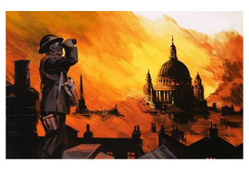  I’d like you to create a piece of artwork that shows an image from the war time. Here are some examples. Firstly you’ll need to create your background image using watered down poster paint or water colours if you have them. Once this is done create silhouette of the city made from black paper. You could even create a silhouette of some soldiers too.  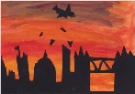  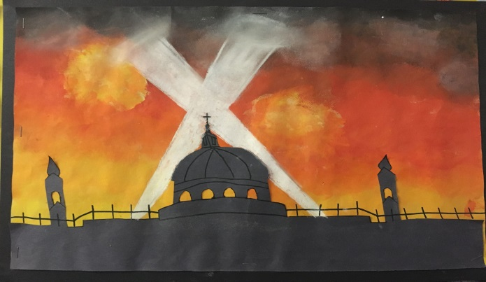
Wed | Stem Activity- Morse Code  A light being turned on and off can be used to send coded messages. This was one of the ways people used to communicate. Read the PDF titled ‘Morse Code’  Home Learning – Summer 2 – Week 3 - Year 5  Have a go at creating your own messages and see if a member of your family can decode them. Then answers the questions on the pdf file in your books.  Happy decoding.
Thurs
Friday | Topic –  Complete an activity from the new Plastic Pollution learning grid.  Go to the school website - Home Learning- Summer 2 – Week 1 – Year 5 – Plastic Pollution Learning Grid.  Don’t forget to share the tasks that you have been doing with us, especially on this important environmental problem.

