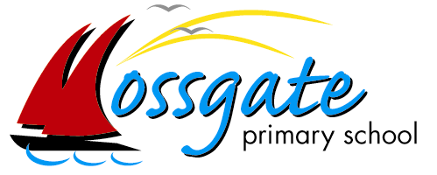
Year 5 Home Learning: Summer 2 – Week 2
Working together to achieve success’

Hello Year 5, we hope you are all keeping safe and well. Here is our next timetable to continue to support your learning at home. We are really enjoying seeing all of the fantastic work you have been doing with your learning, so please continue to share with us via email at year-5@mossgate.lancs.sch.uk and we will share these on our school’s Facebook page every Tuesday. Thank you to all of the families for taking the time to do this at such a busy time. Please continue to use the email address if you have any questions about the learning as well.
Take care and keep safe.
Mrs Elwers and Mrs Massey.

Daily PE:
Start the day with 20-30 minutes of physical activity. Suggestions include: Joe Wicks Daily PE
lesson Natasha Butler Daily Workout / Just Dance videos in YouTube. Additional physical activity are
uploaded weekly onto our school website at:
https://lancashireschoolgames.co.uk/year-3-6-spar-lancashire-school-games-activity-timetable/

Daily Newsround:
Watch the 5 minute news summary daily at 12:15pm by going to https://www.bbc.co.uk/newsround and click
‘Watch Newsround’ in the top right hand corner. Discuss topical items in the news and research any aspects
which interest – this could be a topic, country or person. Newsround is updated daily. You could even produce
your own news report on one of the topics and share it with us!

Maths:
Go to https://whiterosemaths.com/homelearning/year-5/ to access the video resources. Use the video to help explain the concept and then complete the activity (in your exercise book) which you can access by accessing the school website and following this path: ‘Summer 2 - Home Learning – Week 2 – Year 5’.
 | Monday | Tuesday | Wednesday | Thursday | Friday
Mental Maths | Complete 15 minutes of IDL Numeracy (https://idlsgroup.com/) and/or Times Tables Rocks Stars (https://play.ttrockstars.com/auth/school).
 | You will find the videos and PowerPoint presentations by following the White Rose Maths link https://whiterosemaths.com/homelearning/year-5/ and clicking on Week 5 (w/c 18th May). The sheets required for each day have been downloaded and are accessible by following: ‘Summer 2 Home Learning – Week 1 – Year 5’.
White Rose Maths | Lesson 1 –  Adding and subtracting fractions | Lesson 2 –  Add fractions | Lesson 3 –  Add mixed numbers | Lesson 4 –  Subtract mixed numbers | Lesson 5 –  Friday challenge

English: Focus theme – Hygiene, Health and Heroes!
This week explores all things to do with health, hygiene and heroes. What is a microbe? Which scientists made important advances that impact our lives today? What is the NHS and who do you consider a hero in this current climate? When following links online, parents should monitor that children are remaining on that page only and are keeping safe online. Please note some clips display unmoderated comments underneath, which may be considered inappropriate. Adult supervision is recommended to ensure these are not accessed.

Also: Complete 15 minutes of IDL Literacy (https://idlsgroup.com/) daily which develops spelling, comprehension and keyboard skills.
Mon | The clips and reading material today may contain content which is sensitive to your child, given the current climate. It is therefore advised that clips and web pages are watched, read and discussed together with an adult.  Watch and listen to the song: ‘Microorganisms’ by Peter Weatherall – making notes as you watch: https://www.youtube.com/watch?v=tHvHww1tNnA&list=RD1RIlYjxfFmo&index=2  After listening to the song, read this webpage about microorganisms and make notes in your book: https://www.theschoolrun.com/homework-help/micro-organisms  Now watch the short BBC clip: ‘Seeing the bacteria carried on hands’ here:  https://www.bbc.co.uk/bitesize/clips/z34rkqt  I’d like you to create a leaflet for younger children about microorganisms and the importance of washing hands. Using what you have read and watched today, design a leaflet suitable for children in Year 4. Make sure your leaflet is informative yet attractive to children by considering what vocabulary you use and thinking carefully about your layout. You may also want to include images/ pictures to present some of the information.
Tues | Note: The clips and reading material today may contain content which is sensitive to your child. It is advised that this clip and web page are watched, read and discussed together with an adult.  Watch the BBC Teach dramatisation of the scientist Edward Jenner here, making notes as you watch: https://www.youtube.com/watch?v=sJRJeOxX6no  Now read about Edward Jenner’s life here, making any additional notes:  https://www.famousscientists.org/edward-anthony-jenner/  Based on what you have read and watched, design and create one of the following:  - A fact page based on the life and work of Edward Jenner which could feature in a science magazine.  - A comic based on the life and work of Edward Jenner suitable for a child your age. Whichever outcome you select.  Steps to success  - Use your Year 5 skills  - Include all of the key facts about Edward’s life from his childhood up until his death.  - Think about your use of vocabulary.  Make sure it is exciting to read but also informs your reader.
Wed | Read and watch about the scientist, Louis Pasteur – jotting down key information:  Read – DK Find Out Louis Pasteur:  https://www.dkfindout.com/uk/science/famous-scientists/louis-pasteur/  Watch – Youtube: Mini Bio Louis Pasteur:  https://www.youtube.com/watch?v=OXdbQ1JkX7c  Now read and watch about the scientist, Alexander Fleming, jotting down key information:  Read – Britannica Kids: Alexander Fleming:  https://kids.britannica.com/kids/article/Alexander-Fleming/476259/  Watch – BBC Bitesize: Sir Alexander Fleming:  https://www.bbc.co.uk/bitesize/clips/zjx2tfr  Imagine the three scientists you have read about over the past two days, Edward Jenner, Louis Pasteur and Alexander Fleming, have all been nominated for the award, ‘Greatest Scientist of All Time’. You have been asked to select the winner.  Based on what you have read and watched, write down who you think deserves to win the prize. Make sure you write a clear and detailed explanation of why you have selected your scientist over the other two.
Thurs | Explore what the NHS is, when it first began and interesting facts by reading and watching the clips on the CBBC Newsround website page, ‘  What is the NHS?’ here: https://www.bbc.co.uk/newsround/38906932  Based on what you have read and watched, design and create one of the following:  - A poster about the NHS – select the information you found most interesting to create your poster.  - An infographic about the NHS. (An infographic is a collection of images, charts and short pieces of text to provide an easy to understand overview of a topic).  Use facts and images to present all you have learnt about the NHS. An example of an infographic can be found as a pdf on the school website:  Home learning Summer 2 Week 2 Year 5  NHS at 70 infograph
Fri | Watch the video, ‘For the Heroes: A Pep Talk From Kid President’ here:  https://www.youtube.com/watch?v=tgF1Enrgo2g  After watching, write down what an ‘everyday-hero’ means to you.  Think about someone you consider to be an ‘everyday hero’ during this current time in lockdown. This could be:  - someone you know personally, such as a family member, friend or teacher  - someone you have seen on the news, such as Captain Tom Moore – watch this Newsround clip to find out more: https://www.bbc.co.uk/newsround/52277760  - A whole team of people, such as people working in your local hospital.  Once you have selected your everyday hero, write a letter to say thank-you to them personally. When writing your letter, make sure you include the following:  - An opening greeting  - An initial sentence/paragraph outlining why you are writing to this person / people  - Additional paragraphs giving reasons as to why they are your everyday hero  - A concluding paragraph - summarising your reasons / reiterating your thanks  - A suitable sign off – this will be different depending on who you are writing your letter to.  Once you have written your letter try sending it to the person via post. Hopefully you’ll get a reply!

Topic

Mon | Online Safety –  Week 2 –  Alfie’s videos  Watch Episode 1: Block Him Right Good, Alfie again with your child at  www.thinkuknow.co.uk/8_10/watch/  Look at Resource Sheet 1 found at the bottom of this page.  Alfie’s profile. Alfie has taken some important steps to make sure that he is safe when he is making videos and posting them online.  Write down four steps Alfie has taken in your exercise books .
Tues | I’d like you to create a video for younger children explaining the importance of hand washing with soap.  Have a look at this one for some inspiration https://www.youtube.com/watch?v=uvG6uBq-dV0
Wed | Science  On Saturday history was made! It's the first time ever that Nasa astronauts have been sent to space on a rocket owned by the private company, SpaceX. Have a look at this news report https://www.bbc.co.uk/newsround/52526849 . I’d like you to find out some information about this mission and create a presentation about this mission. You could use PowerPoint, make a video or design a poster.  Please include information about:  - The astronauts- who are they and what will they be doing?  - International Space Station  - Space X  - The rocket  - The space suits
Thurs
Friday | Topic –  Complete an activity from the new Plastic Pollution learning grid.  Go to the school website - Summer 1 Home Learning – Week 5 – Year 5 – Plastic Pollution Learning Grid. Don’t forget to share the tasks that you have been doing with us, especially on this important environmental problem.

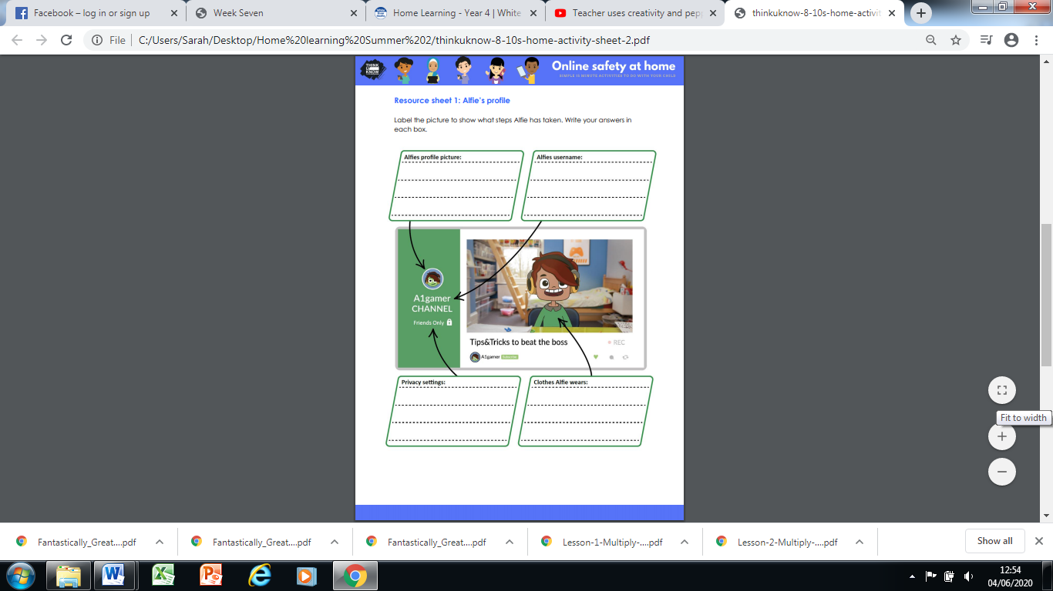
Did you get them all?
1. Profile picture is an avatar, not an actual photo
2. Username does not feature his name.
3. Privacy set to friends only.
4. Wears clothes that are not school uniform or private, like pyjamas.

