Draw the peas into the ten frame to find different ways of representing the numeral w/c 22nd Feb
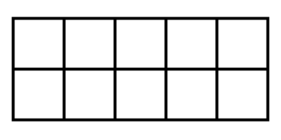
6




5
7

10

Challenge Chest! Solve the equation and draw the correct number of peas on your ten frame.
4 + 3 =

