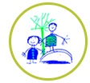

Chinese New Year challenges
It’s the Chinese New Year and the end of half term, so let’s celebrate! There is no expectation to complete all of these challenges, just some ideas to keep busy. Please send pictures for us to share on the website or twitter.
Cosmic yoga - find a space and settle down to do a snowman yoga session.   | 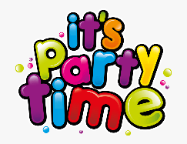  Plan a party. Which games, food, outfits would you like?   | Draw a firework picture. You could have a go at writing some words to describe how a firework sounds.  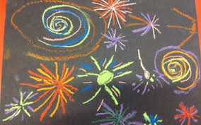  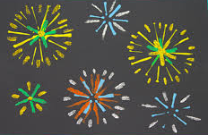 | Play a game with your family.  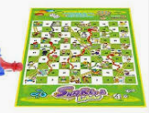  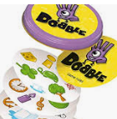
  Make a lantern. You could decorate it with sequins, glitter, tissue paper, or colour it instead. | Make a repeating pattern on a dragon. You could use colours or shapes.  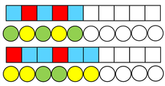  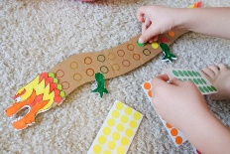 | 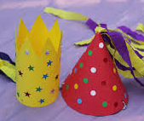  Make a party hat using paper and junk modelling resources.  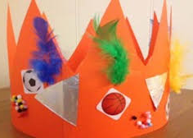 | Ask a family member to read a poem over the telephone, FaceTime or Zoom. Or listen to a story on purple mash.  
Listen to the Chinese New Year music on the link below. Can you move to the music? How does it make you feel?  https://www.youtube.com/watch?v=zi23T5qfiig |   Draw a picture of your family and talk about the things you love/like about them.  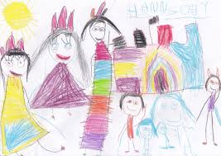 | Watch Cbeebies ‘Let’s Celebrate Chinese New Year’. Talk to your family about the ways in which people celebrate.  https://www.bbc.co.uk/cbeebies/watch/chinese-new-year | Try some Chinese food, like noodles or prawn crackers. Do you like the food? Why/why not? You could have a go using chopsticks whilst you eat. Yum!    

