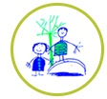

Winter challenges
Continuing our winter topic, there’s lots to do. There is no expectation to complete all of these challenges, just some ideas to keep busy. Please send pictures for us to share on the website or twitter.
  Cosmic yoga- find a space and settle down to do a snowman yoga session. | 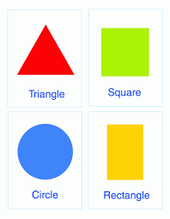  Go on a shape hunt around your house. How many different shapes can you find? You could take a photo or draw a picture and make your very own shape book! | 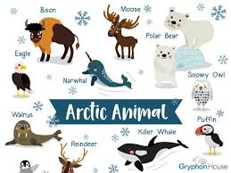  Think of an arctic animal that you would like to find out more about. Find out more about your chosen animal and create a fact book. | Play a game with your family.  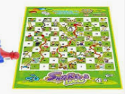  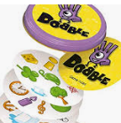
  Play the hot and cold game. Take turns to hide something in the room (as the other people close their eyes or leave the room). They need to try to find it. Help them by saying if they are freezing, cold, warm, or boiling depending how close they are to the hidden item. | Make your own musical instruments e.g. - pots and pans, rice in an empty bottle, elastic bands over a tissue box, water in bottles.  Use these to make a band and play along to your favourite songs or make up your own.  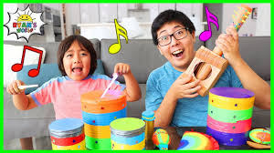  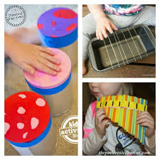  Have a good sing-a-long too! | Watch Andy’s Artic rap  https://www.bbc.co.uk/teach/bring-the-noise/andys-raps-polar-party/zn9fmfr/  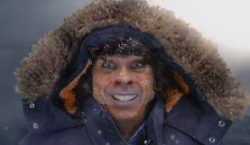 | Ask a family member to read a poem over the telephone, FaceTime or Zoom. Or listen to a story on purple mash.  
Listen to ‘Walking in the Air’ by Howard Blake. Can you find different ways to move like snowflakes swirling in the sky? https://www.youtube.com/watch?v=f0CLyDPY_U0 |   Do something nice for someone. You could help them to do something, make a picture for them, or say something kind. | Make a paper snowman garland. Decorate each snow man in a different way.  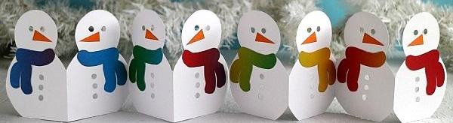 |     Decorate biscuits using icing. Which wintery biscuits will you make?

