
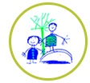
Winter challenges
Continuing our winter topic, there’s lots to do. There is no expectation to complete all of these challenges, just some ideas to keep busy. Please send pictures for us to share on the website or twitter.
  Cosmic yoga- find a space and settle down to do a snowman yoga session.  https://www.youtube.com/watch?v=k71xY0hgZJU | 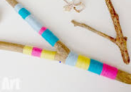  Go outside and see if you can find different shapes sticks and branches. Can you find forked stick? Wrap different coloured wool or string around it. | 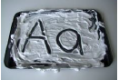  Use shaving foam, bubbles or flour on a baking tray to practise making patterns, writing numbers/letters. | Play a game.  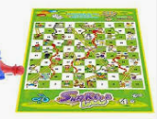  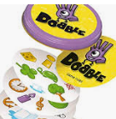
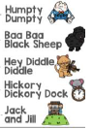  Learn or recite a nursery rhyme or poem. | 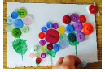  Collect different loose parts around the house, buttons, beads, string, pegs, Jjenga/Lego blocks, coins, nuts and bolts. Make a  picture. |   Make a boat den using cushions, go on an adventure like the boy and penguin. Where will you go? |   Ask a family member to read a poem over the telephone, facetime or Zoom. Or listen to a story on purple mash.
Chalk a hopscotch grid outside and have a game. 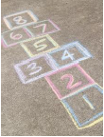 | Make paint ice lollies, using the different colours paint a picture.  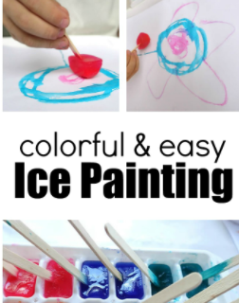 | Create your own art work on the Tate website, they will add it to the museum.  https://www.tate.org.uk/kids/games-quizzes/tate-paint |   Go outside for a walk and see how many different numbers you can find. Take a picture of them, when you get home see if you can record them on paper.


