Can label a penguin
I know facts about penguins

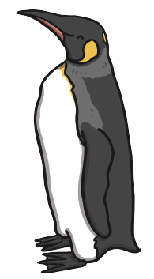
tail
feet
beak
feet

