Mrs Shepherd’s
Cooking Challenge



This week the challenge will be Hummingbird Bakery chocolate brownie. If you do make some of the yummy brownies please email them to enquiries@dobcroft-inf.sheffield.sch.uk. If you didn’t mind us putting the fabulous brownies on Twitter then please let us know in the email.

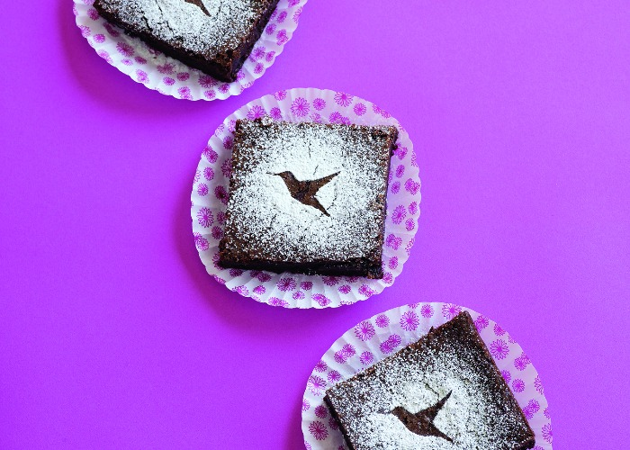

https://www.lovefood.com/recipes/69299/hummingbird-bakery-chocolate-brownie-recipe

