Finding Five
Choose a number card and add the correct number of objects to your five frame. You could also find different ways to make five, and record them on your five frame. Included are are example sentences to help you.
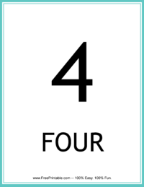

“I have four blue buttons”
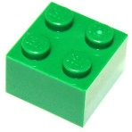 |  |  | 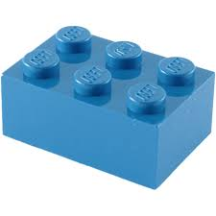
“I have three green blocks and two blue blocks. Three plus two is equal to five”
Your grown up could help you to record each number sentence like this;
3 + 2 = 5

