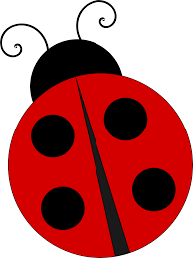
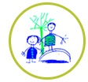
Snowflake Mistake Challenges
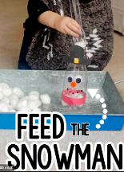
We are starting our winter topic, so the challenges for this week are a wintery theme. There is no expectation to complete all of these challenges, just some ideas to keep busy. Please send pictures for us to share on the website or twitter.
Cosmic yoga- find a space and settle down to do a winter yoga session.  https://www.youtube.com/watch?v=yE1NEiVf2Gk (5 minutes long)    https://www.youtube.com/watch?v=DP9jd1Ug2y4 (15 minutes) | 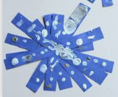  Using sticks from outside, lollipop sticks, paper strips or cotton buds- make snowflake shapes.  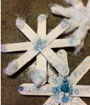 | Watch the Snowflake Mistake story read on cbeebies.    https://www.bbc.co.uk/iplayer/episode/b09jkzfp/cbeebies-bedtime-stories-608-suranne-jones-the-snowflake-mistake | Play a game.  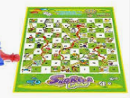  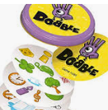
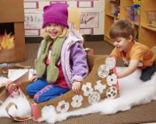  Pretend to be a skier, ski around your garden or make your own pretend sledge. | Listen to ‘The 4 Seasons’ by Vivaldi. Can you tell which part is Spring, summer, Autumn and Winter? Which instruments can you hear?  https://www.classicfm.com/composers/vivaldi/music/antonio-vivaldi-four-seasons/ | 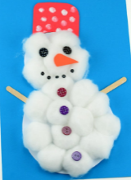  Make a snowman using  cotton wool or real snow. |   Ask a family member to read or tell you a story over the telephone, facetime or Zoom. Or listen to a story on purple mash.
Make a melted snowman biscuit. You need a plain biscuit or rice cake, marshmallow and icing.  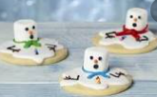 | Go for a walk, what are the signs of winter?  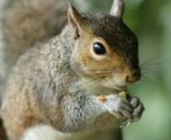 | 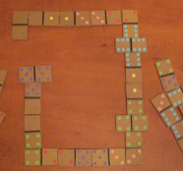  Make a dominoes trail, can you match the numbers? If you don’t have dominoes, make some on cardboard like we did in class. | Feed the snowman  Make a snowman with a plastic bottle, using tweezers fill the bottle with cotton wool or pom poms then decorate it.

