
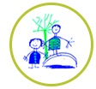
Dinosaur challenges
Here’s a few dinosaur challenges for this week. There is no expectation to complete all of these challenges, just some ideas to keep busy. Please send pictures for us to share on the website or twitter.
Listen to music and stomp, crawl, swoop like a dinosaur. Can an adult guess what type of dinosaur you are?  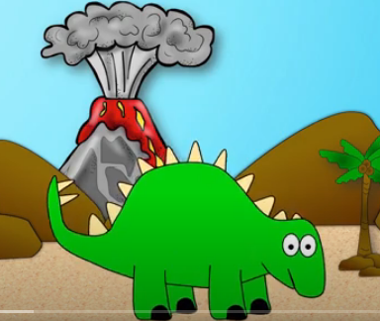 | Make a dinosaur mask.  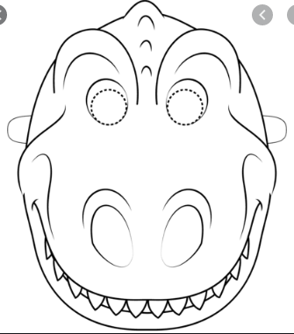  https://www.itsybitsyfun.com/dinosaur-masks.html | Make a marble run using a tray, playdough and a marble.  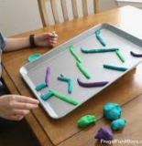 | Play a game.  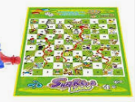  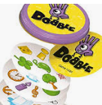
Plan an obstacle course and draw it in chalk on your path outside your house.  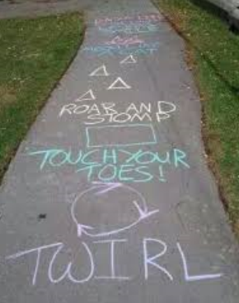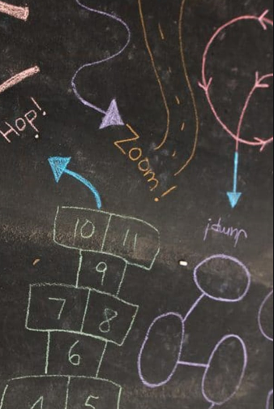 | Bake buns or biscuits, can they be the shape of a dinosaur or another animal.  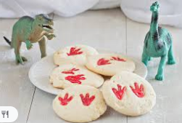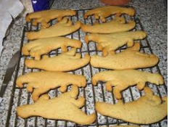 | 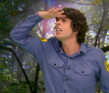  Watch an Andy’s dinosaur adventure programme. Draw a dinosaur.https://www.bbc.co.uk/iplayer/episodes/b03wh7vl/andys-dinosaur-adventures |   Ask a family member to read or tell you a story over the telephone, facetime or Zoom. Or listen to a story on purple mash.
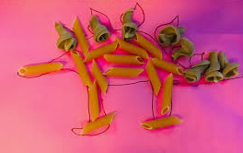  Can you make a dinosaur skeleton using pasta shapes?  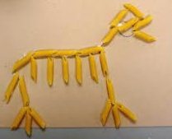  You can glue it to paper and paint over it. | Draw all of the different things you saw on your walk/bike/scooter ride today.  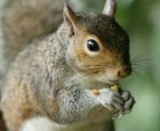 | Do the dinosaur stomp.  https://www.youtube.com/watch?v=Nky93y8nocs  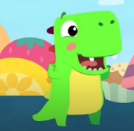  https://www.youtube.com/watch?v=Imhi98dHa5w | Mindfulness  