
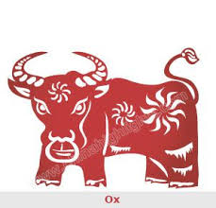
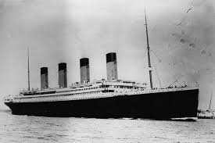
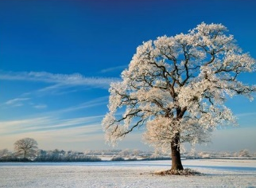
Ice and Fire – Spring 1
Science:
To observe changes across the four seasons.
To identify a range of everyday materials, and describe their properties

Star Words:
Weather, Winter, cold, snow, hail, frost, fog, deciduous trees, evergreen trees, day, night. Materials, properties, glass, metal, wood, brick, plastic, rock, hard/soft, smooth/rough, flexible/rigid.
Key Knowledge:
Seasonal changes: What seasonal changes we see in the UK in winter; weather, length of days, key events/celebrations.
Materials; to distinguish an object and the material it’s made from. To identify a range of everyday materials. To describe their physical properties and to compare and group materials together.

History:
To learn and recall facts about real events beyond living memory and order events on a timeline.

Star Words:
Timeline, past/present/future, then and now.
Key Knowledge:
To order the key events of the sinking of the Titanic.
To recall facts about the Titanic.
To explain how we know something happened in the past.

RE:
To recognise some artefacts and stories from world religions.eg Special books, prayer mats
To look at similarities and differences between us and ensure that we know everyone is equal,
Star Words:
Judaism , Bible, Islam , Koran, Prayer mat Church, Synagogue, Mosque
Year of the Ox, celebration, special, same/different/equal.
Key Knowledge:
How Chinese New Year is celebrated and to retell the story.

Other Curriculum Areas:
Literacy – The Great Explorer by Chris Judge. Writing an Antarctic setting description.
Maths -
PE: gymnastics – combining skills to make a simple movement sequence. Games to apply ball skills to play simple games involving tactics.
Computing: BBC Bitesize Dance Mat Typing.
Music: Exploring rhythm
Composer – Charlotte Bray.
PSHE: Family
Art: Drawing skills using different media.
DT: To use a range of materials to design and build a boat.

