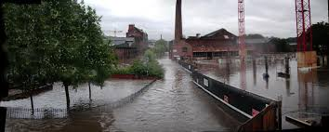

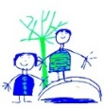
DIS Year 2
Under the Sea – Spring
Literacy:
Finding Nemo adventure story
Fact file about an underwater animal
Learning about apostrophes for omission and possession.
Past and present tense verbs
Plurals

History:
Sheffield Floods of 1864 compared to Sheffield Floods in 2007.
The effects and consequences.

Other Curriculum Areas:
PE: dance skills
PSHE: Focus is on families. Are all families the same?
DT: Create an underwater scene to develop knowledge of lever and sliders
Art: Become confident in using water colours and create an underwater picture.
RE: Buddhism – story, symbols, comparison between other religions
Music: Charanga – beat and pitch
Metacognition: develop further Growth Mind Set skills.
Geography:
We will be learning about the 5 Oceans.
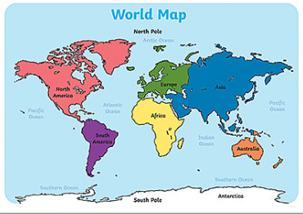
Star Words:
oceans, Atlantic, Artic, Pacific, Indian, Southern, equator. Recap Compass points
Key Knowledge:
Name and Locate the 5 Oceans

Science:
Identify different habitats and Micro habitats in Oceans. Describe how different habitats provide for the basic needs of animals and plants.
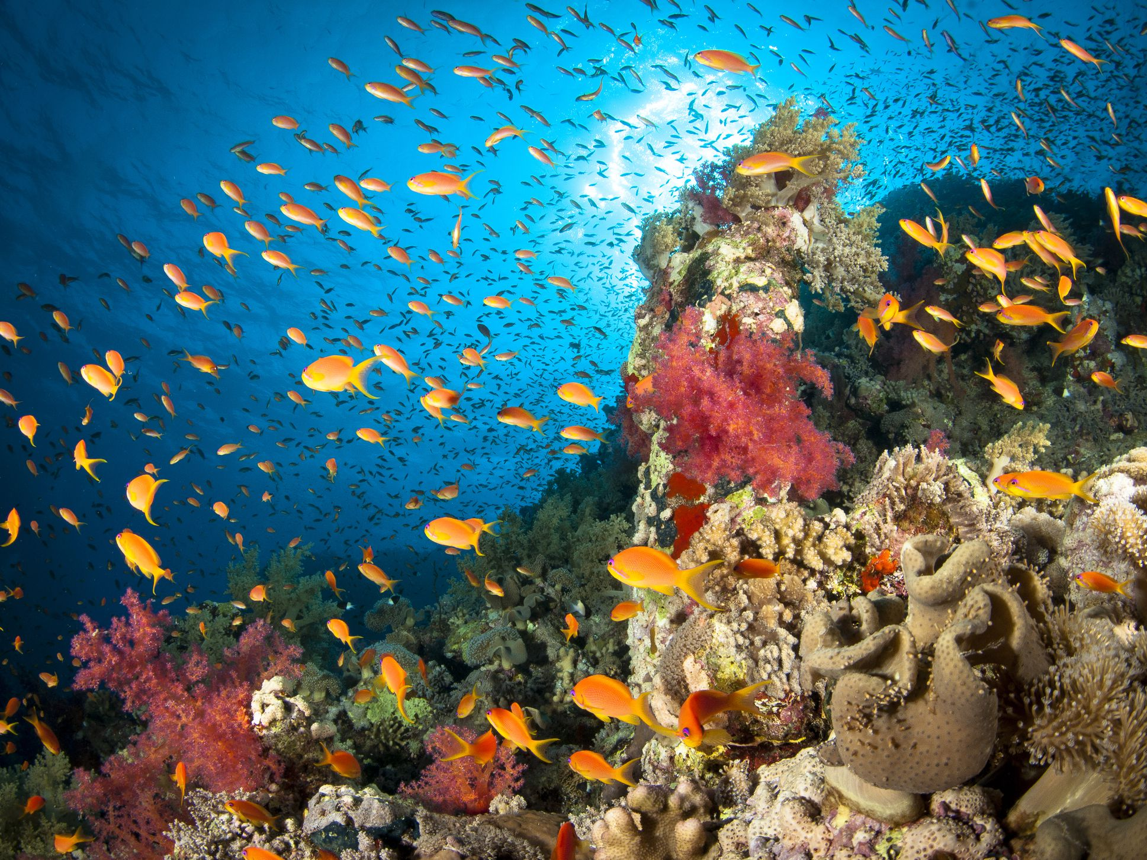
Star Words:
Habitat, micro habitat, oceans, predictors, consumer,
Key Knowledge:
Identify that most living things live in habitats to which they are suited.

